ASTRONOMY 5
Lecture 10 Summary

BLACK HOLES AND HOW THEY SHINE

- General relativity allows us to study strong gravitational fields, e.g., those in which the escape velocity is near the speed of light. The formula for the escape velocity at distance R from an object of mass M is:
________
v_{esc} = √ (2GM/R).

Note that v_{esc} is bigger closer to the mass, which says that it’s harder to escape the closer-in you are. Let’s set v_{esc} equal to the speed of light c and solve for R:
________
c = √ (2GM/R),

and thus

R(where v_{esc} = c) = 2GM/c².

In words, R is the radius where the escape velocity is equal to the speed of light.

- At this radius and below, no light or particle or any other signal can escape. The gravitational field is so intense that the trajectories of light rays are bent, and light that is aimed outwards is pulled back inside. Since no light can escape, we call such an object a “black hole.” Virtually all information is lost about the matter once it falls into a black hole. The only measures that can be discerned from outside are the total mass, total electric charge, and total angular momentum (rotation). This near-total loss of information is summed up by the saying, “Black holes have no hair.”

- The sphere on which the escape velocity is the speed of light is a border that separates the inside of the black hole from our observable Universe, and is thus another type of horizon. It is called the event horizon, meaning you can’t see any events occurring within it. The radius of the event horizon, R above, is called the Schwarzschild radius, in honor of the man who first solved the equations of general relativity around a black hole. Thus

R_{Schwarz} = R = 2GM/c². Schwarzschild radius

- To make a mass M into a black hole, you must compress it to a size smaller than R_{Schwarz}. Note that R_{Schwarz} is proportional to M. The Sun weighs 2 × 10³³ grams. Plugging in (and using the right units for G) we get R_{Schwarz} = 3 kilometers, or 2 miles. Obviously the Sun’s radius is much larger than this, so only very compact objects have regions around them where light cannot escape. R_{Schwarz} for the Earth is just 1 cm…a small marble!

- In general relativity (GR), matter warps spacetime, which curves the paths of moving objects, which we recognize as “gravity.” We will talk more about the underpinning assumptions of GR in Lecture 13. For now, we want to explain the meaning of Figures 24-4 and 24-9 in the text, which illustrate the concept of curved spacetime in GR. Shown below are diagrams of the geometry of space around a dense star and around a black hole. Each of these diagrams represents space on a two-dimensional flat surface around the hole, while the third dimension is used to represent the curved geometry of that surface. The point is to show that the relationship between the radius of a circle and its circumference is altered in a gravitational field around a point mass. To see this, consider two circles on the membrane separated by some distance in radius. According to the diagrams, the radial distance can change a lot even though the circumferences hardly differ. In words, you would have to walk a long way radially outward on the membrane to get from one circle to another, but the circumferences are nearly the same! This is curved space…the usual formula of plane geometry (circumference = 2πr) does not apply. When you see strange relationships like this between radii and circumferences (and areas and volumes) you know you’re in curved space.

Comparing the membrane of the star with that of the black hole, we see that the warp of the star is rounded off near the center while the black hole space gets more and more warped near the center. This represents the fact that gravity is more intense close to the black hole. Far from both star and hole, space is flat because gravity is weak. Bizarre effects occur within a few Schwarzschild radii of the hole, but at large distances, gravity behaves as it would with any less compact object of the same mass. There is a mythical view that black holes suck up everything in sight. This is not true. If the Sun were turned instantly into a black hole, it would quickly get very dark here, but the orbital motion of the Earth around the Sun would remain unchanged.

Curved space near a black hole
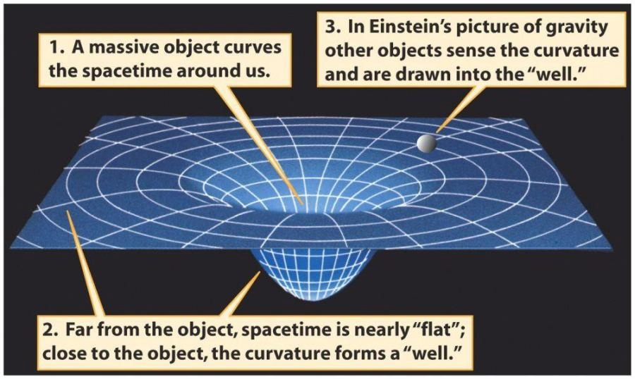
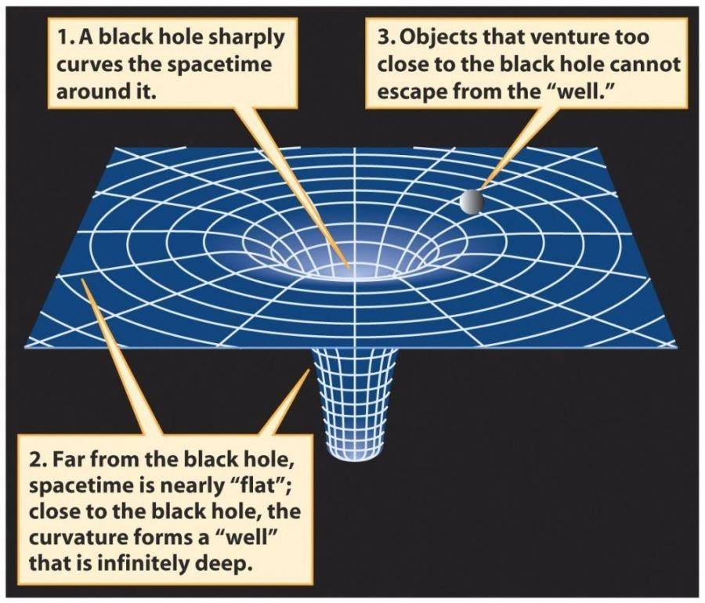
Curved space near a dense star

- The complete solution for spacetime around a black hole shows that there is more than just the geometry in the figures above. A black hole is really an opening in spacetime. Thus, a whole different universe could mathematically be stitched onto the back end (see below). The throat that joins them is called a wormhole. Alternatively, the two ends of the wormhole could open onto two different regions in the same universe (Figure 4). Wormholes are interesting because they can in principle be used for time-travel by short-cutting trips through space and effectively traveling faster than light. In practice, however, the simplest wormholes appear to be unstable and collapse into quantum chaos before they can be used. Theorists argue whether there is any way to stabilize a wormhole by infusing its neck with negative pressure. Wormholes are interesting mathematical solutions to the equations of GR, but there is no evidence that they actually exist.
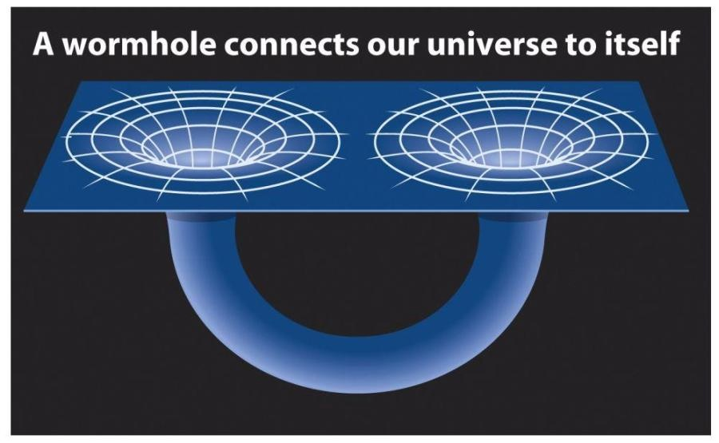
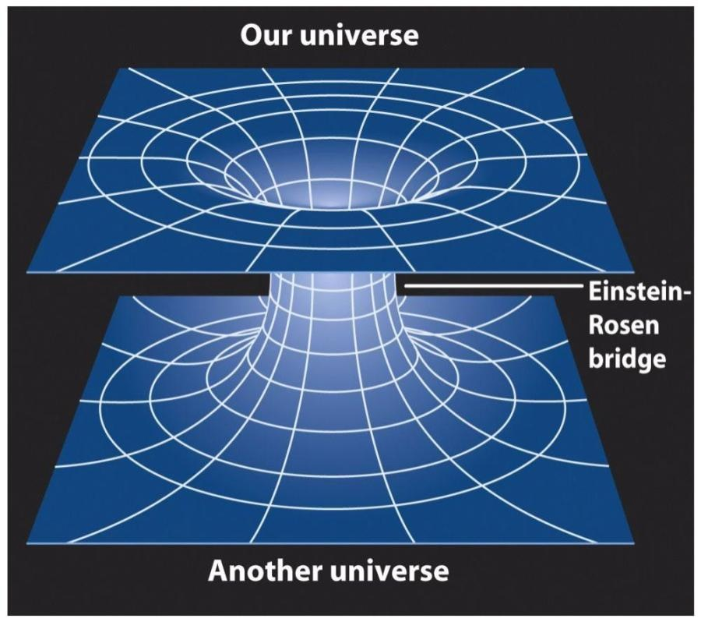

- Watching someone fall into a black hole tells you a lot about the physics of the hole. Imagine a friend in a spaceship who obliges you by falling into a black hole while you observe safely from outside. You are both carrying clocks that the other can observe. Here is what happens as he falls in:

- Your two times diverge. Soon you see his clock going slow; he sees yours speeding up.
- All processes on his spaceship appear to be slow to you, including atomic processes. His atoms emit spectral lines at slower (lower) frequencies, with the result that all photons coming from him are redshifted. This redshift has nothing to do with the Doppler effect! It would exist even if he turned on retro-rockets and hovered motionless over the hole.
- Similarly, he sees all your processes speeded up. Your photons arrive more frequently and at higher (bluer) frequencies. You and your whole spaceship (indeed the whole outer Universe!) are blueshifted to him.
- At some finite time on his clock he falls through the event horizon. If the mass of the hole is large enough (e.g., a billion solar masses), he will notice nothing special, though he is now doomed in a few minutes to be crushed by the central singularity. If M is small, more like 1 solar mass, he and his spaceship will already have been stretched (“spaghettified”) by tides while they were well outside the event horizon.
- As you watch him fall, everything about him appears to move more slowly, including his motion toward the hole. In fact, he slows down so much that you never actually see him fall through it! His signals redshift away to invisibility as he and his ship appear to be frozen in space right above the event horizon. In that sense, no black holes have ever actually been seen to collapse in our Universe!

- What is at the center of a black hole? According to general relativity, it’s a genuine singularity, a point of zero radius and infinite mass density. However, we will see in Lecture 16 that GR is incomplete because it does not properly include the effects of quantum mechanics. A singularity is infinitely small, and so we would expect quantum mechanics to be important. The basic principle of quantum mechanics, called the Heisenberg uncertainty principle, intervenes and smears out the singularity. It is replaced by some sort of “quantum chaos” where spacetime is full of rapidly fluctuating energy densities and time, gravitational fields, and spacetime warps. Known physics breaks down. This is why the physics of wormholes, which are almost singular, are still unclear.

- BLACK HOLES EVAPORATE!!! This is perhaps the strangest thing of all, that objects that seem so solid and indestructible are actually ephemeral. They evaporate by emitting a constant stream of photons and other particles. The energy for this comes from the mass of the black hole according to E = mc². Again, this happens as a result of the uncertainty principle, and we’ll talk about the actual process in Lecture 16. It takes a very long time for BHs to evaporate though ⎯ about 10⁷⁰ years for a BH of 1 solar mass. The mass of black holes that could have had time to evaporate over the life of the Universe is only about 10¹⁵ grams, roughly the mass of Mount Everest.

- MAKING BLACK HOLES: Matter has to get extremely compressed to make a black hole. There are at least two processes in the Universe that are known to do this:

- The death of massive stars: As stars run out of fuel, their centers contract even as their envelopes swell up (Lecture 4). As this happens, the crush of gravity at their centers increases. There is a fundamental limit to the ability of matter to withstand gravity, and condensed blobs of matter larger than about 3 solar masses cannot hold themselves up by gas pressure. If the core mass produced in a supernovae explosion is larger than this, it will contract to a black hole. Several few-solar-mass black holes produced by this process have been detected in nearby binary stars, where their mass pulls on a visible star whose high orbital velocity betrays the presence of the invisible black hole.

- Supermassive black holes at the centers of galaxies: These are the holes that power quasars (Lecture 9), with masses up to a few billion solar masses. How they got made is one of the biggest mysteries of astrophysics. It must have happened during the birth of galaxies, as the heyday of quasars was early in the Universe when galaxies were still very young. There must have been something special about the first accumulations of gas in galaxies that allowed some of that gas (about 0.5% in a typical galaxy) to “go down the drain” at the center. We can gain some insight into this process from models of quasars (next section).

- Modeling quasars: how can black holes shine? It is a delicious paradox that the very objects that are theoretically unable to radiate are in fact the brightest known objects in the Universe. How does this happen?

Recall that the constraint on radiation refers only to matter that is inside the event horizon. The intense radiation from black holes in quasars comes from just outside this region. Quasars radiate because the gas falling into them has to solve a fundamental problem…how to lose its angular momentum. It is actually not easy to fall into a black hole. The event horizon is tiny, and falling particles have to aim right at it, otherwise they swing round in orbit. An analogous problem is water going down a sink drain. The water inevitably has some swirling motion around the drain, which it must lose before it can go down.

Infalling black-hole gas and water both lose angular momentum in the same way, by forming a swirling disk of material near the drain. Material nearest the drain rotates faster and “rubs” against material farther out that is spinning slower. The rotation of the inner material is reduced, and it slowly spirals closer to the middle, and finally down the drain. In quasar models, such spinning disks are called accretion disks.

In the process of rubbing against one another, the rings of gas at different radii become very hot, up to millions of degrees closest to the hole. They glow incandescently, like exceedingly hot stars. In the brightest quasars, this glowing gas disk extends 10,000 times farther than the Earth’s radius from the Sun, about 5% of the distance to our nearest star. Recall the model of the Galaxy in Lecture 1 that says that stars in the Sun’s neighborhood are like oranges separated by several thousand miles. Now imagine a glowing disk in that model much hotter than a stellar surface and 100 miles in diameter! It is this combination of white heat plus comparatively great size that makes quasars so bright.

Ultimately, the energy radiated by quasars comes from the speed build-up of gas as it falls into the hole. Most of this energy of motion gets changed into heat by the frictional rubbing, and is then radiated as X-rays. To sustain the energy rate, the brightest quasars have to swallow about 1 solar mass of gas per year.

The heyday of quasars is long past. When the Universe was just a few billion years old, there were a thousand times more quasars than there are today. We believe that the disappearance of quasars is due to the drying-up of their fuel supply. Loose gas was copious in the early Universe, before it had condensed into stars. Now most of that gas has been locked up and is not available to fall into central black holes. As noted in Lecture 9, the black holes are there, lurking in all bright galaxies, but they are largely dormant now. For example, there is a million-solar-mass black hole 30,000 light years away at the center of our Milky Way, but it manages to produce only a faint radio source today, a pale whisper of what it must have been like billions of years ago.

The latest model for quasars triggers their formation by merging two gas-rich disk galaxies. Fluctuating gravity during the merger drives some of the gas to the centers of the galaxies, where it builds two black holes, which shine as quasars. Finally the galaxies merge, and the BHs do, too. In the final stages the quasars are very bright, and they make all the surrounding gas so hot that it evaporates out of the galaxies. The quasar thus commits “suicide” ⎯ it kills itself. The remnant galaxy has a large spheroidal component formed as a result of the merger, which is where we find dormant massive BHs today, at the centers of elliptical galaxies.

