ASTRONOMY 5
Lecture 11-12 Summary

ENERGY, HEAT, AND LIGHT
and the
COSMIC FIREBALL RADIATION

“And God said, Let there be light.”

- ENERGY, THERMAL ENERGY, AND HEAT:
Three major types of energy:
  - Kinetic energy: energy of moving matter (e.g., a falling rock, also heat)
  - Potential energy: energy that is being stored for later conversion into kinetic energy (e.g., the energy stored in the rock perched high on a ledge before it starts to fall)
  - Radiative energy: the energy carried by light and other forms of EM radiation
Molecules and atoms within matter are always moving. The hotter the substance, the faster they move. Heat, or thermal energy, is the kinetic energy of motion of all these particles as they rush around (gas) or vibrate (solid) in all directions.
- Temperature is a measure of the average kinetic energy of heated matter⎯the higher the temperature, the faster the particles in the matter are moving. We will express temperatures on the Kelvin scale. Each Kelvin degree is the same size as a Centigrade degree, but the zero of the Kelvin scale is at absolute zero, not the freezing of water:
Absolute zero: 0 K
Freezing water: 273 K
Room temp: Approx 300 K
Sun’s surface: 5000 K
The kinetic energy per particle increases in proportion to the temperature. “Having thermal energy” is “having a temperature that is not zero.”

- When objects get hot, they radiate EM radiation (photons). Examples are the hot filament in a light bulb and the even hotter surface of the Sun. (This thermal radiation is sometimes called “black-body radiation,” for reasons that are historical and rather obscure.) Why do hot bodies emit EM waves? Because the charged particles inside them (electrons and protons) are wiggling due to thermal kinetic energy. When charged particles wiggle, they emit EM waves. A familiar example is a radio antenna, which emits radio waves because the electrons inside it are being made to zoom up and down, at the frequency of the emitted wave.

- Thermal, or blackbody radiation has a unique spectrum that looks like this:

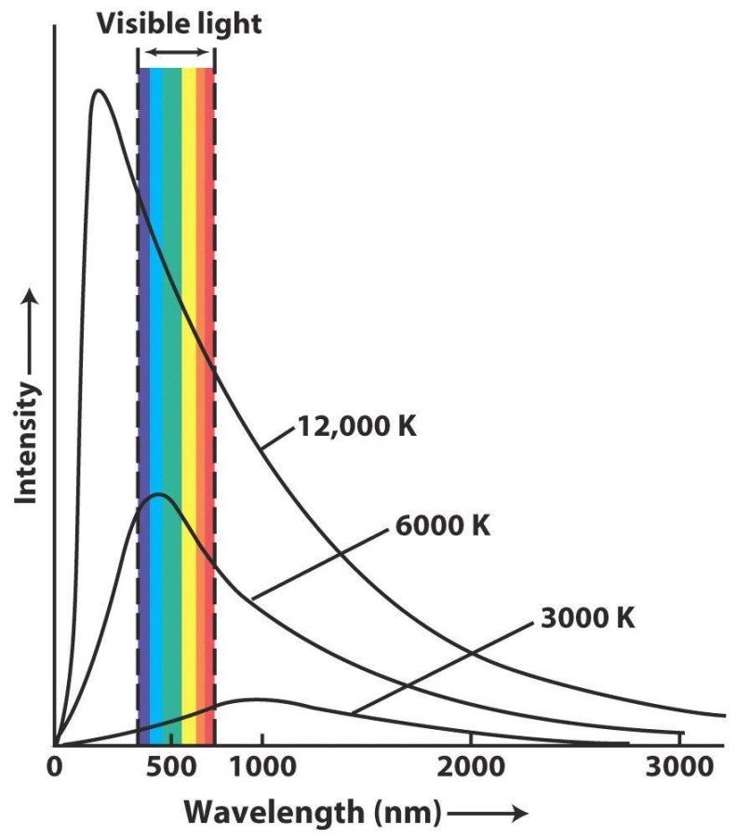

The radiation peaks at a particular wavelength that is given by the temperature.
The relation between peak wavelength and temperature is Wien’s law:

λ_{peak} = 0.29 cm / T (in degrees Kelvin). Wien’s law

This means that, as an object gets hotter (higher T), its peak wavelength of emission gets shorter (bluer). And because
E_{phot} = const. / λ, (from Lecture 3)

it means that the emitted photons also get more energetic. Summing up:

Higher T ⎯→ Hotter ⎯→ More photons and
Higher energy photons

- PLASMAS:

What happens to solid matter as it gets hotter and hotter?
- First it melts (becomes a liquid)
- Then it vaporizes (becomes a gas)
- Then it ionizes (becomes a plasma)

The early Universe was very hot…. it was a plasma.

In a plasma, particles have lots of thermal energy and move fast. Atoms bump into other atoms, knocking their electrons loose. As a result, the atoms become ionized, and the electrons roam freely, unattached to nuclei.

Instead of being locked up in distinct energy levels, the free electrons can take on any kinetic energy. So any photon that passes through the plasma can be scattered or absorbed. Plasmas are therefore opaque because light cannot pass through them freely---it bounces off the free electrons. Plasmas are like a very dense fog.

Examples of opaque plasmas: Surface of Sun: looks solid, you can’t see into Sun.
Candle flame: try looking through it, it’s opaque.

Hydrogen gas has to be hotter than about 3000 K to make a plasma.

- THE COSMIC FIREBALL RADIATION: The cosmic fireball radiation is thermal radiation that came from the Big Bang; it fills the whole Universe. It was actually predicted to exist back in the 1940’s to account for the large amount of helium in the Universe (24% by mass overall). Soon after the Big Bang, when the Universe was only about 100 seconds old, some of the primeval hydrogen in the Universe combined to make helium in nuclear reactions, at a temperature of 10⁹ K (“K” = Kelvin). Thus, we know that the early Universe had to be at least this hot. We’ll study these reactions, called primordial nucleosynthesis, in more detail in Lecture 19.

Twenty years later, in 1964, a group of famous physicists at Princeton set out to detect the predicted thermal radiation, but before they could find it, astronomers Penzias and Wilson just down the road at Bell Laboratories stumbled on it by accident while testing a microwave antenna (==> accidental Nobel Prize!).

- As the Universe expands, its temperature cools, the thermal photons lose energy, and their wavelengths stretch. This cooling and stretching is really the same thing as the Doppler effect due to the expansion of the Universe, discussed in Lecture 6. Recall how the Doppler effect stretches wavelengths when distances are increasing and compresses them when distances are shrinking. All photons traveling in the Universe stretch with the expansion, including the cosmic fireball photons, and this increase in wavelength corresponds to a fall in temperature by Wien’s Law (see above). By today, the temperature has fallen to 2.73 K (roughly 3 degrees above absolute zero), and the peak wavelength of the radiation has lengthened to 1 mm (microwaves). Hence the name: Cosmic Microwave Background radiation, or CMB.

- These are the rules for how the CMB radiation cools as the Universe expands (recall that “a” is the scale factor, with a_{now} = 1):
Temperature (in degrees K): T = (3/a) K = 3 (1+z) K
Peak wavelength (in mm): λ = a mm = 1/(1+z) mm
Photon energy (in erg): E = 2 x 10⁻¹² a⁻¹ erg = 2 x 10⁻¹² (1+z) erg
The wavelengths stretch in proportion to the scale factor, and the temperature and energy of the photons fall inversely as the scale factor. Note that if you insert a = 1 and z = 0 in the above formulae, you recover today’s values.
Table 1 shows how hot and dense the Universe was at various times. The two graphs in the handout show the temperature (T) and the scale factor (a) versus the age of the Universe, in years. These graphs are log-log graphs with scales based on powers of 10, which makes large ranges in quantities easy to plot. Note also that the symbol “∝” in Table 1 and Figure 1 means “is proportional to.”
- At early times, the Universe was so hot that it was an ionized plasma and was therefore opaque to photons. When the hydrogen gas that filled the Universe cooled to a temperature of 3000 K, it went from being a plasma (opaque) to neutral gas (transparent). We can now plug this T into the first equation in (8) to find that a = 1/1000, i.e., the Universe was 1/1000th its present size.
So, before T = 3000 K, the Universe was both ionized and opaque (notice how we are using temperature as a time label). But at 3000 K, the electrons and protons of hydrogen combined to make neutral gas atoms, i.e., the gas went from ionized to neutral. In doing so, it also became transparent. This major transition occurred when the Universe was about a 400,000 years old. It is usually called recombination, though strictly speaking there is nothing “re-” about it. After recombination, photons could travel freely over essentially infinite distances, and that is why we are able to see galaxies very far away today.
- There are two ways to think about the CMB:
  - The way described above: The original Big Bang created thermal photons along with space itself. These hot photons filled every corner of the Universe from the very first instant. The expanding Universe is like an expanding room filled with a gas of photons. As the room expands, the gas cools. These are the CMB photons we see today coming at us from all directions, which have now cooled to 3 degrees K above absolute zero.
  - A second, equally valid way: Look out into space past all the galaxies to earlier and earlier times (layers of the lookback onion). Finally you get to the time 1 million years after the Big Bang, the layer of recombination. At that point, the Universe becomes an opaque wall, and you can’t see any farther. The wall has a temperature of 3000 K, which means that if it weren’t moving away from you, it would shine almost as brightly as the surface of the Sun. However, because of the expansion of the Universe, its radiation is highly redshifted, and instead of being received at 1 micron (peak wavelength for 3000 K), it is redshifted by a factor of 1000, to 1 mm (microwaves!).
THE CMB SHOWS US THE OPAQUE WALL OF THE PRIMEVAL FIREBALL, REDSHIFTED DOWN IN ENERGY AND TEMPERATURE BY A FACTOR OF 1000 DUE TO THE EXPANSION OF THE UNIVERSE.
- Practically speaking, we cannot see any farther than the CMB wall. Our horizon radius (Lecture 2) is the outermost layer of the lookback onion that corresponds to precisely t = 0. This lies 14 billion lyr away from us. The CMB wall is 400,000 light years in front of the horizon and blocks it from our view.

