ASTRONOMY 5
Lecture 13 Summary

GENERAL RELATIVITY AND THE
GEOMETRY OF THE UNIVERSE

Nature and Nature’s Law lay hid in night.
God said, let Newton be!, and all was light.
⎯ Pope

It could not last; the Devil, howling ho!
Let Einstein be!, restored the status quo.
⎯ Modern retort

INTRODUCTORY REMARK ON “CLASSICAL” GR MODELS: This lecture describes what might be called “classical” general relativity models of the Universe. These assume two things:

- The only gravity-generating stuff in the Universe is matter, both ordinary and dark.
- The Universe is the same everywhere (Cosmological Principle). This means it
looks the same to all observers, and hence can’t have any edges or boundaries. Space must either be infinite or curve back on itself, like the Earth’s surface.

The reason for (2) is that it makes the GR equations for an evolving universe easy to solve⎯we don’t really know if it’s true for all of space, but it does seem OK for the part of the Universe we can see. In the next lecture we will explore models that keep (2) (the Cosmological Principle) but abandon (1). These are the so-called accelerating, or Λ, models of the Universe that involve a new kind of repulsive gravity. However, in this lecture, when we speak of “gravity,” we mean the normal, attractive kind.

OVERVIEW OF CLASSICAL GR MODELS:

- The expansion of the Universe is constantly being slowed down by the (attractive) gravity of its own mass. If the matter density is low, then gravity is weak, and physics says that the expansion should continue forever (an open, or unbounded universe). If the metter density is high, gravity will halt the collapse, and the Universe will recollapse someday (a closed, or bounded universe). Both time and space are bounded in a closed universe; both time and space are infinite (unbounded) in an open universe.

- The borderline density that divides these two fates is called the critical density. Critical density at any epoch is given by:

ρ_{c} = 3H₀² / 8πG, Critical density

where H₀ is Hubble’s constant at the same epoch and G is the constant that denotes the strength of gravity. If H₀ = 70 km/sec per Mpc (Lecture 8),

ρ_{c} = 10⁻²⁹ grams/cm³,

which is roughly equivalent to 6 hydrogen atoms per cubic meter of space. At exactly critical density, the Universe would expand forever, but with a speed that would get ever closer to zero as time went on.

An analogy to a critical-density universe is a rock that has exactly escape velocity from the Earth. Any lower velocity and the rock will fall back. Any higher and it gets to infinity with positive energy of motion. At escape velocity, it coasts to infinity but without any extra energy (or velocity) to spare.

Note that critical density is a hypothetical value. The real Universe could have critical density, or it could have less or more. We will see below that it has less.

- The quantity

Ω_{m} = ρ(actual) / ρ_{c} Definition of “Omega-matter”

expresses the actual density of the Universe relative to the critical value. Ω_{m} = 1
would be a critical density Universe. The density of all matter in and around
visible galaxies is estimated to be only

ρ_{gal} = 3 x 10⁻³⁰ grams/cm³.

This is 3 times less than critical density (above), or Ω_{m} = 0.3. So, unless there is a lot of undetected matter in the empty spaces between the galaxies, it looks like the Universe will expand forever.

- The next plot shows how the scale factor, a, grows in universes with different densities and decelerations. There are five cases: Ω_{m} = 0 (ρ = 0), Ω_{m} = 0.9, Ω_{m} = 1.0, Ω_{m} = 1.1, and Ω_{m} = 1.5. Note the places where the lines are straight; a straight line means that the Universe is expanding at constant speed, i.e., galaxies are not slowing down or speeding up. This means that there is no deceleration, and thus that the effect of gravity is unimportant. The Ω_{m} = 0 universe is like that at all times---it has no matter and so there is no deceleration. The places where the lines curve downward are places where the Universe is slowing down, i.e., it is decelerating. This happens when gravity is important. The Ω_{m} = 1.5 universe is like that at all times---it is always slowing down, and strongly. The Ω_{m} = 1 universe is also slowing down at all times, but weakly. The Ω_{m} = 0.9 unverse is slowed down at early times but expands at constant rate at late times. Matter is important early but not later. At late times, it acts like it has no matter at all.
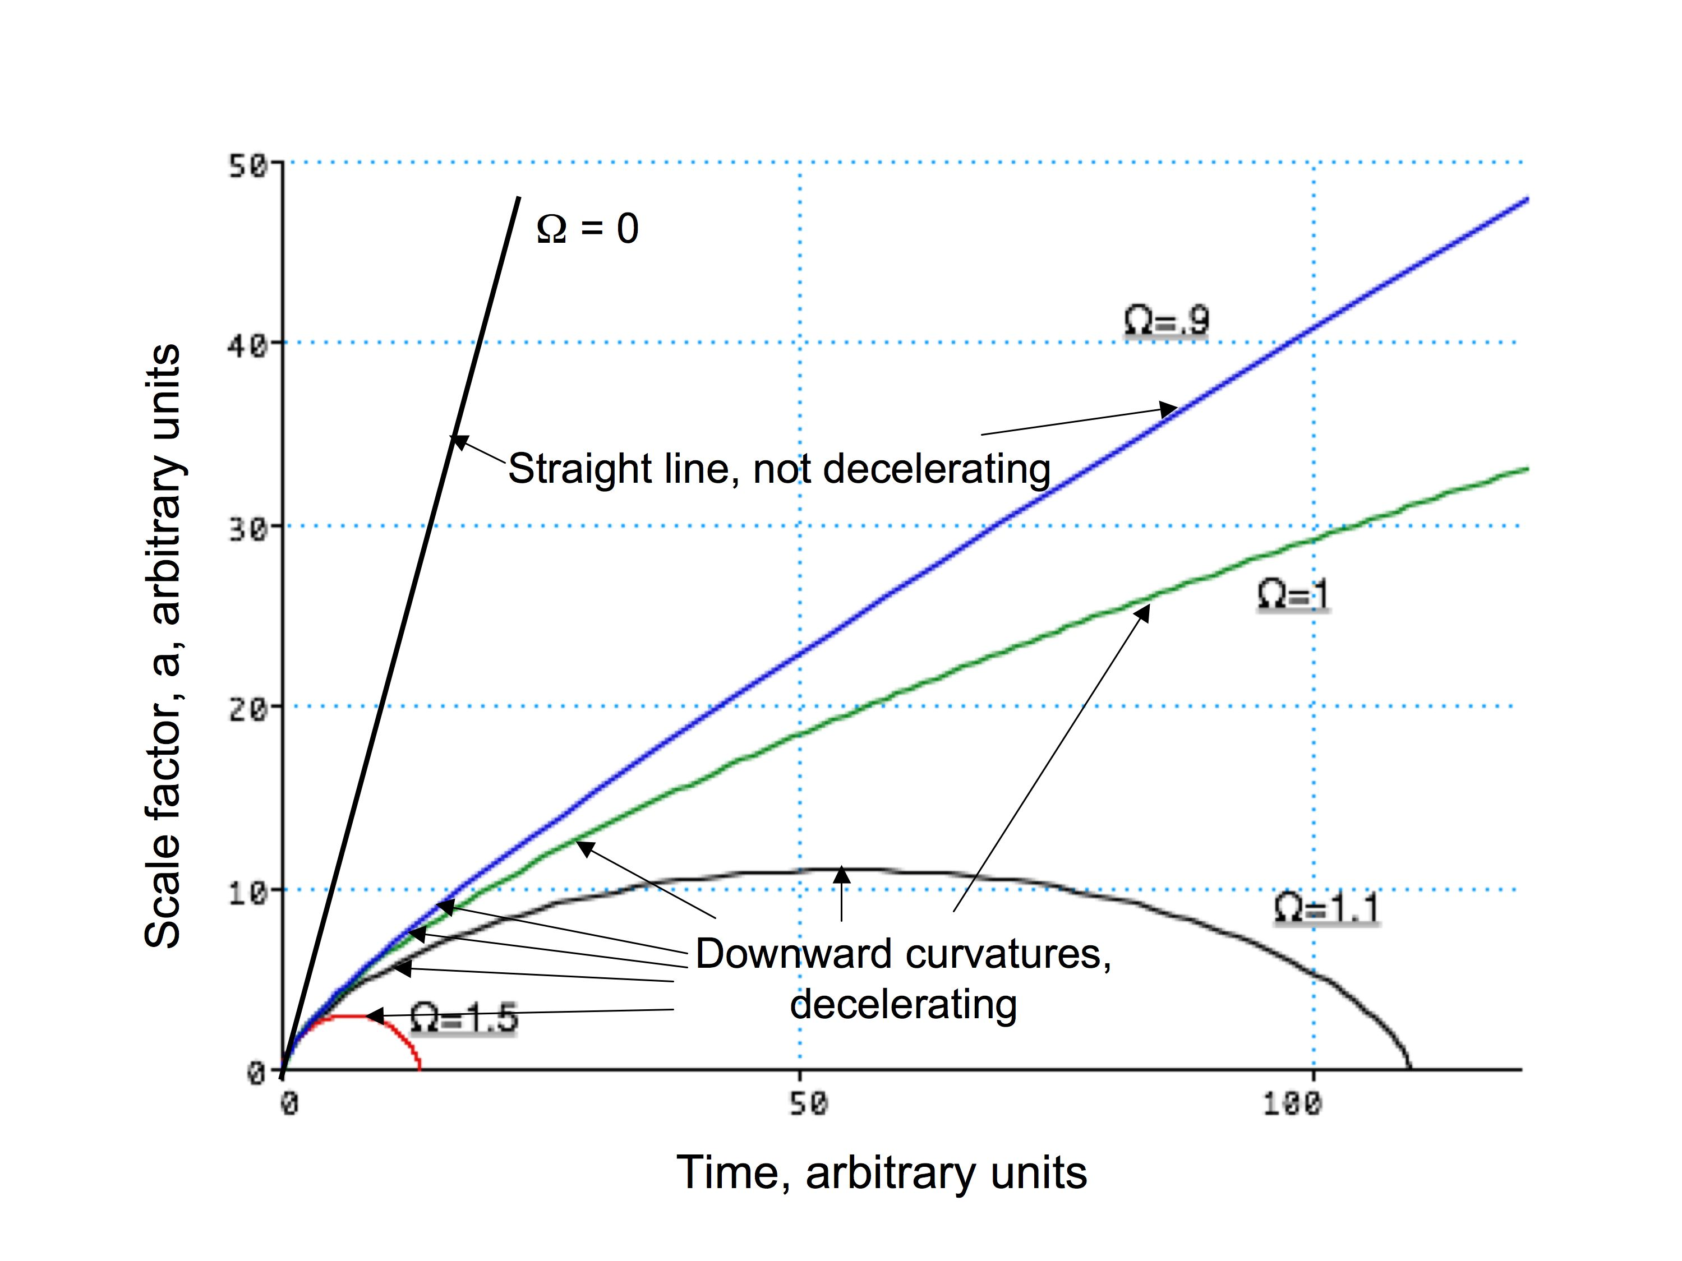Figure: The expansion rates of different universes with different amounts of matter in them. All these universes started out at t = 0 with the same expansion rate.

- In classical GR models, the age of the Universe depends only on Ω_{m} and H₀:

For a universe that is not slowing down, the age is just (Lecture 8):

t = 1/H₀ = 14 billion years (Ω_{m} = 0; no slow down)

If the Universe is slowing down, it must have been expanding faster in the past. On average it has been going faster than it is now, so it took less time to get to its present size than we would judge from the present rate. Quantitatively, if the density were critical (Ω_{m} = 1), one can show that the age of the Universe would be only

t = 2/3 x (1/H₀) ====> 9 billion years.

But we have seen that the oldest stars are 14 billion years old (in globular clusters), and so the Universe cannot be as young as 9 billion years. This is one more piece of evidence that Ω_{m} cannot be as large as 1….it makes the Universe too young.

Note: matter always decelerates the expansion, but, as noted above, a strange new form of energy called vacuum energy seems to exist that exerts a repulsive gravitational force, causing the Universe to speed up at recent times. This is the essence of the so-called “Λ-models” (pronounced “lambda-models”). The slowing down followed by speeding up alters the logic about ages given above, and there is no longer a simple relation between t and 1/H₀. Λ-models are discussed in the next lecture.

- General relativity is Einstein’s improvement over Newton’s formulation of gravity. It is based on the concept that the presence of matter warps spacetime.
According to GR, the curvature of spacetime is what causes bodies under the influence of gravity to follow curved paths. GR is an improvement over Newton because it can deal with really strong gravitational fields and because it allows us to calculate the bending of light rays by gravity (according to Newton, gravity would not pull on light because photons have no mass). (A “strong” gravitational field is one where falling bodies attain velocities close to the speed of light. The classic example of a strong field is a “black hole.”)

- According to classical GR models of the Universe, the curvature of space and the ultimate fate of the Universe are intertwined. Here is a summary:

Geom. of Average Ω_{m} Total Type of Ultimate Appar size of
Space Density Volume Universe Fate Dist Galaxies
⎯⎯⎯⎯⎯⎯⎯⎯⎯⎯⎯⎯⎯⎯⎯⎯⎯⎯⎯⎯⎯⎯⎯⎯⎯⎯⎯⎯⎯⎯⎯
Spherical > Crit. > 1 Finite Closed Collapse Magnified
Flat Crit. 1 Infinite Flat Expand Normal
Saddle < Crit. < 1 Infinite Open Expand Minified

- Sample tests of “curved space:” A symptom of curved space is that the geometrical formulas for the shapes, areas, and volumes of geometrical figures that we learned in geometry class don’t work.

Examples:

Space geom. Angle sum Circumf. of Area of Volume of
in triangle circle circle sphere

Spherical > 180° < 2π r < π r² < 4/3 π r³
Flat 180° 2π r π r² 4/3 π r³ (standard)
Saddle-shaped < 180° > 2π r > π r² > 4/3 π r³

Flat space is familiar, standard geometry.

Note: In GR, the path of a light ray is the shortest distance between two points; hence, the equivalent of a straight line. To draw a triangle in the Universe, do it by shining three laser beams between the vertices.

The figures below show the shapes of triangles in spaces of various curvatures. Positive curvature corresponds to a spherical space geometry; negative curvature corresponds to a saddle geometry. Note how the sum of the angles is different in the different cases.

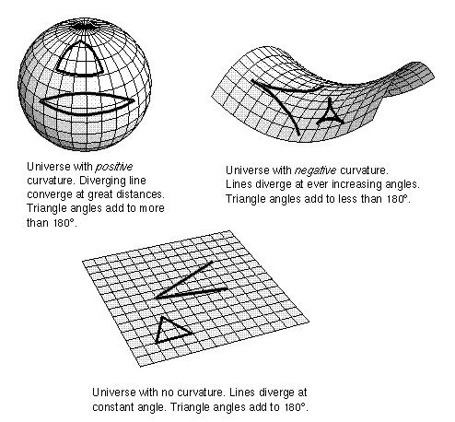

- We can test the geometry of the Universe by using the size and brightness of distant objects:

Examples:

Angular sizes of distant galaxies will look small in an open universe, big in a closed universe.

Brightnesses of distant galaxies (or other objects) will look dim in an open universe, bright in a closed universe.

The effects of curved space get larger at larger distances; at z = 1, the effects on brightness and apparent size are 20-40%. (Note: z = 1 is a lookback time of about 8 billion years out of a total 14 billion years. At z = 1, the scale factor a = 0.5, so the Universe was half its present size.)

- For such tests to work, the distant objects must be identical to local ones in terms of size and/or brightness. Such constant objects are termed standard candles or standard rulers. The history of cosmology has been a search for standard candles and rulers. Galaxies are not good candidates because we believe they evolve significantly over billions of years. The best standard candle at present is thought to be a kind of supernova explosion called a Type Ia. Type Ia’s are as bright as whole galaxies for a few weeks and can be seen out beyond z = 1. Type Ia’s together with other data seem to be pointing to an accelerating, Λ Universe. More on Type Ia’s next lecture.

