ASTRONOMY 5
Lecture 14 Summary

AN ACCELERATING UNIVERSE?

Who ordered this???
⎯⎯ Enrico Fermi, on the unexpected
discovery of the neutrino in 1932

- Introduction: In Lecture 13 we sketched the foundations of classical cosmological models: the open, closed, and critical-density types. We assumed ordinary attractive gravity from matter only, which always acted to slow down the expansion. In such cases, there was a one-to-one link between the geometry of space (space curvature) and the amount of matter: high-density universes had spherical geometry, low-density universes had saddle-shaped geometry, and critical-density universes were flat.

In this lecture we are going to break the link between the matter density and the geometry. We will do this by introducing a new gravity from another source, not ordinary matter. This source will be unfamiliar and completely counterintuitive. It is vacuum energy density from a field that does not decline in intensity as the Universe expands. Such an energy density plays havoc with the equations for the expansion of the Universe and drives it into hyper-inflation.

Why do this? Because recent measurements indicate that the classical cosmological models do not match our Universe. Specifically, our Universe seems to be flat yet has a density much lower than critical. The only way to get this forbidden combination is to introduce a new form of gravity. The name of this new stuff is Ω_{Λ} (“Omega-Lambda”), or just “Lambda” for short. It is being called the most important discovery in fundamental physics since the discovery of quantum mechanics 80 years ago. It comes out of left field, having no roots in any current particle-physics theory. No one knows where the heck it comes from or what it portends.

- Recall the simple formula for the critical-density universe model (Lecture 13):

Ω_{m} = 1 Critical-density universe

Here, Ω_{m} (“Omega-matter”) is the quantity Ω_{m} = ρ(actual) / ρ_{c}, where the symbol ρ means density. Thus, the equation says simply that in a critical-density universe the real matter density, ρ(actual), is the same as the critical density, ρ_{c}.

In the theory of general relativity, there is a deeper meaning to this equation. The number on the right-hand side expresses the curvature of space, and the value “1” means that the geometry is flat. So, you can think of this equation as really an equation for space curvature. Looked at this way, Ω_{m} is the space curvature coming from matter (remember, matter tells space how to curve in GR), and the curvature in a critical-density model is simply that needed to make the geometry flat. In the language of physics, Ω_{m} is the “source term” for the space curvature generated by matter.
(Parenthetical remark: “matter” includes all matter, dark as well as ordinary matter. Thus Ω_{m} is really Ω_{DM} + Ω_{ord}.)
- It is easy now to see how to break the tight link between matter and space curvature in the classical cosmological models⎯simply wave your hands and add a new term, Ω_{Λ}!

Ω_{m} + Ω_{Λ} = 1 Flat Lambda-universe

This universe is still flat (i.e., has “1” on the right-hand side) but no longer has critical density (i.e., Ω_{m} is less than 1 if Ω_{Λ} > 0).

The tricky part is what sort of medium is needed to create Ω_{Λ} with the right properties to fit into the equations of GR. We don’t prove it but simply assert that a constant energy density that does not decline or dilute with expansion has the right mathematical behavior. The net result is to add another “source term” to the curvature, one from vacuum energy. In words, the above equation says that the curvature from matter plus the curvature from vacuum energy together add up to make the Universe flat.

- Historical note: Einstein derived the equations for space curvature for general relativity including at first the source term for matter only, Ω_{m}. He later saw that it was possible to add the additional term Ω_{Λ} by invoking constant vacuum energy. He wanted to do this because he believed that the Universe was stationary, not expanding or contracting, and he saw that a repulsive force from Ω_{Λ} could be tuned just so as to counteract the attractive force of gravity and “hold the Universe up.” This was in 1917.

Shortly after that, two things happened: 1) Other theorists soon showed that Einstein’s static universe model was in fact unstable and, given the slightest push either way, would collapse or expand forever. Such an unstable universe could not long exist in nature, just as a pencil cannot long balance on its point. I find it hard to imagine that a scientist of Einstein’s calibre could have missed this basic point, but he did. 2) In 1929, Hubble discovered that the real Universe was actually expanding. Both of these points appeared to demolish Einstein’s Ω_{Λ} term, and he was said to refer to it in later years as “my greatest blunder.”

In fact, the concept of Ω_{Λ} has proven to be one of the most fruitful in cosmology. We shall see that it spawned the idea of “inflation,” a very early hyper-expansion of the Universe that solves many problems with the standard Big Bang model such as: why the Universe is so similar everywhere, why space curvature is so flat, where matter and energy came from, and where the density fluctuations came from that made galaxies. However, this early acceleration is well founded in high-energy particle physics. By contrast, the current acceleration does not yet have any natural explanation. In the opinion of many physicists, TODAY’S NON-ZERO Ω_{Λ} IS THE MOST UNEXPECTED DISCOVERY EVER MADE ABOUT THE NATURE OF THE UNIVERSE.

To distinguish today’s Ω_{Λ}from the intense energy density field that drove early inflation, the term dark energy is being used to denote today’s Ω_{Λ.}

- Why we think the Universe is flat:

This comes from the cosmic microwave background radiation. The CMB radiation is not precisely uniform but rather has tiny ripples on it, at a level of 1 part in 100,000. These were first discovered by the COBE satellite in 1990, but the best image of them has been captured by the Wilkinson Microwave Anisotropy Probe (WMAP satellite). The celestial sphere is covered with low-level “measles,” which are density fluctuations generated during the first inflation. Theory says that one size scale should stand out above all others in the CMB image, and indeed, this special scale stands out strikingly in the WMAP picture. The characteristic size scale of the measles is about 1 degree (twice the diameter of the Moon).

It turns out that this size scale can be calculated from first principles, and it hardly depends on Ω_{m} or any other property of the Universe. That means it is a standard ruler whose absolute length is known, in meters.

This new breakthrough is what allowed us to measure the geometry of the Universe to high precision. The apparent angular size of this ruler on the sky depends on the curvature of space. Relative to flat space, recall that objects look bigger than expected in spherical geometry but smaller than expected in saddle-shaped geometry (Lecture 13). Thus, the angular size of the “measles” in the CMB is an accurate measure of the curvature of space.

The result is that the curvature is very close to flat. In fact, Ω_{m} + Ω_{Λ} = 1 to within just 1%.!

This result can be shown in the following diagram, which illustrates various cosmological models. Ω_{m} is plotted on the horizontal axis, and Ω_{Λ} is plotted on the vertical axis. Each combination of Ω_{m} and Ω_{Λ} is a point in this diagram. The characteristic size of measles in the CMB says that Ω_{m} + Ω_{Λ} = 1. This is the equation of the downward-sloping line, which is the locus of all flat universes. The CMB measles say that the Universe must lie somewhere along the red line.

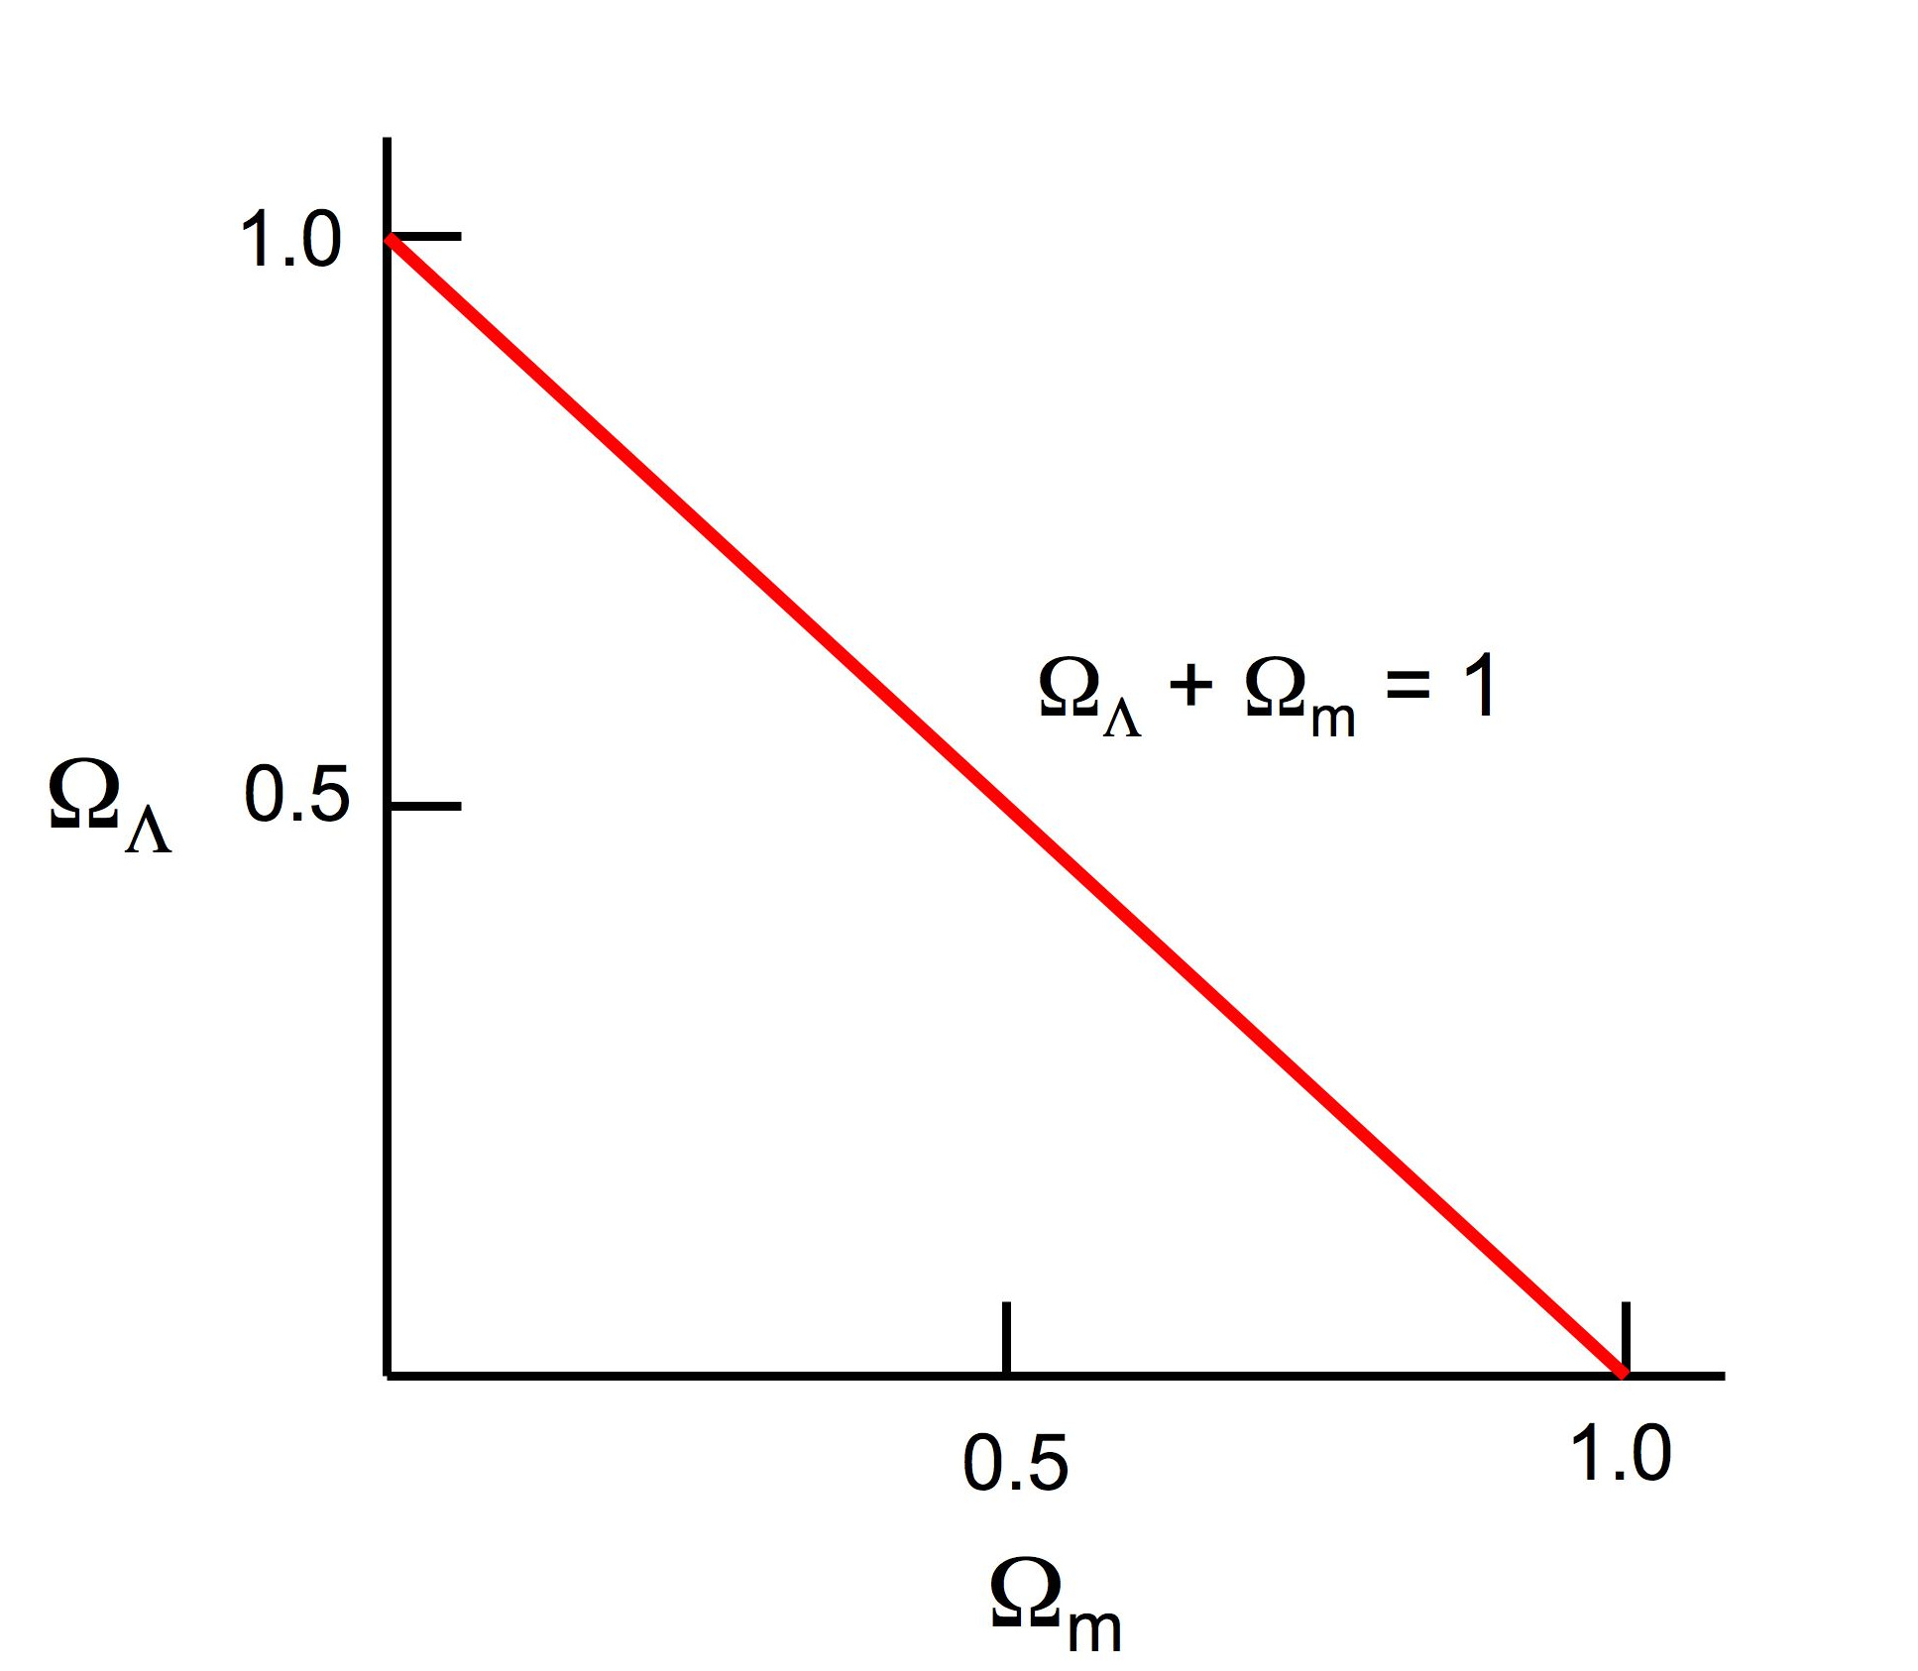
Figure: Flat Universes

- Why we think that Ω_{m} is only 0.3:

Where along this line does the Universe lie? To determine this, we must measure something else, for example, Ω_{m} alone. We already mentioned this in Lecture 13, where we gave a value for the total amount of mass (including dark matter) associated with visible galaxies. We called the resulting density of matter ρ_{gal}, and we got a value for Ω_{m} that was around 0.3, and in any case much less than 1. However, this number was “iffy” because it is hard to be sure that all the dark matter is detected this way. There might be more dark matter between galaxies that this method is not sensitive to.

A second new observational breakthrough solves this problem. A new “standard candle” has been developed that allows us to probe the geometry of space out to large distances. A standard candle is like a standard ruler except that the brightness is constant rather than the length (see Lecture 5 on standard candles). The new standard candle is a particular kind of supernovae, called Type Ia. Such supernovae are believed to arise from close binary stars in which one star grabs mass from the other. This can cause it to exceed a fundamental mass limit, triggering an explosion. Since all of these supernovae start the same way, they are thought to be highly uniform. Indeed, measurements of dozens of these supernovae in nearby galaxies indicate that their brightnesses are the same to within 10% (after some corrections are made).

The goal is now to measure the apparent brightnesses of these supernovae at large distances from us (high redshift). The rate of fall-off of brightness is a measure of the geometry of the Universe. The results are shown in the figure below. The horizontal axis is redshift, and the vertical axis is a measure of supernovae brightness, getting fainter upwards. Predictions for various combinations of Ω_{m} and Ω_{Λ} are shown. The scatter of the points around a smooth curve is fairly small.

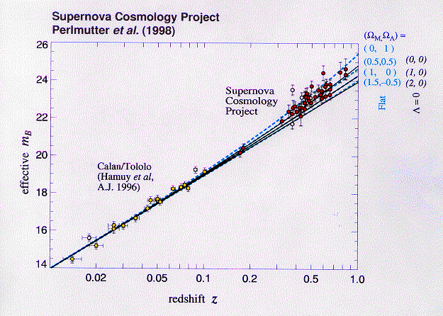
Fainter

The result of this new measurement is shown in the next figure. The CMB constraint Ω_{m} + Ω_{Λ} = 1 (flat universe) is repeated as the downward sloping straight line from the figure above. The new constraint from Type Ia supernovae is added as a series of probability ellipses; the largest of these says that the Universe must lie somewhere inside it with a probability of 99%. Where the constraints intersect is the allowed region for the Universe, shown as the red dot. Hence, the combined data from the CMB plus supernovae say that Ω_{m} is roughly 0.3 and Ω_{Λ} is roughly 0.7. Note that this value of Ω_{m} agrees well (orange arrow) with what we found from ρ_{gal} around visible galaxies in Lecture 13. This value was also Ω_{m} = 0.3, which shows that there cannot be much additional matter between galaxies after all.

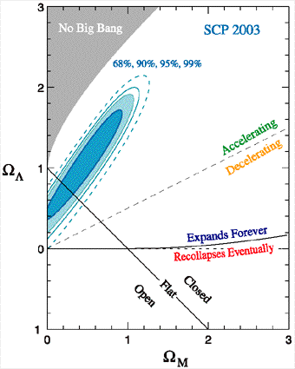
ρ_{gal}

- The predicted future evolution of the Universe:

  - A universe with Ω_{m} = 0.3, Ω_{Λ} = 0.7 expands forever. Not only does it have less than critical density (Ω_{m} = 0.3), it also has an additional repulsive force from Ω_{Λ}. This universe is accelerating, and so far as we know, there is nothing to stop it in future. A plot of the scale factor in the future looks like the top line in the figure below. Other model universes are shown for comparison. Note that they all “kiss” the same line with the same slope at the time labeled “Now”---this means they all have the same expansion rate/Hubble constant (H₀) now. The size (i.e., the scale factor a) of the Lambda universe (top line) doubles roughly every 10 Byr in future and continues to do so without limit.

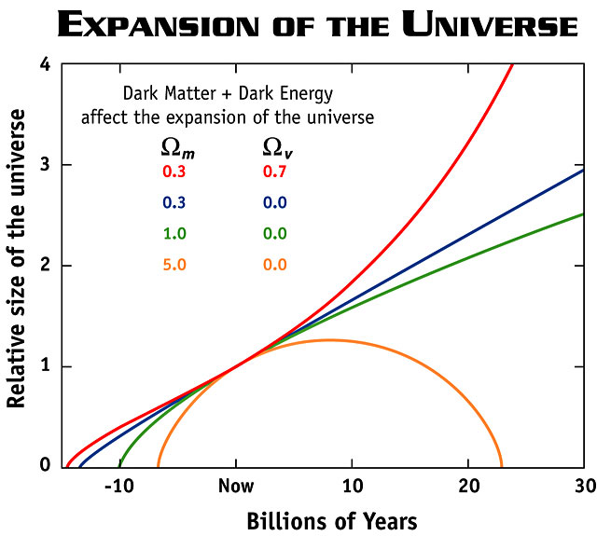

Ω_{Λ}
Now

  - As the Universe expands, matter will become more dilute while the dark energy density stays constant. This will reduce Ω_{m} still further relative to Ω_{Λ}. In future, Ω_{m} will tend to 0, and Ω_{Λ} will tend toward 1.
  - As dark energy comes to dominate over matter, the Universe enters a hyper-inflating phase in which it literally expands faster than the speed of light. That is because every galaxy is continually accelerated without limit and ultimately moves faster than the speed of light. We will not actually see galaxies go faster than light, however. The situation is analogous to objects falling into a black hole, but inside out---Doppler shifts become infinite and objects become highly redshifted. But time also slows down from our point of view, and so we never actually see a galaxy break the speed-of-light barrier---it simply redshifts out of sight.
  - However, structures that have already gravitationally formed will have enough gravity to resist the acceleration and will remain intact. Thus, our small Local Group of galaxies—Andromeda, our Galaxy, plus a handful of smaller satellite galaxies—will remain visible to us, but the rest of the Universe will accelerate out of sight and disappear! This will happen roughly 100 Byr from now.
  - Cultural note: with the rest of the Universe invisible, it will be essentially impossible to reconstruct cosmic history and the evolution of galaxies. All traces of the Big Bang will be erased, including the cosmic expansion of galaxies and the CMB radiation (which will be completely redshifted out of sight along with the galaxies). If humans have not preserved our present knowledge of our cosmic origins, it will no longer be possible to reconstruct them. All evidence of where we came from will be lost.
  - The ultimate outcome of the new Lambda model is unknown. It may be that Ω_{Λ} is truly a constant and will remain so forever. If so, the hyper-inflation will also go on forever, driven by Ω_{Λ}. On the other hand, Ω_{Λ} could turn out to be like the original vacuum energy density field that drove early inflation. As we shall see, this field decayed after roughly 10⁻³² sec, and its energy content was the reservoir that provided the matter and energy of today’s Universe. If a similar event happens in future, the hyper-inflation will cease, and the energy that is released in the decay of Ω_{Λ} may appear in some totally new form at that time. We just don’t know.

