ASTRONOMY 5
Lecture 15 Summary

THE FORCE AND PARTICLE ZOO

- THE FOUR BASIC FORCES OF NATURE: a brief overview.
  - GRAVITY: The universal force…affects every particle and is generated by every particle, including even massless particles like photons.
  - ELECTROMAGNETISM: Affects only electrically charged particles. Binds electrons into atoms, and atoms together to make “solid” matter. (In fact, seemingly solid matter is mostly empty space.)
  - STRONG FORCE: Affects quarks, binds them together to make protons and neutrons. Binds protons and neutrons to make atomic nuclei.
  - WEAK FORCE: Affects both quarks and leptons (for definitions of these terms, see below). Holds electrons and protons together to make neutrons.
ARE THERE REALLY FOUR SEPARATE FORCES…OR ONLY ONE?
STAY TUNED…..
- The Standard Model of particle physics says that there are two types of particles in the Universe: “matter” particles, which are acted on by forces, and “force-carrier” particles, which transmit forces between matter particles. The idea that forces are carried by the exchange of certain particles between other particles is a new idea that originated in this century.
- MATTER PARTICLES in the Standard Model:
  - There are two basic types of matter particles: quarks and leptons.
  - Three families within each type: electrons, muon and tau.
  - Quarks assemble themselves to make baryonic (i.e., “heavy”) particles like neutrons and protons and even heavier relatives.
  - The leptons (“light ones”) are lighter particles such as the electron and the neutrino. Leptons do not join together like quarks but come in singles.
  - Baryonic matter is also the cosmologist’s shorthand for “ordinary matter,” comprised of atoms (protons, neutrons, and electrons) as in the periodic table. This name distinguishes it from dark matter, which we have already seen cannot be made of ordinary matter. The name “baryonic” is illogical because ordinary matter contains electrons, which are leptons, but the name has stuck anyway.
  - Neutrons and protons are each comprised of three “up” and “down” quarks. Neutrons and protons weigh about 1 Gev. A “Gev” means 10⁹ electron volts, which is a unit of energy (remember, E = mc², so mass can be expressed in terms of energy. In regular mass units, a proton and neutron weigh about 1.7 x 10⁻²⁴ gram.) An electron is about 2000 times less massive than a proton (i.e., weighs about 0.5 Mev, or 8 x 10⁻²⁸ gram). Note that quarks have +2/3 and -1/3 charges!
d -1/3 u +2/3
Proton = u u Neutron = d d
+2/3 +2/3 -1/3 -1/3
- Other combinations of quarks make rare, even heavier baryons. These are unstable and decay quickly into neutrons and protons; they are not present in everyday ordinary matter.

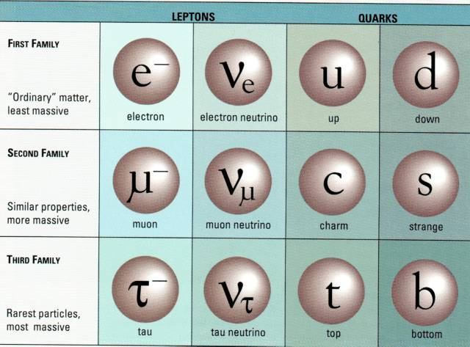
+2/3
-1/3
-1/3
-1/3
+2/3
+2/3
Quarks combine to make baryons
“Bary” = heavy
Leptons = “light ones”

- Baryons have substructure in the form of quarks, but leptons and quarks are fundamental.
- Each force acts through the exchange of its own kind of carrier particles. The force carriers are also called “bosons” (for obscure reasons). Feynman diagrams like that below are used to represent forces between particles caused by the exchange of carrier particles.
  - Two electrons (like charges) repel one another via an exchange of photons:
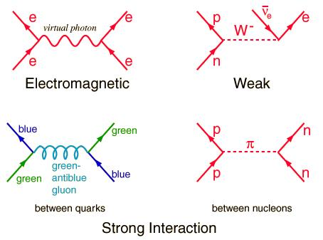
Photons carry the electromagnetic force
  - A neutron decays into a proton and electon via the weak force (this is an example of radioactive decay).
W (also Z) bosons carry the weak force

- FORCE/PARTICLE SUMMARY IN THE STANDARD MODEL:

Force Relative Boson Particles Range Example
Strength Carrier Acted Upon —————————————————————————————————Strong 1 Gluons Quarks 10⁻¹⁵ m Quarks bound in nuclei EM 1/137 Photons Charged Infinite Electron to nucleus
Particles Weak 10⁻⁴ W,Z Quarks & 10⁻¹⁶ m Radioactive decay
Leptons Gravity 10⁻³⁹ Gravitons All Infinite You to Earth

Note: the strengths of the forces are their values at low energies, i.e., around here. Note: gravitons have not actually been discovered yet but are thought to exist.
- Sample question: what forces does a neutrino feel?
Answer: Neutrinos are highly elusive, mysterious particles. They are very light leptons with no charge. That means they can’t feel the electromagnetic force (EM) because they are neutral. From the table above, they can feel the weak force and gravity. However, the weak force is very weak indeed. Neutrinos can go through several light years of lead before being halted by running into lead atoms. Consequently, they are extremely hard to trap in laboratory experiments…they go right through the detector! Particles like neutrinos that interact via only the weak force and gravity are said to be weakly interacting.
Preview of a future conclusion: Dark matter is thought to be weakly interacting. Perhaps it’s partly neutrinos! But mostly it’s thought to be some other kind of weakly interacting particle that is not even contained in the Standard Model. Stay tuned….
- REVIEW: Matter vs. anti-matter. Each matter particle has an anti-matter partner. Antiparticles have the same mass as their matter partner but opposite charge. Every particle is also described by a series of numbers, called “quantum numbers,” which refer to other properties besides mass and charge. The quantum numbers of anti-particles are opposite in sign to those of their matter partners.
When a matter particle encounters its anti-matter partner, the two annihilate one another in a flash of energy (2 photons).
When matter is observed at a distance (via photons or gravity), it is impossible to tell whether it is composed of matter or anti-matter…the photons and gravitons it emits are the same. People thought for a time that distant galaxies might be made of anti-matter. However, that now seems unlikely because there would always be boundaries between the matter and anti-matter where the two types would be annihilating. Since we don’t see mysterious flashes of energetic photons from such regions, we think the whole Universe must in fact be homogeneous and made of matter.
- Supersymmetry is an extension of the Standard Model that doubles the total number of particles. Each regular particle has a supersymmetric partner particle with properties that are related but different. All of these supersymmetric particles are unstable and decay to the lightest one, which the theory says must be stable. This lightest supersymmetric particle (or LSP) is a prime candidate for dark matter.

PARTICLE SYMBOL REFERENCE GUIDE:
Photon: γ Antiphoton (same as photon): γ Proton: p or p⁺ Antiproton: p or p⁻ Neutron: n Antineutron: n

Quarks:
Up: u Down: d Top: t Bottom: b Charm: c Strange: s

Leptons:
Electron: e⁻ Antielectron (also called a positron): e⁺ Electron neutrino: ν_{e} Muon: μ Muon neutrino: ν_{μ} Tau: τ Tau neutrino: ν_{τ}
- FORCE/PARTICLE SUMMARY IN THE STANDARD MODEL:

