ASTRONOMY 5
Lecture 16 Summary

THE UNCERTAINTY PRINCIPLE AND ITS CONSEQUENCES:
THE “VACUUM” IS NOT EMPTY

Given for one instant an intelligence which could comprehend all the forces by which nature is animated and the respective positions of the beings which compose it, if moreover this intelligence were vast enough to submit these data to analysis, it would embrace in the same formula both the movements of the largest bodies in the universe and those of the lightest atom; to it nothing would be uncertain, and the future as the past would be present to its eyes.
⎯⎯ Pierre Simon de Laplace
French mathematician 1749-1827

God does not play dice.
⎯⎯ Albert Einstein’s famous
denunciation of quantum mechanics

Today an estimated 30 percent of the U.S. gross national product is based on inventions made possible by quantum mechanics, from semiconductors in computer chips to lasers in compact-disc players, etc.
⎯⎯ Max Tegmark and John Archibald
Wheeler, modern physicists

- The fuzziness of the quantum world is expressed in Heisenberg’s famous UNCERTAINTY PRINCIPLE (dating from the 1920’s):

  - The more precisely you measure the position of a particle, the less precisely you can know its velocity (at the same instant), and vice versa:

Δx × Δ(mv_{x}) = h / 4π. Uncertainty Principle I

Here, a particle of mass m is located on the x-axis at some rough location x, and it is moving along the x-axis with rough velocity v. The symbol h is Planck’s constant, another fundamental constant of our Universe. The quantity “mv” is mass times velocity, which is “momentum.” Finally, the symbol “Δ” is physicist’s lingo for “uncertainty in,” or “error in,” or “interval in.” In this case, “Δx” means “uncertainty in our knowledge of the x-position,” while “Δ(mv_{x})” means “uncertainty in our knowledge of the momentum along the x-axis.” (Note the “x” subscript on v_{x}; that means we are talking only about the component of velocity in the direction of the x-axis. From here on we will often drop the subscript.) The Uncertainty Principle says that the harder we try to refine our knowledge of the position x, the less precise our knowledge of the momentum mv_{x} can be, and vice versa. We are doomed never know both with perfect precision at the same time.

  - There is a corresponding principle for energy and the time interval over which it is measured:

ΔE × Δt = h / 4π. Uncertainty Principle II
Hence, if you want to know the energy very precisely (small error ΔE), you have to take an average of it over a long time interval (large Δt). Conversely, if you have only a short time interval over which to sample a system (small Δt), you will be stuck with a large uncertainty in your knowledge of its energy (large ΔE).
- The Uncertainty Principle combines with E=mc² to yield surprising new physics:
  - Recall Einstein’s principle that matter can be converted back and forth to energy according to E = mc². (Example: the Sun (and H-bombs) get energy by converting 4 hydrogen atoms into one helium atom, which weighs about 1% less. The difference in mass, Δm, appears as photon energy according to E = Δmc². This is how the Sun shines.)
  - Since mass and energy are equivalent, Uncertainty Principle II can equally well be expressed as an uncertainty in the amount of matter present:

Δ(mc²) × Δt = h / (4π),

or,

Δm × Δt = h / (4πc²). Uncertainty Principle III

In words, this says that, in a short space of time Δt, the amount of matter present in any small region is uncertain by the amount Δm given above.

- Uncertainty Principle III means that even a perfect vacuum is not really empty!

A perfect vacuum is nominally totally empty space. However, UP III says that the amount of matter in it is not absolutely zero, but rather it fluctuates on small scales by an amount Δm on timescale Δt. This amazing non-conservation of matter-energy occurs via the spontaneous creation and disappearance of matter-antimatter pairs, called “virtual” particles. The appearance-disappearance timescale Δt for each type of particle is related to its mass by UP III, because creating a particle-antiparticle PAIR requires a spontaneous mass fluctuation equal to TWICE that particle’s mass. The formula from UP III is therefore:

Δt = h / (4π 2mc²), Appearance-disappearance
time scale for virtual particles
of mass m

For example, electrons have a mass of 9 × 10⁻²⁸ grams. The above formula then says that everywhere in the Universe, electron-positron pairs are appearing and disappearing on time scales of 3 × 10⁻²² sec!

That is not the limit. Protons are 2000 times heavier than electrons, but they can also spontaneously appear and disappear….on time scales that are 2000 times shorter. They therefore come and go at intervals of 1.5 x 10⁻²⁵ sec. On extremely short time scales, fluctuation energies are huge, and truly gargantuan particles appear and disappear. Energetic photon pairs appear and disappear right alongside matter particles at all energy levels.

This means that THE VACUUM IS NOT REALLY EMPTY. It is a lively, seething mass of fleeting virtual-particle pairs of all possible types, each kind coming and going on its own time scale. Empty space is not inert −− these virtual particles have measurable effects even though they are short-lived. In fact, the “active vacuum” is what shapes the basic character of all forces of nature, as we shall see.

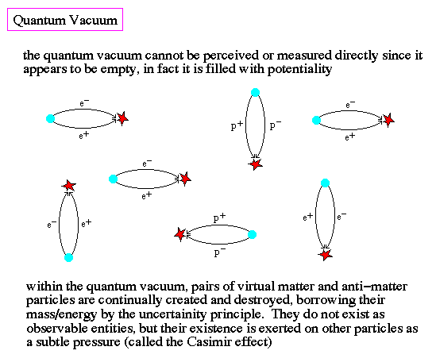

Appearing/disappearing matter-antimatter pairs (schematic). In reality, all types of particles that are energetically permissible are constantly coming and going, including photons (not just electrons-positrons and protons-antiprotons as shown here).

- These vacuum fluctuations (via the creation of virtual particle-antiparticle pairs) are an example of a fundamental phenomenon known as quantum fluctuations, or quantum “noise”. Nothing in the microscopic world is reliably constant −− all is fluctuating and unpredictable on short time scales and small distances.

- A major new idea in cosmology is that all the galaxies and superclusters of galaxies we see in the Universe were born out of such tiny quantum fluctuations. It has even been suggested that the Universe itself began as a quantum fluctuation! We will explore the role of quantum fluctuations and how they grew to become huge galaxies in coming lectures.

