ASTRONOMY 5
Lecture 19 Summary

“WHEN HELL FROZE OVER”: PRIMORDIAL NUCLEOSYNTHESIS AND OTHER EPIC MOMENTS IN COSMIC EVOLUTION

- Review of conditions in early Universe:
- The Universe after inflation was filled with a hot, ionized plasma.
- Particles and CMB photons continually collided and shared energy; the matter and radiation were in equilibrium at the same temperature T.
- At earlier times, everything was hotter and more energetic; T was higher.
- As the Universe expanded, it cooled and the density declined; matter and radiation became less energetic; T fell.

- Threshold temperatures for particle creation:

Recall the pair-production/annihilation reactions: These are reactions in which photons react to make matter-antimatter pairs, and matter-antimatter pairs annihilate to make photons via E = mc² (Lecture 11). Here is an example using electrons and positrons:

Pair production: photon + photon ⎯→ electron + positron
Annihilation: electron + positron ⎯→ photon + photon

Each particle/antiparticle pair has its own such reaction. These reactions were going on continually in the energetic witch’s brew of photons and particles that characterized the early Universe. BUT NOTE…the backward reaction can always occur whereas the forward reaction needs two photons that together are energetic enough to make the mass of the particle/antiparticle pair. Thus, the photon energy (E = const/wavelength from Lecture 3) must exceed the rest-mass energy of the particle pair (E = 2 × mc²). That in turns means that the photons must have a minimum temperature, T_{min}, to create a given particle/antiparticle pair. Annihilation still happens after this temperature…but pair production stops because the photons have cooled off too much:

Fizzle!
Photon + photon ⎯→ electron + positron
No go!

From now on, it’s one way only…antiparticles of that type can only disappear.

Each particle/antiparticle pair has its own threshold temperature, T_{min}, which is approximately 10¹³ K/(mass of particle in proton masses). More massive pairs shut down at higher temperatures.

- THREE TYPES OF FREEZEOUT:

As the Universe expanded, it fell through a series of temperature breakpoints called freezeouts. Some of these freezeouts changed the fundamental physics of the Universe, with major consequences today. The freezeouts are of three types:

- PARTICLE/ANTIPARTICLE FREEZEOUT: The temperature breakpoint T_{min} where photons stop creating a particular particle-antiparticle pair because they no longer have enough energy (already seen in point 2).

- STRUCTURE FREEZEOUT: The easiest kind to understand. Happens when a new structure appears that could not exist previously at higher temperatures because it would have been broken apart by the high energies. A familiar example (not relevant to the Universe) is the freezing of water; ice crystals get broken by heat to make liquid water and can exist only below 0 C.

Examples, in order of falling T from early to late times:

Quark confinement: Quarks began to stick together to make neutrons and protons below 10¹³ K. We have not mentioned this before.

Primordial nucleosynthesis: Neutrons and protons begin to stick together to make helium nuclei and other light elements below 10⁹ K, see below.

Recombination: Electrons and hydrogen and helium nuclei begin to stick together to make neutral atoms at 3000 K. This is when the Universe became transparent and when the cosmic microwave background photons began to travel freely. Created the “redshifted wall” of the CMB.

- FORCE FREEZEOUT: A temperature breakpoint where forces split apart and become “de”-unified. There are three force freezeouts corresponding to the three force splittings of Lecture 17:

Force that splits off Temperature Particle energy Time Era name

Gravity 10³² K 10¹⁹ Gev 10⁻⁴³ s Planck era
Strong 10²⁷ K 10¹⁴ Gev 10⁻³⁵ s GUT era
Weak 10¹⁵ K 100 Gev 10⁻¹² s Weak era

The Planck Era is the limit of known physics, since going before that requires a force theory that unifies gravity and quantum mechanics, which we do not have. This is effectively the beginning of physics as we know it. Some theorists believe that the splitting off of gravity from the other forces created our space and time by triggering the Big Bang.

The GUT Era marked the splitting off of the strong force. Theories for how this happened predict a brief interval of superfast expansion, termed INFLATION. We saw in Lecture 18 that inflation was effectively the alma mater (“nurturing mother”) of our Universe, shaping its geometry, providing all its mass and energy, and planting tiny seeds that later grew into galaxies, clusters, and voids.

The Weak Era is the splitting off of the weak force from the electromagnetic force. Strangely, it does not seem to have had any major consequences. We will not mention it again.

- PRIMORDIAL NUCLEOSYNTHESIS: an important structure freezeout. We observe today that about 25% of the mass of ordinary matter (i.e., atoms) in the Universe consists of helium, while 74% is hydrogen and 1% is heavy elements cooked in stars. Theories to synthesize the helium in stars fail…there is 10 times too much of it. In 1944, the physicist George Gamow got the idea of making helium by fusing together hydrogen atoms in a hot early Universe. The reactions are basically the same as those that take place later at the centers of stars…this is how the Sun and other stars shine, because the helium weighs about 1% less than the four hydrogen protons that go into it, and the difference comes out as energy.

In the context of the Universe, we can think of this transition as a structure freezeout…the four protons stick together to make helium (two protons + two neutrons) rather like water molecules stick together to make ice as water freezes (ice crystals have slightly lower energy than liquid water). The “melting temperature” for helium is 10⁹ K. Hence, when the Universe fell through this temperature, much of the hydrogen “froze” into helium atoms.

Detailed calculations match the observed abundance of helium very well, along with three other trace elements that are also produced. This is shown in the next figure, which plots the predicted abundances of these elements versus the number density of hydrogen protons in the Universe. The gray squares show measured abundance values, and one sees that one number density of protons (vertical line in figure) matches all the measurements within their errors.

Gamow’s theory implied that the early Universe was hot, and therefore that the Universe today should still be filled with thermal photons, albeit much cooler because of the expansion. This idea is what inspired Princeton physicists to search for the cosmic microwave background radiation in 1964, but they were scooped by the Bell Lab guys Penzias and Wilson, who won the Nobel Prize.

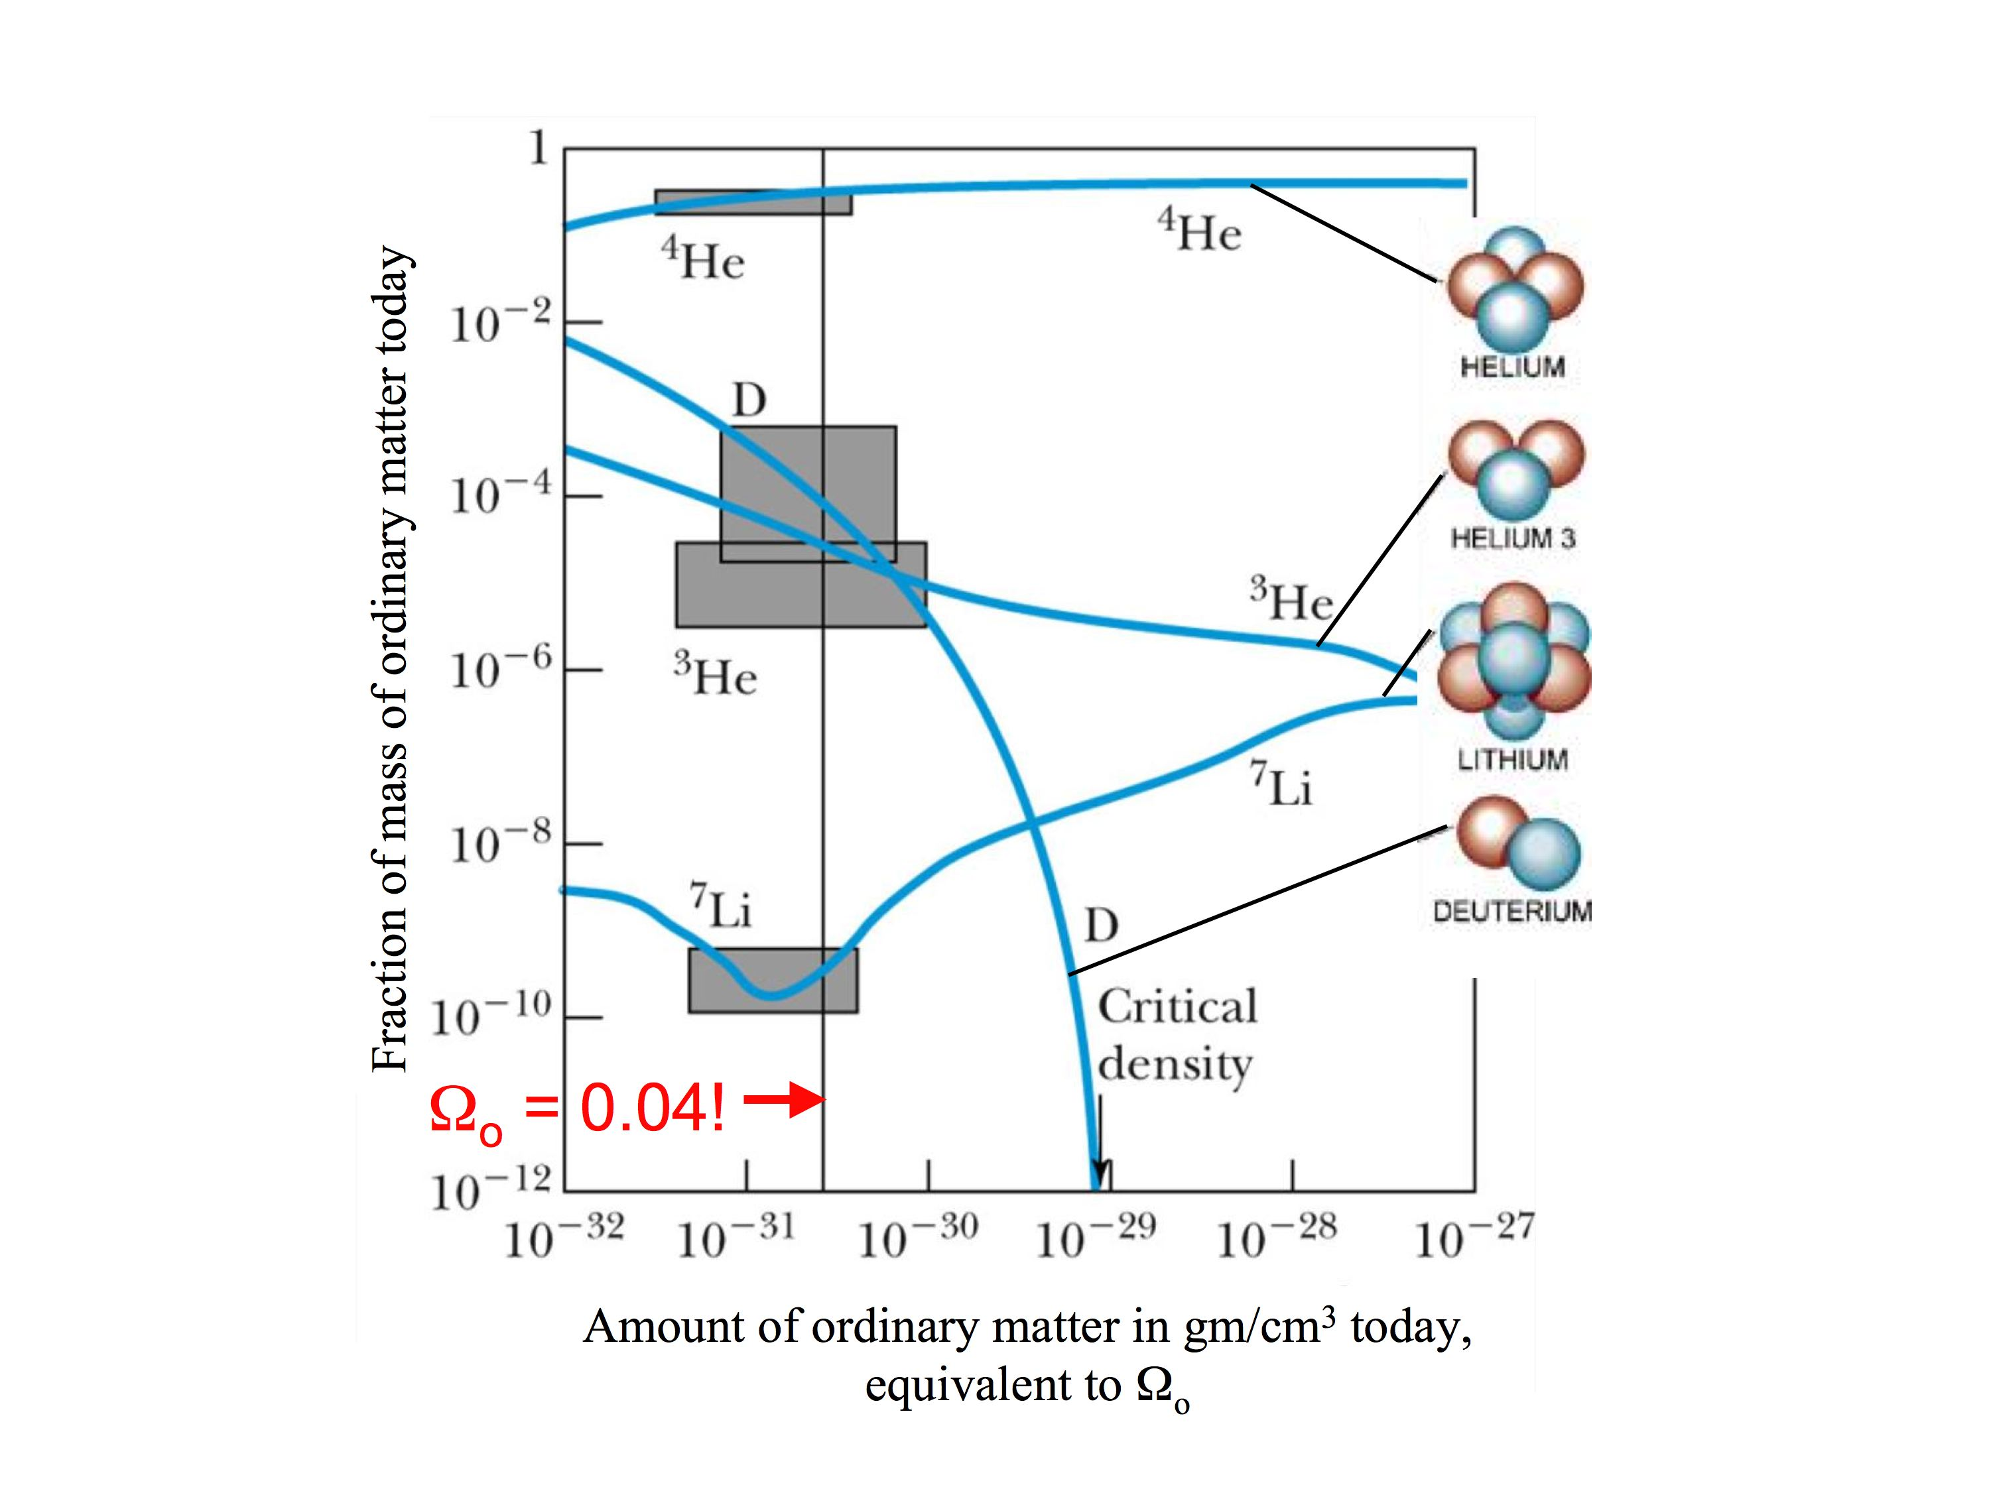

The above magic number density implies a mass density in ordinary matter today. This can be compared to the critical density to derive the Ω in ordinary matter; call this Ω_{o}. The above figure says that Ω_{o} = 0.04. We saw in Lecture 14 that Ω_{Λ} = 0.7 (from dark energy) and Ω_{m} = 0.3 (from total matter). But Ω_{m} consists of dark matter plus ordinary matter, and so Ω_{m} must equal Ω_{d} + Ω_{o}. If Ω_{o} = 0.04 (from primordial nucleosynthesis), we must have Ω_{d} = 0.26. A more exact calculation gives the numbers in the following pie diagram. Here, “cold dark matter” is a fancy name for dark matter, and “atoms” means ordinary matter. This pie diagram is our best estimate for the matter-energy budget of the Universe.

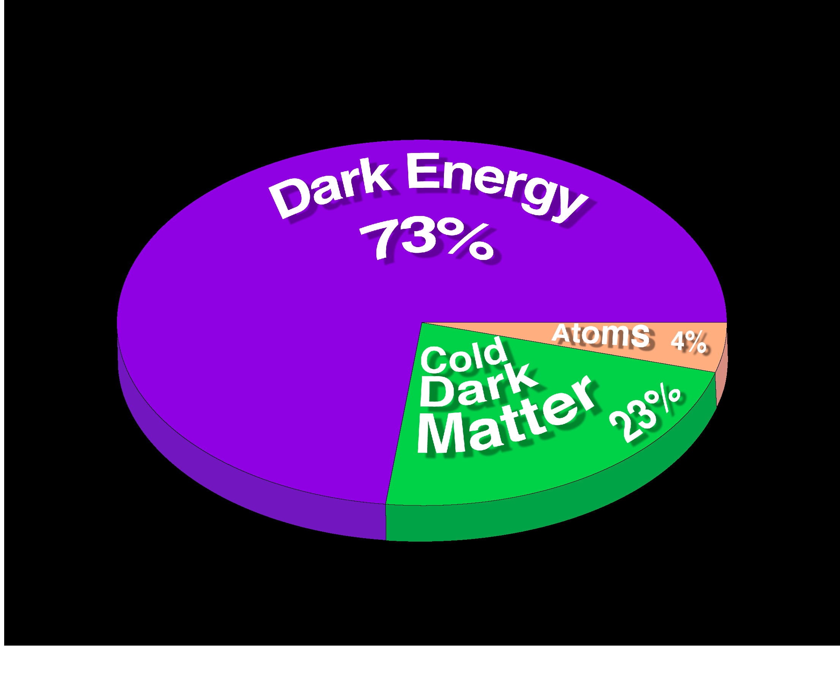
The importance of primordial nucleosynthesis theory to cosmology cannot be overstated. It indicated that known physics could be used to model the Universe when it was only three minutes old. This success emboldened physicists to apply more speculative models at even earlier times, and in this sense, primordial nucleosynthesis theory is the mother of all cosmological models.

- The following graph summarizes key stages in the expansion of the Universe:

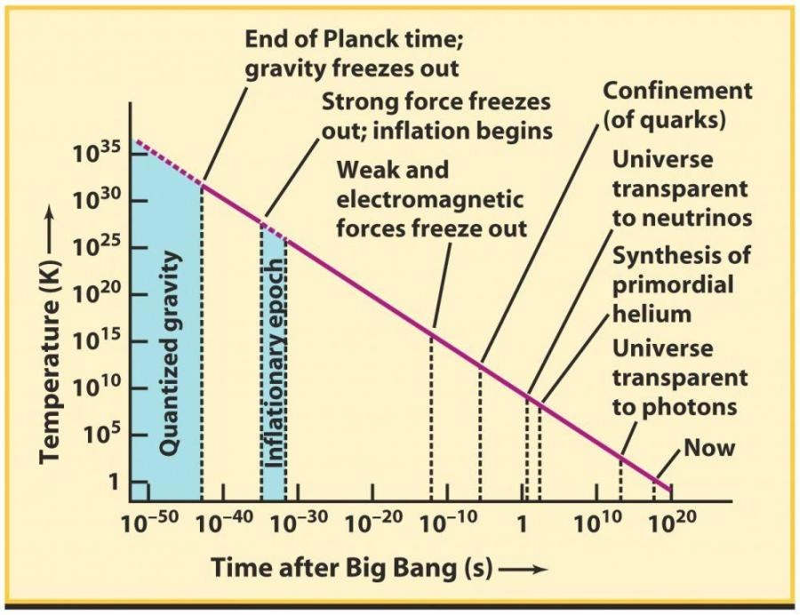

- Major question: IF EARLY ENERGETIC PHOTONS WERE CONSTANTLY MAKING PARTICLE-ANTIPARTICLE PAIRS, WHY DIDN’T ALL THE MATTER AND ANTIMATTER ANNIHILATE? WHY DO WE HAVE ANY MATTER AT ALL LEFT TODAY? WHY ISN’T THE UNIVERSE PURE PHOTONS?

Answer: This perfect annihilation would occur only if the original numbers of particles and antiparticles created at the end of inflation exactly balanced. Since we have matter left today, there must have been a slight excess of matter over antimatter. Observations show that there is one proton today left over for every 10⁹ CMB photons. This is a small number, but NOT ZERO!

In Lecture 18, we saw that the energy density of the early Higgs field was converted into matter and photons at the end of inflation. Evidently the reactions that created these early particles were asymmetric and created a bit more matter than antimatter. Accelerator experiments actually show traces of this imbalance. Weird thought: the reason that we exist at all is due to a slight (and ugly) difference between the physics of matter and antimatter, at the level of one part in 10⁹! Like so many other things, the deep origin of this imbalance is unexplained. Like the four forces and constants of nature, it is simply a fact of our Universe.

