ASTRONOMY 5
Lecture 22 Summary

THE PLANCK TIME AND “BEFORE”

It seems likely that the Universe is an eternal, self-reproducing
entity divided into many mini-universes, with low-energy
physics and perhaps even the dimensionality of space differing
from one to the other.
−−− Andre Linde, inventor of eternal inflation

I believe that soon any cosmological theory that does not lead to the eternal reproduction of universes will be considered as unimaginable as a species of bacteria that cannot reproduce.

−−− Alan Guth, inventor of classic inflation

What I really want to know is, how many different ways can God make a universe?
−−− Albert Einstein

1) The PLANCK TIME: the ultimate limit to the known laws of physics.

We have encountered two very different theories of forces: the theory of gravity from general relativity (GR), and the Grand Unified Theory (GUT) for the combined strong, weak, and electromagnetic forces. The latter involves virtual force carriers, and hence depends on the Uncertainty Principle and quantum mechanics, whereas the former says nothing about the Uncertainty Principle. One theory says that the physical world is inherently unpredictable, whereas the other says that it can be predicted perfectly as long as we know where matter is distributed.

It is perhaps inevitable that two such contradictory ways of looking at the world must eventually collide, and this can be shown explicitly. The Appendix below shows how to derive a tiny length scale, called the Planck length, below which our knowledge of the laws of physics in the early Universe fundamentally breaks down. This is the scale on which quantum mechanics and general relativity collide.

The value of the Planck length is 1.6 × 10⁻³³ cm. On scales shorter than this, the mass-energy density in the early Universe was inherently uncertain due to quantum fluctuations. Since the curvature of spacetime is determined by this energy density according to GR, this means that the inherent fabric of space (and time) was also uncertain. Going backwards in time, spacetime is thought to dissolve into a flickering, seething broth of enormous fluctuations in the energy and mass visible to each observer. Spacetime dissolves into a “quantum foam,” in which clocks tick randomly backward and forward and “objects,” if there are any, appear and reappear discontinuously at different locations in space. Smooth space and time coordinates as we know them no longer exist.

In cosmology, the Planck length kicks in when the horizon radius, ct, is equal to the Planck length. Setting ct = 1.6 × 10⁻³³ cm, we find that this happens when the age, t, of the Universe is 0.5 × 10⁻⁴³ sec. This time, called the Planck time, is the magic moment when the mass within each observer’s horizon becomes undefined because of Uncertainty Principle fluctuations. This is the time when GR collides with quantum mechanics.

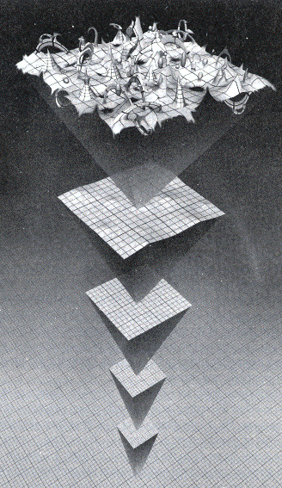

A brave attempt to represent the fabric of spacetime close to the Planck time is shown above. Earlier times are toward the top.
A common belief of many cosmologists (but not universal): The Planck time is the moment of creation of our Universe. Space and time as we understand them came into being at that moment.

Properties of the Planck time, to nearest powers of 10:

Planck time = 10⁻⁴³ sec (when our U’s clock started?)
Planck length = 10⁻³³ cm (horizon radius at Planck time)
Planck mass = 10⁻⁵ g (mass inside horizon at Planck time)
Planck density = 10⁹² g/cm³ (energy density at Planck time)

2) Eternal inflation is an alternative theory that does away with “the beginning” entirely.

This theory was invented by the Russian cosmologist Andre Linde in 1982 as an elaboration of Guth’s original inflation picture. A benefit is that the theory sidesteps the Planck time. Highly speculative, but shows to what limits the concept of inflation can be taken.

- Go back to right after the nominal Planck time but before the GUT era (i.e., between 10⁻⁴³ sec and 10⁻³⁵ sec). Linde assumes there was an energy field present that was very like the Higgs field of GUT inflation. This “inflaton field” is like the Higgs field in that the Universe is technically a vacuum (no particles) when filled by this field, even though the energy density of this field is big. Like the Higgs field, the energy density of the inflaton field stays constant even though the Universe expands. By analogy, this field drives inflation just like the Higgs field does later at the GUT era or dark energy is doing today. In fact, the bigger the inflaton field energy, the faster inflation takes place, so this earlier inflation was even faster.

- Linde assumed that the inflaton field has a built-in tendency to decline in energy density, like a ball rolling downhill. However, there is an unusual effect. Because we are close to the Planck time, quantum fluctuations in the energy density of this field are large and important. The inflaton field is fluctuating in a major but not catastrophic way.

- Choose a spot at random where the field energy and the inflation rate are moderate. If there were no quantum fluctuations, the inflaton field would inevitably roll down to zero, and inflation at that spot would cease. A downward quantum fluctuation would make it decline even more rapidly. However, the spot might also experience an upward fluctuation, in which case it would inflate faster than normal. Clearly, upward regions tend to take over the volume from downward regions because they inflate faster, and this keeps inflation going as a whole. If the process is properly tuned, quantum fluctuations can keep the overall inflaton field from dying away, i.e., inflation in the large is eternal.

Back to a spot with a downward fluctuation: It may fluctuate so far down that upward quantum fluctuations are too small to retrieve it, and then the inflaton field dies to zero there or close to it. This downward patch stops inflating, at least not so fast, and “drops out.” If a residual inflaton field is left and this is equated to the Higgs field of normal inflation, a “baby universe” is born, ready to enter the GUT transition. According to eternal inflation, this is how we began: our Universe is an “inflaton dropout.”

- Summary of eternal inflation:

- Our Universe is a “drop-out” from eternal inflation, a downward quantum fluctuation in the inflaton field.
- An infinite sea of other drop-out universes also exists, separated by chasms of inflating space. They can never communicate with one another, being swept apart faster than the speed of light.
- The total volume of inflating space grows eternally, forever spawning new universes in a “fractal” fashion. There never will be an end to eternal inflation…and likewise perhaps no need to imagine that there ever was a beginning?
- The original inflaton field is the “Mother of All Universes.” Do we need to think about where She came from? Is this a meaningful question?

3) String theory attempts to deal with “Before” the Planck time:

Eternal inflation sidesteps the Planck time by dumping us out into our Universe before the GUT transition at 10⁻³⁵ sec but after the Planck-time conundrum at 10⁻⁴³ sec. Well behaved space and time already exist in eternal inflation, and the equations of the eternally inflating inflaton field are written down using these variables. Because the inflaton field is self-replicating infinitely far into the past as well as into the future, time and space might have existed into the infinite past, and the problem of where they came from is also side-stepped (though perhaps not very satisfyingly). Likewise, the problem of unifying gravity with the GUT force is also sidestepped…these forces simply always were separate.

Not everyone is convinced that eternal inflation is right. There is a whole other school of theories involving a fully unified force, so-called string theory (sometimes called M-theory or the Theory of Everything), which truly does attempt to unify gravity with the GUT force.

Basic ideas of string theory:

- String theory says that fundamental particles (like quarks and electrons) are really not points but rather tiny “strings” that exist and vibrate in a higher-dimensional space “rolled up” inside the Planck length. These extra dimensions (the theory says that there are six in addition to the four “extensive” space-time dimensions of our Universe, for a total of 11 dimensions in all) exist like an “interior universe” at every point in our four-dimensional spacetime. These “cureld-up” dimensions have not yet been discovered because it would take incredibly small (i.e., energetic) particles to probe them. However, they are there, and their effects can be felt..

With 7 extra dimensions to play with, the shape of these interior spaces is very complex and convoluted. The favorite picture is that the interior space is a member of a mathematical family of so-called Calabi-Yau spaces, discovered by mathematical topologists and now adopted by the community of string physicists. You can build up a mental image of increasing complexity first by visualizing tiny circles embedded at each point of spacetime, then spherical surfaces, then solid spheres, each figure adding an extra dimention. Some brave attempts to render full 7-dimensional Calabi-Yau spaces in 3-d are shown below.

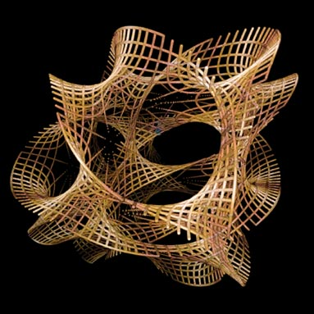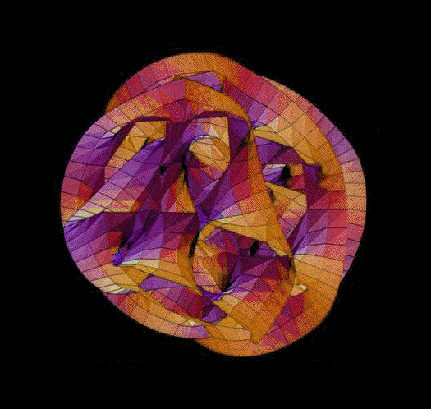

- In the basic theory, a particle consists of a string that moves in, vibrates on, and/or winds around thin tubes in the Calabi-Yau space. Physical properties of the particle such as mass, charge, and family ID are determined by the length of the string, the rate and manner of its vibration, and the number of times the string winds around a donut-like tube in the space.

The following sections c-e are optional asides on string theory:

- An advantage of string theory is that it avoids the mathematical singularities inherent in the point-model of particles, which lead to mathematical infinities. To illustrate this, consider the collision of two particles in the old point-particle picture versus the new string picture. In the old picture, two infinitely small entities came close together. The new picture of a particle collision is illustrated below, which schematically renders the evolution of two strings moving on a Calabi-Yau surface. Initially the two strings are separate, indicating two separate particles approaching the collision. Then their strings merge, creating an entirely new entity (e.g., a force-carrying boson), and finally two strings separate at the end of the interaction which, depending on the nature of the collision, might be the same particles that entered or two entirely new particles. A collision is just the continuous deformation of interacting strings. Nothing gets infinitely small, and consequently no quantities get infinitely large.

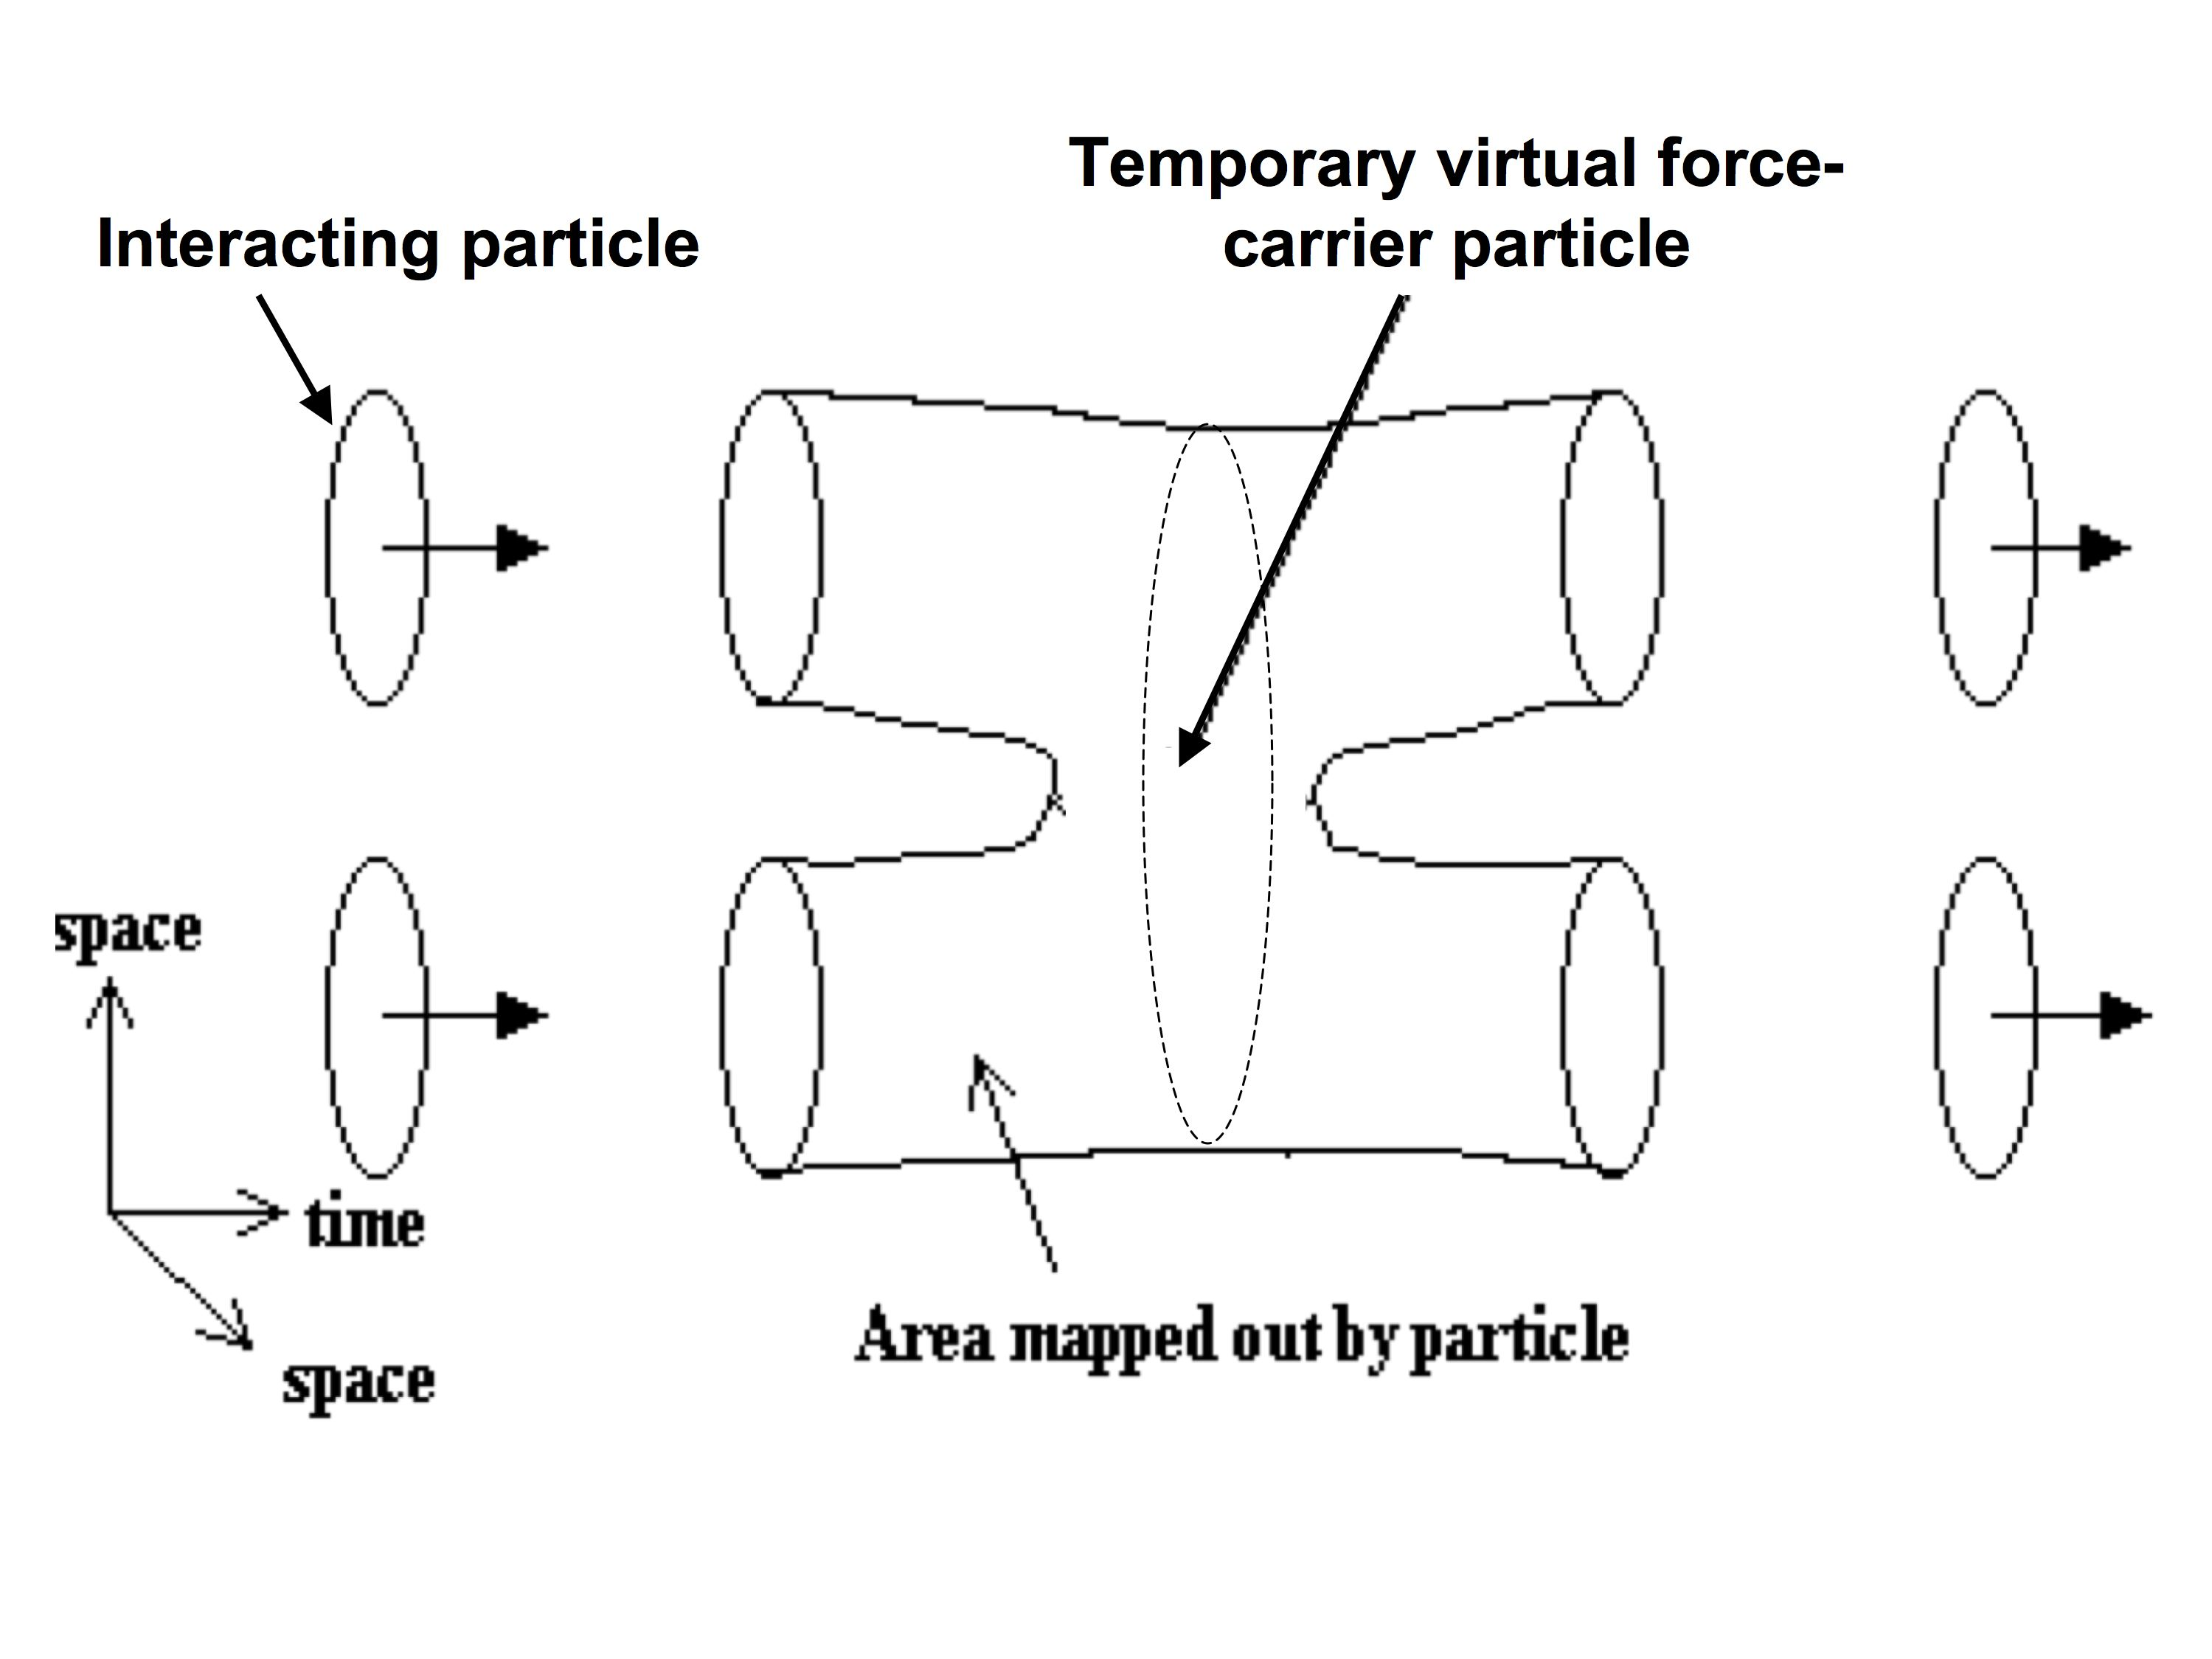

A particle collision in string theory.

- An early advertisement for string theory was the fact that an easily derived particle had all the right properties to be the graviton. Thus, it is expected that a successful string theory will provide the long-sought fully unified force that merges gravity with the other three forces.

- A problem with string theory until recently was that there were five separate versions of the theory that all seemed to be equally valid and no one knew how to choose among them. A big breakthrough has been the realization that all five of these versions are in fact different aspects of a unified parent theory, called M-theory or the Theory of Everything. Nevertheless, the total number of versions of this parent theory are still conceivably infinite, and it is not clear whether all versions, or just some, or even just one, are suitable for making universes. Some people believe that only one theory will be viable, i.e., that there is only one self-consistent way to make a universe, but this is not universally held.

4) String theory and cosmology: There is no unified view on this. Here are some thoughts:

- An important point is that string theory, like eternal inflation, also sidesteps the problems of the Planck time, but by positing that particles have a finite size. Thus, the Universe cannot get arbitrarily dense at early times because particles cannot get that close together. String theory calculations indicate that the smoothing scale is large enough to tame the wild quantum fluctuations in spacetime at the Planck time. The Planck time is intercepted by the finite size of strings.

- Where did the Universe actually come from in string theory? One idea is that it descended from a dense, pre-existing Calabi-Yau “nugget” in which all 11 dimensions were small and curled up on a scale equal to the Planck length. Strings were constantly vibrating and wiggling on the surfaces in this space. In one place, strings that represented particles collided with strings that represented antiparticles, and the two sets annihiliated. Since strings bind up the high density of the Calabi-Yau nugget, this annihilation let loose the bounds, and that part of the nugget expanded. Calculations show that at most, three dimensions can be let loose in this way, while the others would remain curled up on their small Planckian scale. These dimensions are identified with the three expanding space dimensions of our Universe, while the curled-up 7-dimensional pieces of space are particles embedded within it. In this picture, the particles in our Universe are remnants of the original curled-up Calabi-Yau space, around which our space has expanded, engulfing them like airbags!

- An exciting possibility in string theory is that the expansion might start out in different ways and that different starts could yield universes with different properties and laws of physics. The notion that many universes exist, all different, is implied by the “Anthropic Principle,” a cosmological view which I think has merit. It is therefore intriguing that string theory can potentially make an infinitude of different universes, as that is what a rational version of the Anthropic Principle seems to require. More on anthropic cosmology in Lecture 23.

APPENDIX: derivation of the Planck mass and the Planck time:

- At each age of the Universe, t, there is a horizon radius given by ct, the distance light was able to travel through the Universe by that time (the cosmic horizon radius today is 14 B lyr, for example). The horizon radius around every point marks the maximum portion of the Universe that an observer at that location could see as of that moment. Since the horizon radius is the same in all directions, the observable volume is a sphere with radius ct. Within that volume is a quantity of mass, called the horizon mass, which we will denote by M_{h}. The horizon mass is steadily increasing with time because the horizon radius is constantly growing and encompassing more matter.

- Recall the Uncertainty Principle from Lecture 16. Version II says that

ΔE × Δt = h / 4π. Uncertainty Principle II

We substituted E = mc² to derive yet another form, Uncertainty Principle III:

Δm × Δt = h / (4πc² ), Uncertainty Principle III

or

Δt = h / (4πc² Δm).

In words, over a period Δt, a physical system is potentially allowed to fluctuate in mass by an amount Δm.

- Let’s apply this to the horizon mass today to calculate the time over which it could fluctuate by an amount equal to itself. That would be a very big fluctuation. The horizon mass today is about 10⁶⁰ g, and the fluctuation time for such a large mass turns out to be 10⁻¹⁰⁸ sec!

- Can the horizon mass actually fluctuate by that amount today, even in principle? No, because it turns out there is a second requirement−−the system cannot be too big. A quantum fluctuation cannot be physically any bigger than the light-travel distance cΔt because information about the quantum wave function cannot propagate any farther than that during the fluctuation time Δt. In the case of the horizon today, it would take one side of the horizon some 28 billion years even to “know” that a quantum flicker on the other side had occurred, and in the meantime, the original fluctuation would have died out long before.

- But…the horizon mass is smaller in the past, and the permissible fluctuating timescale for it, Δt, is therefore bigger from Uncertainty Principle III. That means the size of the fluctuating region cΔt is also bigger. Furthermore, the horizon radius ct is getting smaller in the past. At some point, there comes a time when the horizon radius gets bigger than the fluctuating size-scale, which means that horizon-sized fluctuations can occur. At this time (and before), the whole horizon mass can undergo quantum fluctuations equal to itself. The mass within the horizon is then ill-defined…in fact one cannot speak of there being any particular mass there at all!

