ASTRONOMY 5
Lecture 4 Summary

THE LIFE CYCLES OF STARS

- Nearly all the light in the Universe is emitted by stars. Stars are what make galaxies shine at visible wavelengths.

- The Sun as a star:

- The Sun is a giant globe of hot gas, mostly hydrogen with some helium and a smattering of heavier elements like carbon, oxygen, iron, etc.

- Vital statistics: 870,000 miles across (about 100 times diam. of Earth); surface temperature = 6000 K, central temperature = 15 million K; luminous power = about 10²⁵ light bulbs; mass 2 x 10³³ grams (300,000 Earth masses).

- Why is the Sun bright? Because it is generating heat at its center, which flows outward, making the surface glow. The heat comes from nuclear reactions in the core, in which smaller atomic nuclei merge to form larger ones. The products weigh less, releasing energy according to E = mc². Some sample reactions:
p + p ⎯→ ²H (deuterium) + e⁺ (positron) + neutrino
¹²C + p ⎯→ ¹³N + photon
¹⁴N + p ⎯→ ¹⁵O + photon
These reactions take place only in the center, where the Sun’s temperature is above 10 million K. Question: why does the temperature have to be so high in order to make these reactions take place?
Here is the p + p reaction in detail. The main energy comes off as a positron (e⁺), which annihilates with an electron (e–), releasing two energetic photons (γ’s). These get absorbed by surrounding particles, generating heat.
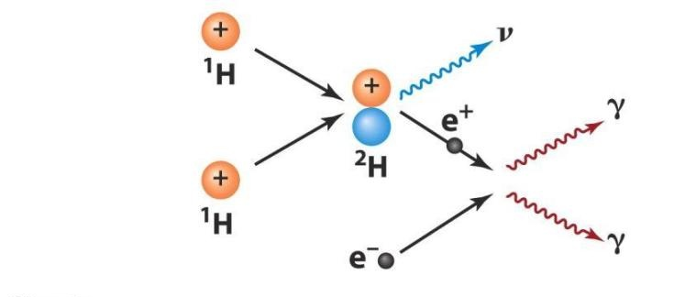
Thus, stars shine by “burning” hydrogen (and helium) into heavier elements. All heavy elements were made in stars. This is called nucleosynthesis.

- The atoms of the Sun are held together by their mutual self-gravity. Gravity pulls the Sun together, but gas pressure pushes outward and resists gravity’s compression. The two forces are in balance. We say that the Sun is in gravitational equilibrium.
- How does the Sun stack up against other stars?
A good way to compare stars is to plot them in an HR diagram. The horizontal axis is surface temperature (or color---hot stars are blue, cool stars are red). The vertical axis is luminosity. Here are some HR diagrams. The left one shows just the main sequence, where newly born stars lie, and the right one shows how stars evolve off the main sequence as they use up their fuel. First they move to the upper right,
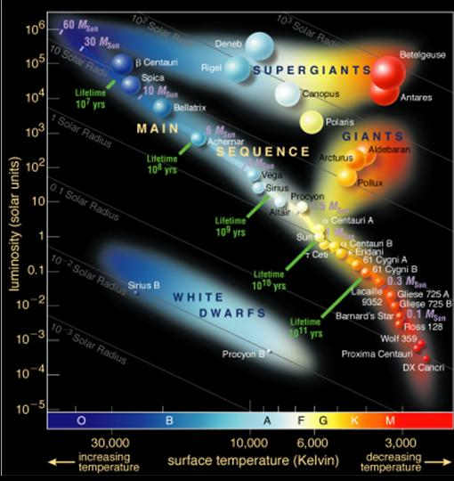
becoming giants and supergiants. If they are above 8 solar masses, they explode as supernovae. If they are below 8 solar masses, they fade to become white dwarfs, which are at lower left.
- Main points about stars:
• A star’s mass determines its location along the main sequence.
• Massive stars are hot, blue, and bright; small ones are cool, red, and dim.
• Massive stars have shorter lives: a few million years for 20-60 solar masses, 10 billion years for the Sun, 100 billion years for 0.2 solar masses.
• It follows that you can estimate a star cluster’s age from its “turnoff” on the HR diagram. The clusters that have bright blue stars are young; the clusters that have only dim yellow and red stars are old.
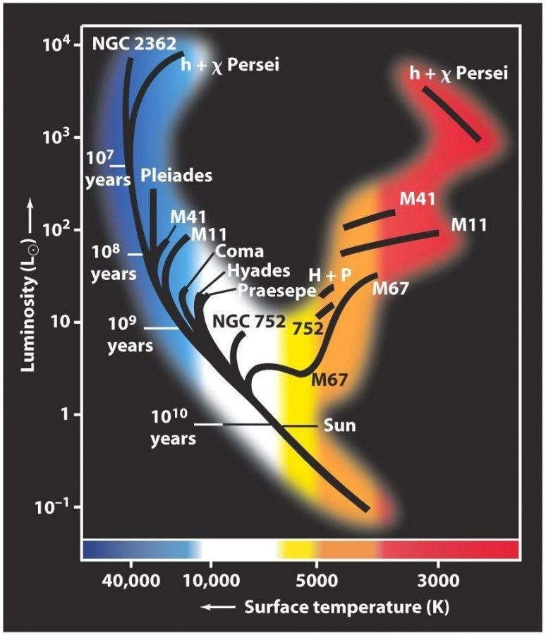
• Stellar populations that contain blue stars or look blue overall are still making stars. After star formation ends and the blue stars age away, the population becomes “red and dead.”
• Hence, overall degree of blueness correlates with the number of very young stars. The color of a galaxy is a crude measure of how fast it is forming stars.
- Where did the Sun and other stars come from? Star formation is one of the least understood processes in the Universe. A rough sketch goes like this:
- Inside galaxies, the space between the stars is filled with gas, called the interstellar medium. This gas is mostly primeval hydrogen and helium that was formed at the beginning of the Universe---it is primeval. The interstellar medium is full of clumps where the density is higher. There, self-gravity tends to pull the gas together, triggering stars to collapse. The spiral structure of a galaxy seems to play a role in triggering this collapse---most stars form in spiral arms.
- Young massive hot stars cause the gas around them to become ionized (see Lecture 3), which makes it glow. An example is the Orion Nebula, visible to the naked eye as the “sword” below Orion’s belt. A burst of new stars can produce a star cluster weighing up to several million solar masses. Such newly formed groups of stars can be seen in the images of nearby galaxies, where they appear as bright blue clumps and star clusters.
- The Sun was born about 4.6 billion years ago, probably in a small group of stars that has since dispersed. The planets formed at the same time. We can see such solar systems forming now in the Orion Nebula. University of California astronomers lead the world in detecting extrasolar planets---more than 200 extrasolar planets have been detected orbiting around other stars.
- Interstellar gas is the raw material needed for star formation. When a galaxy (or part of a galaxy) runs out of gas, it stops making stars.
- A picture of our neighbor galaxy Andromeda shows two distinct regions:
- The outer region, called the disk, is rather blue and full of clumps of young stars. Radio telescopes show that it is also full of interstellar gas, so there is plenty of fuel to make new stars.
- The inner region, called the bulge, is red and smooth. This red population formed long ago---the blue, massive stars that originally formed have died and disappeared. Radio telescopes show that there is also a hole in the gas distribution at the center, so there is no fuel for making young stars now.
- BLUE AND CLUMPY MEANS YOUNG STARS ARE STILL FORMING. RED AND SMOOTH MEANS STAR FORMATION CEASED LONG AGO.
- Supernovae are the explosive death throes of massive stars.
- The explosions spew some of the heavy elements that the star has just made out into the interstellar medium. Ejection speeds are up to 20,000 km/sec!
- Each generation of supernovae adds more heavy element nuclei to the interstellar medium. A galaxy is a giant cosmic stew that keeps getting richer and richer in heavy elements. The net result is to gradually turn primeval hydrogen and helium (coming from the Big Bang) into the heavy elements that comprise the periodic table. Stars are where heavy elements get made.
EXCEPT FOR HYDROGEN AND HELIUM, WHICH ARE PRIMEVAL, OUR BODIES ARE COMPOSED ENTIRELY OF STARDUST.
Questions to ponder:
1) How many stars were you once part of?
2) What is the probability of your atoms, which were once widely spaced over thousands of light years of space, coming together in one place to make you?

