ASTRONOMY 5
Lecture 5 Summary

MEASURING THE MILKY WAY

- To get an absolute scale for the Milky Way Galaxy, we need to know how far away objects are. Nearby stars TEND TO LOOK bright, and distant stars TEND TO LOOK dim, but there is enough spread in stellar luminosities that you cannot use just brightness alone to gauge distance th distance of a star without more information (the same is true of galaxies). You need to narrow down the kind of star (or galaxy) you are looking at. Classes of objects that have very predictable and uniform brightnesses are called standard candles. You also need one absolute distance to get started---for this we use the size of the Solar System.

- Distances are measured in a series of steps known as the astronomical “distance ladder.” Here is a typical distance ladder:

  - Measure the size of the Solar System by bouncing radar radio waves off other planets and measuring the time delay of the return signals (radar is EM radiation, so it travels at the speed of light).
  - With the size of the Earth’s orbit now known, measure the distance to some nearby stars using the parallax effect in their positions as the Earth goes around the Sun. Foreground stars will seem to move against the background of distant stars, the more so as they are closer. From their distances, you can now calculate the absolute luminosities of these stars in units of the Sun’s luminosity. (Problem Set 2 shows you how to use the inverse square law for the dimming of light to measure distances and absolute luminosities of stars.)
  - Use this sample of known stars to calibrate the relation between absolute luminosity and color for main sequence stars (see Lecture 4).
  - Observe some star clusters that have main sequence stars along with a rare kind of variable star called a Cepheid variable. Notice that brighter Cepheids have longer periods of variation (weeks rather than days). The relation between period and luminosity is quite tight, so Cepheids are good standard candles once their periods are known. Calibrate the relation between absolute luminosity and period by comparing the brightnesses of the Cepheids to the known brightnesses of the main sequence stars in the same clusters.
  - Cepheids are intrinsically bright stars visible in other galaxies to considerable distances. Find some nearby galaxies and search them for Cepheids (take many pictures over several weeks and find stars in the images that vary in brightness). Measure their periods and use these to deduce their absolute luminosities. Get the distances to the galaxies by comparing the apparent brightnesses of the Cepheids to their absolute luminosities.

- We cannot see far in the plane of the Milky Way because of the layer of absorbing dust. However, massive globular star clusters are visible to large distances above and below the plane. The Galaxy has about 100 of these clusters. Most of them lie on one side of the sky, toward what we now know is the Galactic center (this was the first clue that the Sun is offset from the center of our Galaxy.) RR Lyrae variables are pulsating stars similar to Cepheid variables and are also good standard candles. They are found in globulars and can be used to measure distances to them. The globulars are found to populate a spherical halo thousands of light years in extent. Other galaxies have similar halos of globulars, which are always centered on their parent galaxies. The center of the Milky Way’s globular halo is about 8,000 pc (25,000 ly) away from the Sun. This is one of the better ways to measure the Sun’s distance from the center of the Milky Way.

The net picture of the Milky Way with its bulge, disk, and halo of globular clusters looks like this:

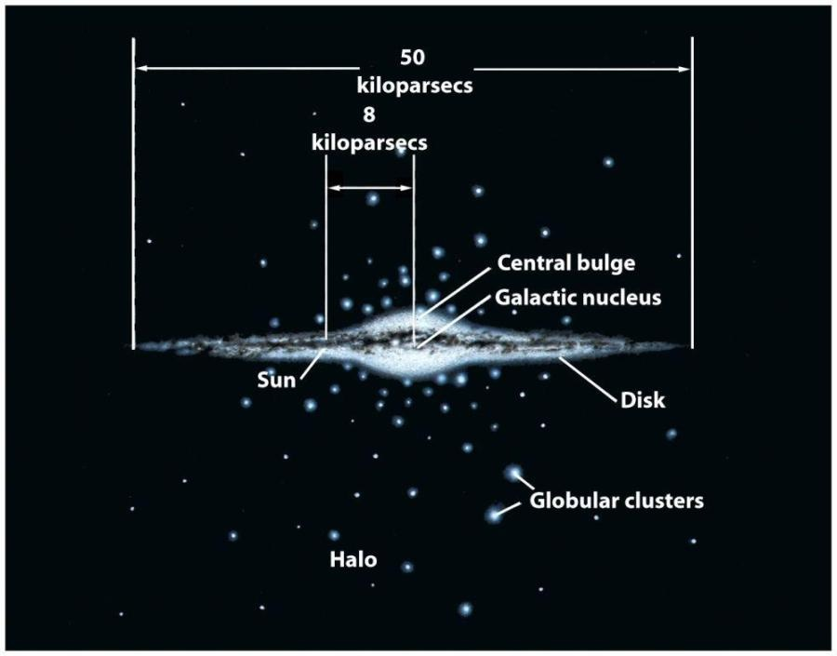

- Emission from the Milky Way has been mapped over the sky using different kinds of telescopes. Each wavelength shows a different component. Visible light (0.5 microns) shows stars but is badly obscured by the band of dust in the plane. Slightly longer wavelengths (1-3 microns, near-infrared) are less obscured and give a good view of the redder (i.e., cooler) stars, which tend to be old. Even longer (heat) wavelengths (25-100 microns, mid-infrared) show dust heated by starlight. Finally, 21 cm wavelengths (radio waves) show the layer of neutral hydrogen gas in the plane. out of which stars are forming (see Figures 25-1, 25-6, and 25-10 in text).

- The components of the Milky Way can be classed into into two groups: a highly flattened disk and a roughly spherical halo (the spheroid). Properties are as follows:

- THE DISK: A mixed population of stars over a wide range of ages, from 10 billion years to recent (text calls the disk stars “Population I”). Gas and dust forms very thin layer in middle of disk, where youngest stars are now forming. Star clusters of various sizes and ages ranging from very young to quite old. All objects (gas, stars, dust) are in nearly circular orbits in a single plane about the Galactic center (like planets in a solar system). Disk has been making stars continuously for a long time.

- THE SPHEROID: Stars are uniformly old (over 10 billion years) (text calls the spheroid stars “Population II”). No gas or dust. The most striking objects are the globular clusters, but a diffuse swarm of single stars fills whole volume, more densely packed in center and fading away to nothingness at edge. Objects are on highly elliptical, swooping orbits arranged in random planes. Whole thing is called the halo or spheroid; the prominent, brighter inner region is called the bulge.

- A closer look at the bulge shows that one side appears slightly larger on the sky than the other. Simplest interpretation is that the Milky Way is a barred spiral, with one end closer to us. So the “bulge” is really part bar, aimed toward us.

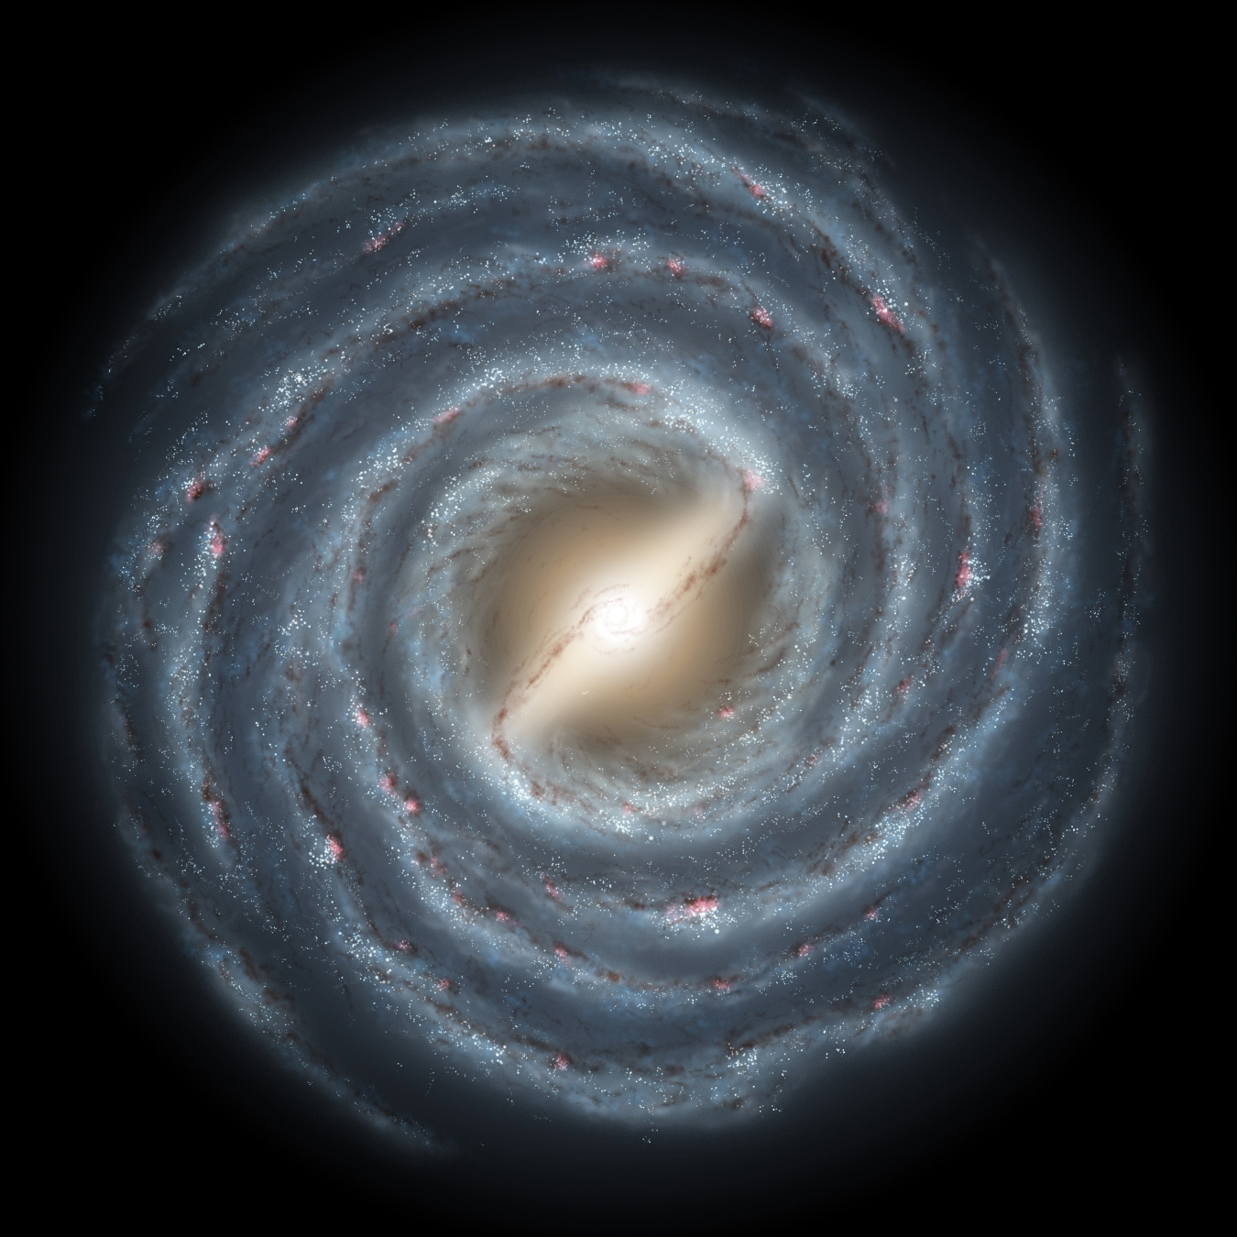
X Sun

- Using a geometric trick, it is possible to “guesstimate” the distance from us of hydrogen 21-cm gas clouds in the plane, and thereby make an in-plane map of the gas distribution. This map strongly suggests spiral structure. A tendency of our gas to congregate into spiral arms is confirmed by maps of external galaxies, where we can get a clearer view. The higher density of gas in spiral arms is the major reason why stars tend to form there.

- Images of the nearby barred spiral galaxy M83 (next page) illustrate the different components in that galaxy Panel a in visible light highlights the bluer, younger stars, which follow the spiral arms. These have just formed. The middle panel is a 21-cm gas map showing gas clouds, which are giving rise to stars. They also follow the arms. Finally the third panel shows the old stars, which have a smoother distribution because the young clumps tend to disperse with time unless they are actually gravitationally bound into star clusters.

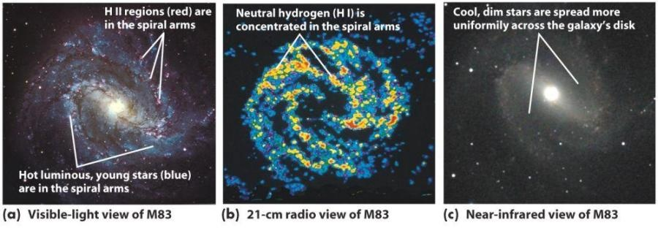

- Extra teaser, not for credit: you may wonder what causes long-lived spiral arms. They occur only in disks and are due to the influence of the mutual gravitational attraction of the disk stars and gas for one another. Briefly, a suitable arrangement of disk matter can deform naturally circular stellar orbits into ellipses. The same effect causes the orientation of the ellipses to twist smoothly as a function of radius (see figures). Stars going in this pattern tend to “converge” where the ellipses get close together, so the density of matter is higher there. This “asymmetric” distribution of matter is what is needed to deform the circles into ellipses in the first place, and hence the spiral pattern is self-sustaining. Bars differ in detail but are the same idea.

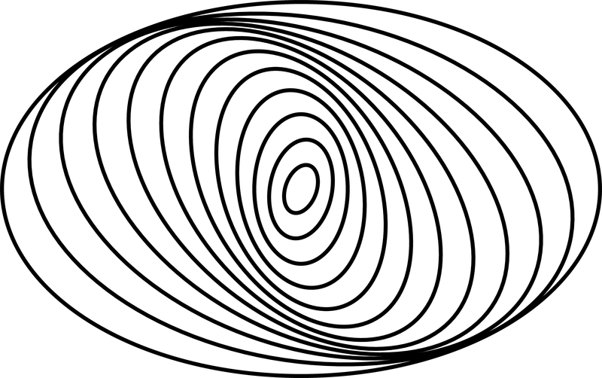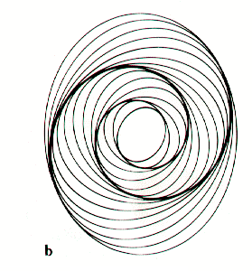

The whole pattern rotates around the galaxy slowly and is called a density wave.
The textbook’s figure 25-19 likening spiral density waves to the slow-down and bunching of cars in a traffic jam is not accurate---it’s convergence, not a slow-down.
The textbook also mentions spiral arms that are created when clumps of stars in the disk are sheared out into spiral shapes by differential rotation. Spirals from this second mechanism are short-lived, like the spiral whorls of cream in a coffee cup.

