ASTRONOMY 5
Lecture 6 Summary

WEIGHING GALAXIES: DARK MATTER

- This lecture is about measuring the speeds and motions of astronomical objects, specifically, the rotation speeds of spiral (disk) galaxies. The standard tool to measure speeds is the Doppler effect, which is sensitive to motion along the line of sight only. The Doppler effect is illustrated below:

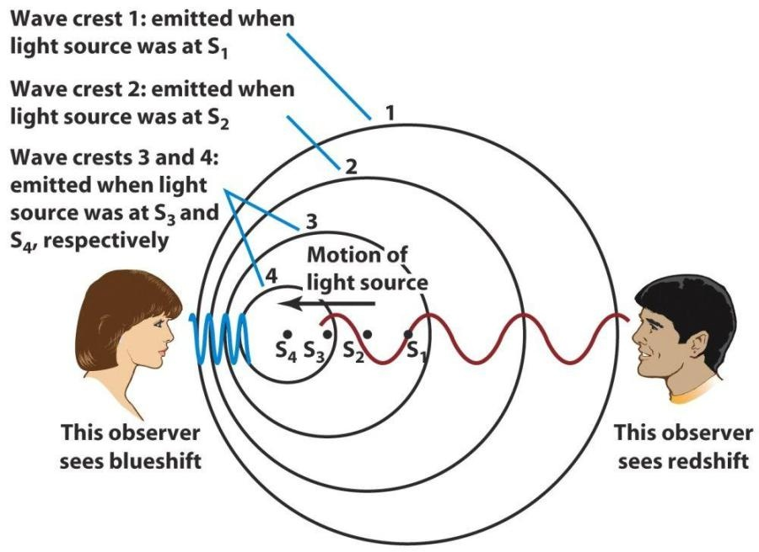

When the source comes toward you (observer on left) the frequency (of light, sound, whatever) is higher. When the source goes away from you, it is lower. If the waves are light, the light is blueshifted (or redshifted). If the waves are sound, the sound is higher-pitched or lower-pitched. Example: siren on police car going by you---high pitch◻◻ low pitch as the car approaches and then recedes.

- Doppler shift equation for light (p. 113):

Δλ = v Doppler effect
λ₀ c

λ₀ = wavelength if source not moving (subscript 0 means “intrinsic”);
also called the rest wavelength or laboratory wavelength
Δλ = wavelength shift (“Δ” does not multiply λ; it means “change in λ”)
v = velocity of the source measured along the line of sight
c = velocity of the speed of light = 3  10⁵ km/s (note: for sound waves you would use the speed of sound, which is slower)

You get Δλ by measuring the wavelength of a known feature in the spectrum (like a hydrogen emission line) and comparing to the rest wavelength λ₀. The difference is Δλ.

- Spiral galaxies are flattened, rotating galaxies held together by gravity. Their disk stars are going in roughly circular orbits about the centers. Each star has a speed v and a distance R from the center. The amount of mass inside a sphere of radius R centered on the center of the galaxy is approximately:

M(R) = v² R / G, Mass inside a star’s orbit

where M(R) is the amount of mass inside the orbit, v is the speed at R, and G is a physical constant expressing the force of gravity. (We do not derive this equation, but there is a derivation based on Kepler’s third law for planetary motion in Box 25-2 in the text. We show in class that the equation makes intuitive sense.)

We get v by taking a spectrum of the galaxy and measuring the Doppler shift of each part of the galaxy along the major axis (see figure). We get R from the angular size of the galaxy on the sky plus its known distance (which has to be gotten separately. Problem Set 2 has examples of converting angular distance to radial distance in light years [or parsecs] if you know the distance to the object).

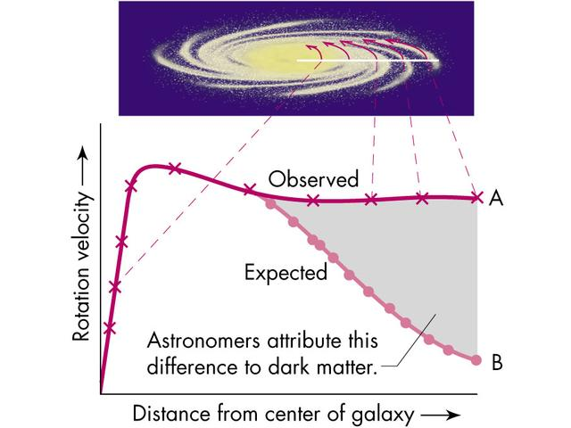
Major axis
R
v

A plot of rotation velocity v vs. R like that above is called a rotation curve. Observed rotation curves are pretty much flat as far out as we can measure them, way beyond most of the starlight (i.e., v is constant). But if mass goes as light, we expect them to fall off far from the center, as predicted by the M(R) equation. Hence, we deduce that M(R) must keep on growing beyond the edge of the visible galaxy! This is DARK MATTER! It does not show up on photographs or indeed in images made in any part of the electromagnetic spectrum (X-ray, infrared, radio, etc…). We sense its presence only through its gravitational influence on the orbits of stars and gas clouds.

Conclusion: Galaxies are surrounded by massive halos of invisible matter. This is the main evidence for so-called “dark matter.” Looking at a galaxy is like looking at an iceberg…the stars that you see are only about 10% of the total mass, and the total extent of the halo is about 10 times bigger than the visible radius. The remaining 90% of the mass is dark. Galaxies are a lot bigger and more massive than they look.

- More evidence for dark matter is found in clusters of galaxies. Clusters are spherical systems with galaxies orbiting inside them on randomly oriented orbits, similar to the scrambled stellar orbits that make up the spheroidal halo of the Milky Way. Galaxies in clusters are moving at speeds over 1000 km/sec. There is not enough mass in stars to hold these clusters together…there must be additional DARK MATTER in clusters, too. We think this is just the dark matter halos that were around all the galaxies when the cluster formed.

From weighing both single galaxies and clusters of galaxies, we can get total masses for many objects. We can also estimate their stellar masses from measuring the brightness of their starlight together with a knowledge of how brightly stars shine. Finally, we can add in the mass of gas and dust (which does not add very much).

The conclusion is that the 90% -- 10% ratio of dark to ordinary matter is universal: all galaxies have the same ratio, and so do clusters, which are comprised of galaxies. Therefore, this ratio seems to apply everywhere in the Universe. Conclusion: most of the Universe is made up of some mysterious matter whose identity we don’t yet know. More about candidates for dark matter later.

