ASTRONOMY 5
Lecture 8 Summary

THE EXPANDING UNIVERSE

- The Universe is expanding, as shown by the fact that galaxies are flying away from us in all directions. Equal expansion in all directions leads to Hubble’s Law:

v = H₀ r Hubble’s Law

Here, v is the radial velocity of a galaxy away from us, and r is its distance away.
So a graph of velocity vs. distance looks like this:
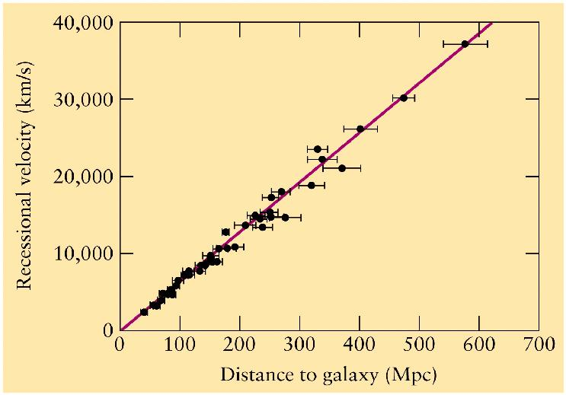

H₀ is the slope of the line. It is called the Hubble constant, and its value is:

H₀ = 20 km/s per million light yr.

We can also write this as:

H₀ = 70 km/s per Mpc,

where Mpc means “megaparsec,” or one million parsecs (recall that a parsec is a little more than 3 ly).

Until recently H₀ was uncertain by a factor of two because galaxy distances were
uncertain by that amount, but distances to galaxies were finally measured accurately in the last decade by the Hubble Space Telescope.

- The Hubble expansion was discovered by using the Doppler effect applied to the spectra of galaxies. In the Doppler effect, the motion of a source of light to or from an observer shifts the observed wavelength of light to the red or blue.

Blueshift ====> Motion toward observer
Redshift ====> Motion away from observer

Because the galaxies are moving away from us, their light is redshifted and their wavelengths are lengthened.

- The textbook (p. 636) tries to distinguish between the “ordinary” Doppler effect due to velocity through space and what it calls the “cosmological” Doppler effect due to the expansion of space. I think this is artificial: the two effects are one and the same. Galaxies are moving away with ordinary velocities, just like cars or people. However, the textbook does make the important point (p. 635) that objects that are bound together by gravity (or other forces) are not expanding with the Universe. Atoms are not expanding, neither is your body, the Earth, the Sun, the Galaxy, or clusters of galaxies. A final philosophical claim by the textbook (p. 636) is that it is “meaningless” to ask what lies beyond the Universe because the Universe by definition contains all space. This is a nifty if somewhat shifty way to dodge the question of what the Universe expands into. That our Universe contains all space is no longer so obvious as it once was. There may be other universes and, if so, how the geometry of our space connects to theirs is a legitimate question. A few (brave) people now try to calculate such things.

- Let λ₀ be the original wavelength of light emitted by a galaxy and λ be the wavelength at which we see it now. The redshift z is defined as:

z = (λ − λ₀) / λ . Redshift

We can rearrange this to get the amount of stretching of the wavelengths between the time they are emitted and when they are observed.

λ = (1 + z) λ₀ . λ vs. redshift
Important note: you will notice that the formula for z here [z = (λ−λ₀)/λ₀] is the same quantity that was used in the Doppler formula for v/c in Lecture 6 [v/c = Δλ/λ₀], since Δλ = λ−λ₀. It would therefore seem that z exactly equals v/c. But distant objects have z > 1. How can this be if nothing can go faster than light? The answer is that the version of the Doppler formula in Lecture 6 is the simple version that applies only at low speeds, when v is below about 10% of c. Above that, you have to use the special relativistic version (thanks to Einstein), which removes the contradiction. This is given in Box 26-2, where an accurate plot of z vs. v is shown (see also numbers in Table 27-1). As v gets large compared to c, z gets bigger than 1; as v approaches c, z gets infinitely big.

- The stretching of the wavelengths is the same factor as the expansion in the size of the Universe between the emission of the light and its reception. Wavelengths expand in proportion to the size of the Universe (we don’t derive this rigorously; just take on faith). Define a scale factor, a, for the Universe, such that:

a = 1 now
a = smaller in the past
a = 0 at the very beginning

All distances in the past = a × (present distances).

From discussion above,

a = λ₀ / λ .

So, a = 1 / (1 + z) . Scale factor vs. redshift

This simple formula tells you how much smaller the Universe was when the light
you are receiving now from an object was emitted.

- The Hubble law can be rearranged to get a rough estimate of the age of the Universe. Assume that all velocities have always been the same as they are now, i.e., that galaxies are not slowing down or speeding up (not quite true, as we shall see, but close). Pick any two galaxies. Their distance apart is just

r = v t , Distance = velocity × time

where t is the age of the Universe. Solve for t:

t = r / v .

Insert Hubble’s law (v = H₀ r) to find

t = r / (H₀ r) .

The r’s cancel and you get
t = 1 / H₀ . Rough age of the Universe is the
inverse of the Hubble constant.

Numerically, here is the rough age you get from H₀:

H₀ = 70 km/s per Mpc ===> Age = 14 billion years

This is indeed close to the best age from precision cosmology, which is 13.8 Byr plus or minus 10%. The instant that the expansion began is affectionately called the “Big Bang.”

- Clearly, the Universe must be older than its oldest stars. The ages of Milky Way globular clusters can be measured from the positions of their “turnoffs” in the HR diagram (see Lecture 4). They are estimated to be 13 Byr old with an uncertainty of ±2 Byr. Hence, the globular clusters must have formed soon after the Big Bang. They are truly very old.

- Just because all galaxies are going away from us does not mean we are at the center:
  - All observers see the same thing − they can’t all be at the center.
  - A “center” has meaning only if there are edges. There are at least two ways to get rid of edges:
    - Make the Universe infinitely big − with no boundaries and no edges.
    - Make space finite but have it curve back on itself, like the surface of the Earth.
There are General Relativity models for the Universe of both types. The matter density of the Universe turns out to determine its geometry. More on this in future lecture.

On the other hand, there might really be edges but they are very far away, beyond our horizon (see next paragraph). The point is: we are not in a special location just because we see all galaxies going away from us − all observers in our visible patch of the Universe see that, too.

- Recall from Lecture 2 that around every point in the Universe (at any instant) is a sphere called the horizon. You cannot see beyond or communicate with anything outside of your horizon because there hasn’t been enough time for light or any other kind of message to travel farther than that (nothing can go faster than light). The horizon radius is given by the speed of light times the age of the Universe:

Horizon radius = c t. Horizon radius

The limited age of the Universe means that we can see only so far.

- SOLUTION TO OLBER’S PARADOX:
Recall Olbers’ Paradox and the simplest Universe:
    - Infinitely big
    - Infinitely old
    - Static: not expanding or contracting

Olbers’ Paradox turns out to be solved about equally by points 2 and 3:
- The Universe is not infinitely old − when we look out to large distances, galaxies have not formed yet, so there are no stars along the line of sight at very large distances.
- The Universe is expanding − visible light from distant stars is redshifted into the infrared and radio regions of the spectrum, where we can’t see it.

- WHY THE EXPANDNG UNIVERSE SHOWS A HUBBLE LAW:

The first graph shows some galaxies around us in the Universe at two different times. We are at the center. The gray dots show the galaxies as they are now; the black dots show them at a later time when the Universe will be about 10% bigger. The scale factor, a, will therefore be 1.1 times its value now, and all separations will be 1.1 times as big as now. The arrow shows a sample velocity vector connecting two dots. See how the velocities get bigger for more distant galaxies. This is Hubble’s law.

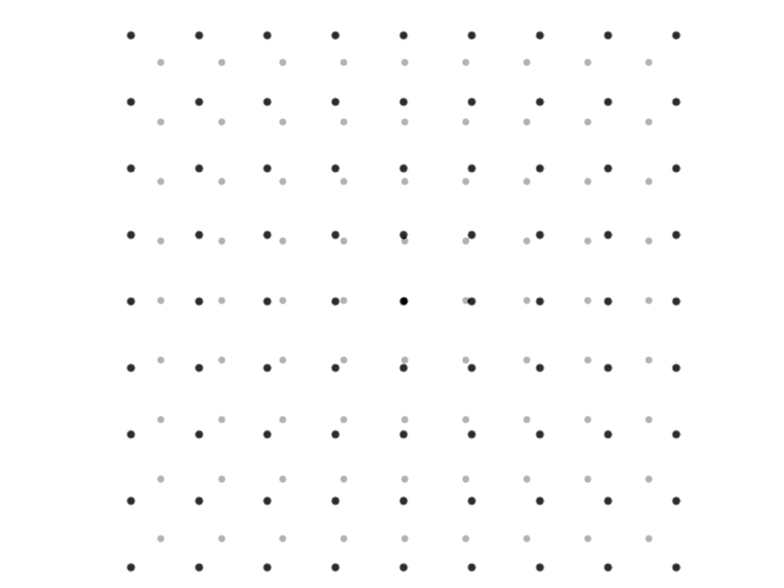

The Milky Way was the central galaxy above. Now imagine that we inhabit galaxy A to lower left. Relative to ourselves, we don’t move, but we see the galaxies around us expanding. The picture from our new viewpoint looks like this:

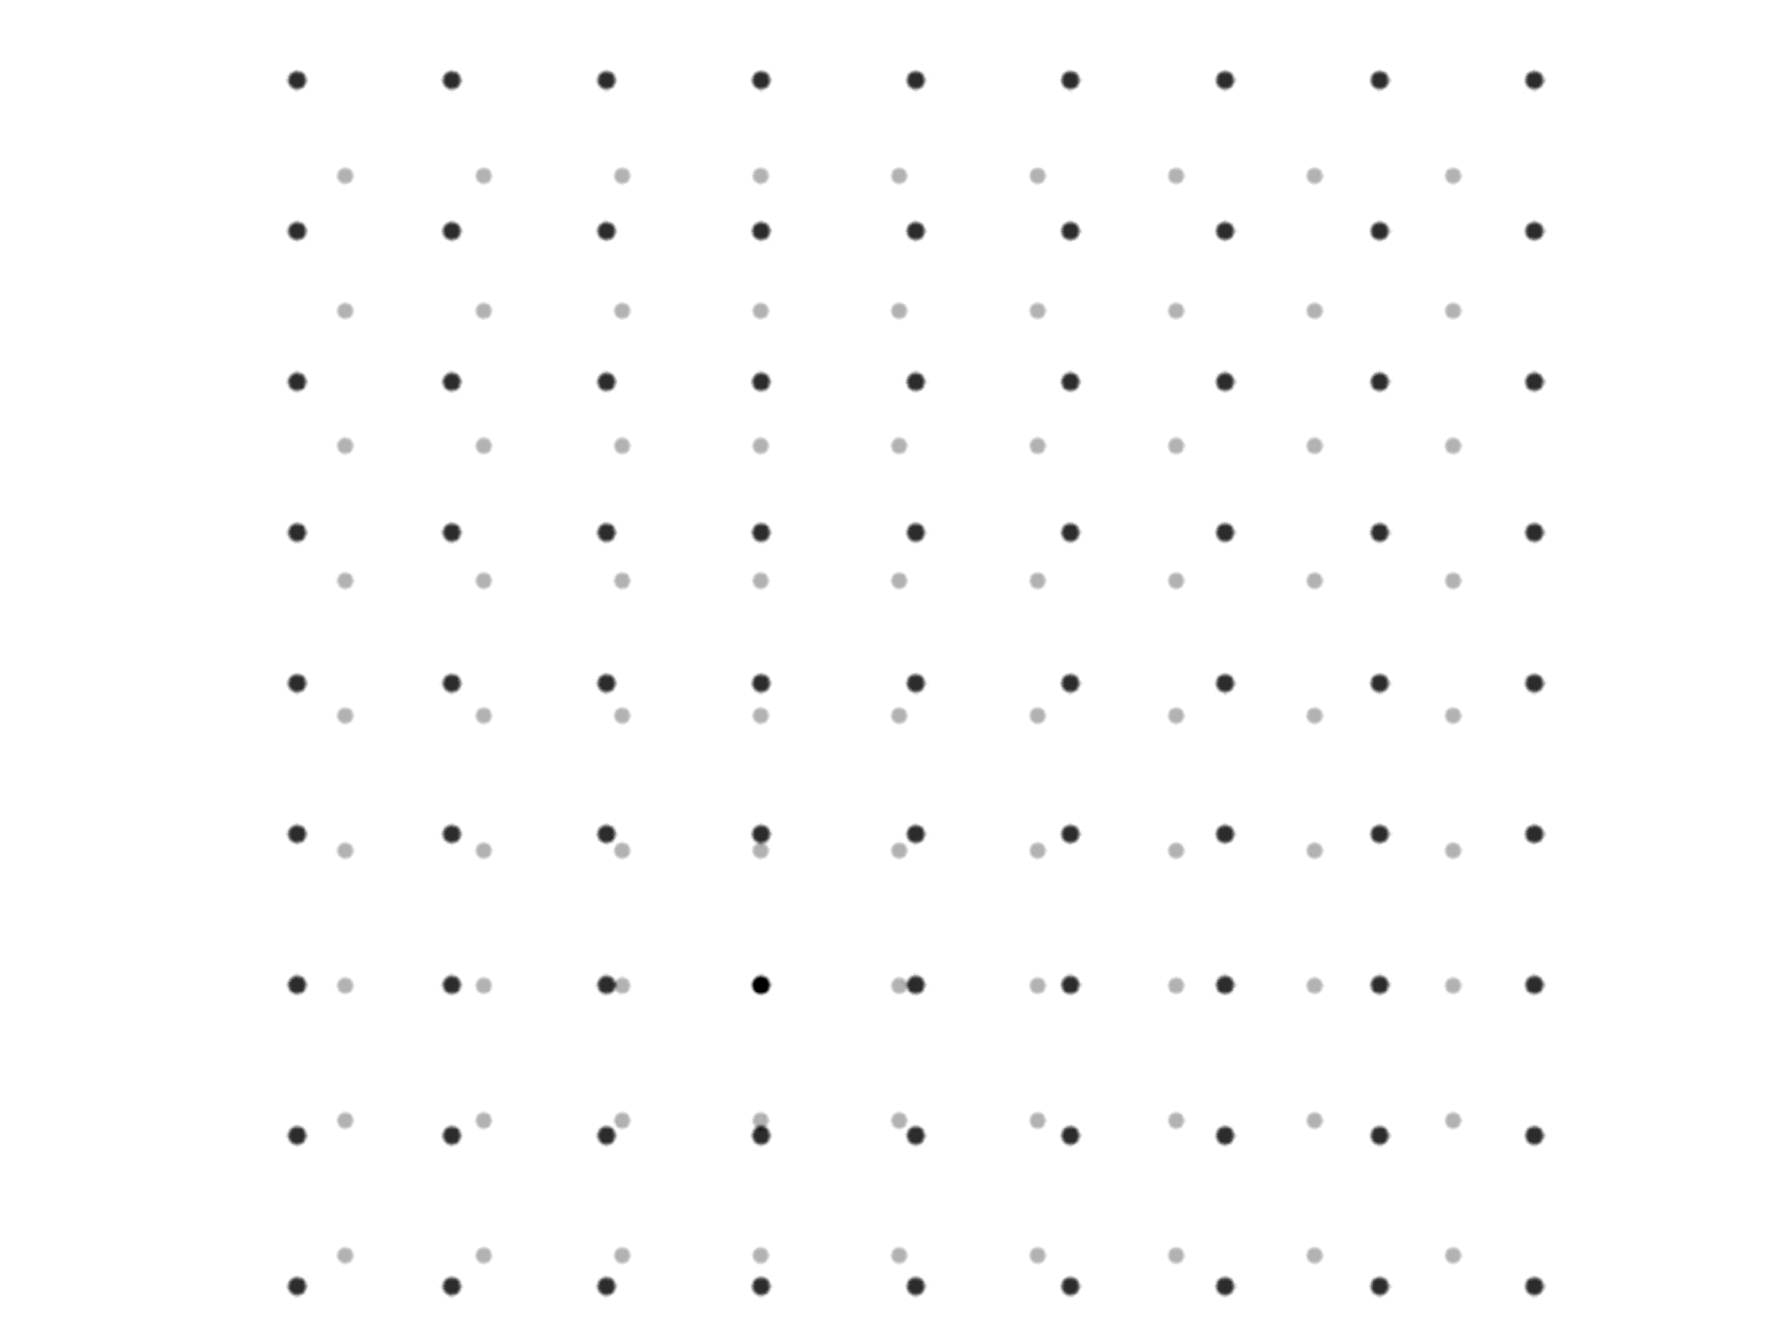
A

Similarly, we might inhabit Galaxy B at upper right. Then the picture around us would look like this:

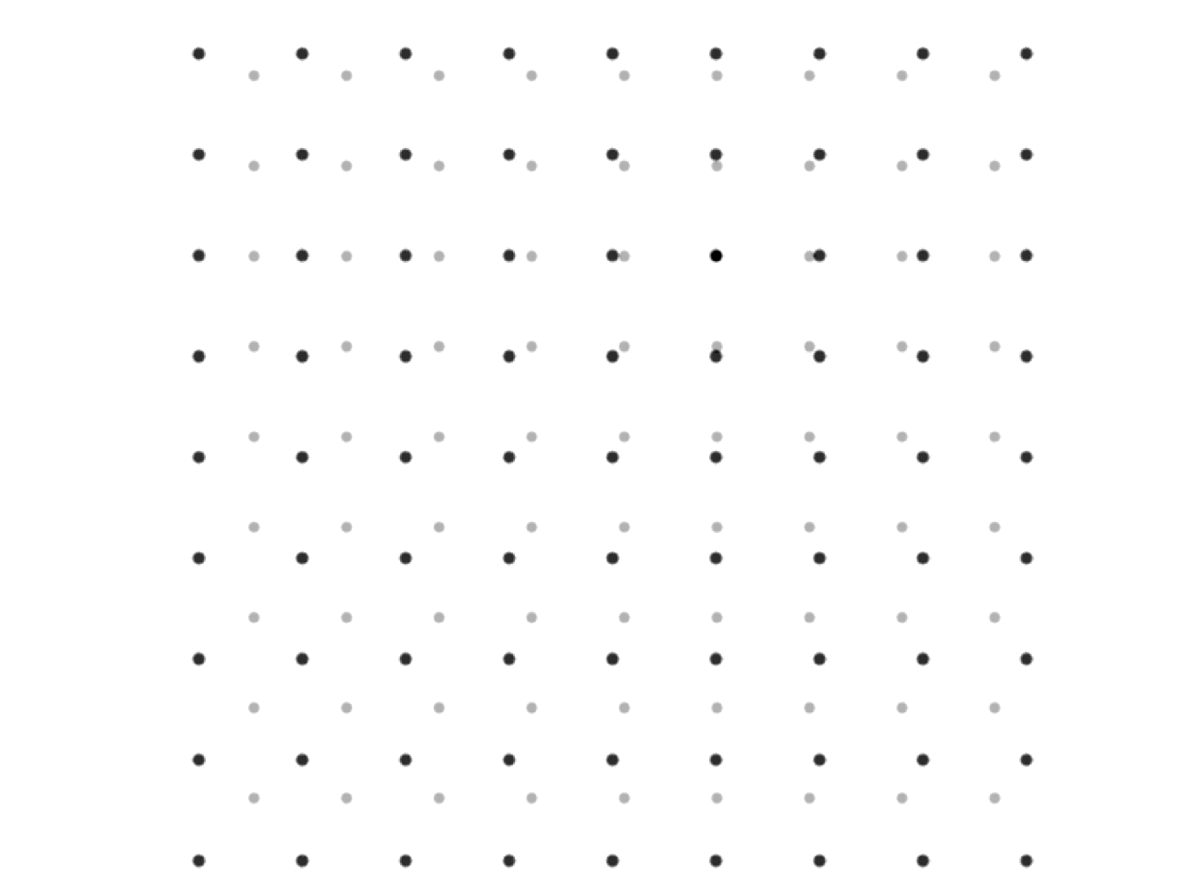
B

Note that the pattern of redshifts seen around Galaxies A and B are the same as seen around the Milky Way. Hence, all observers in a uniformly expanding universe see the same pattern of redshifts ⎯ everyone sees the same Hubble law. Seeing a Hubble law does not mean that you are at the center of the Universe.

