ASTRONOMY 5
Cosmology and Galaxies
Spring 2007

QUIZ # 4, April 13, 2007

Your name: ____________________________________

Please fill in the blanks:

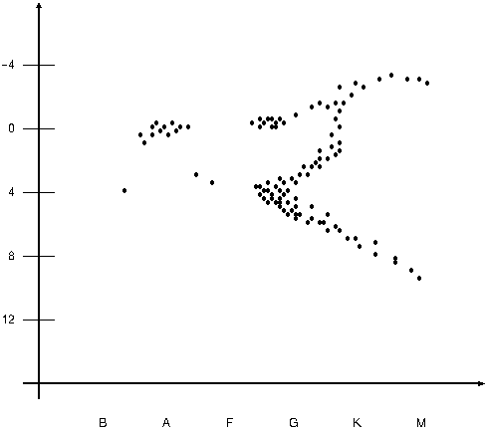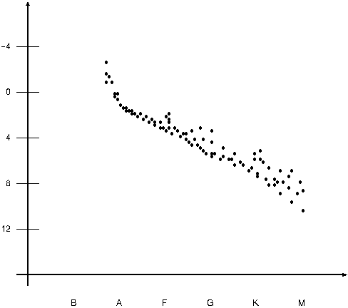
Hot Cluster A Cool Hot Cluster B Cool

Above are HR diagrams for two star clusters shown to the same scale.

1) Which cluster is older? _________

2) Which cluster has more massive stars? _________

3) Which cluster has the bluest stars? _________

4) Concept question:
Which cluster is more likely to contain intelligent life? Why? _________

5) “Metals” is the astronomer’s word for all elements heavier than _________
helium. You would expect the oldest stars in the Galaxy to be
“metal-poor” because: (pick all that apply)
(a) There were very few supernovae before these stars.
(b) The oldest stars are closest in composition to the primeval material
coming out of the Big Bang.
(c) The interstellar gas was not yet very enriched in metals when
these stars formed.

