Student Instructions: Register and Sign In
Getting Started – Enter the section URL provided by your instructor:
http://connect.mheducation.com/class/r-guha-thakurta-fall-2016
After entering the web address above, Click “Register Now”
- Enter your e-mail address
- If you are a new user, you’ll click to enter your access code, purchase access online or start the 21 day Free Trial.
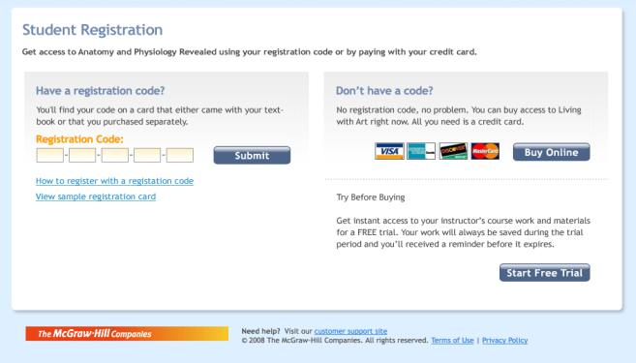
- Fill out the registration form.
- You can access your Connect homepage by clicking on “Go To Connect Now”
- At your Connect homepage you can access your assignments, study center, grades, and other resources provided by your instructor. Start by clicking any of the assignment titles displayed on the list.
Please visit the following site for registration help: http://bit.ly/StudentRegistration
Need More Help?
CONTACT US ONLINE
Visit us at:
http://mpss.mhhe.com/contact.php
Browse our support materials including tutorial videos and our searchable Connect knowledge base. If you cannot find an answer to your question, click on “Contact Us” button to send us an email.

GIVE US A CALL
Call us at:
1-800-331-5094
Our live support is available:
Mon-Thurs: 9 am – 11:59pm EST
Friday: 9 am – 7 pm EST
Sunday: 7 pm – 11:59pm EST

FREQUENTLY ASKED QUESTIONS
WHAT DO I NEED TO GET STARTED WITH CONNECT?
You will need two things: First, a Student Access Code (purchased at the bookstore with your textbook) and second, the Course URL (given to you by your instructor).
HOW DO I REGISTER?
My instructor is using a package with Connect:
If your instructor is using Connect, you will receive a course specific web address (URL) from your instructor. The web address will enable you to register for your instructor's course using a registration code.
I have registered previously:
If you have already registered for Connect and are re-taking a class or registering for an additional class, you will still need to obtain your instructor's course specific web address (URL) to register. You will not be required to create a new account if the Connect access from your previous registration has not yet expired, and you are using the same textbook. You will need to purchase Connect access for each course you are taking.
WHAT IS THE COURSE URL AND WHERE DO I FIND IT?
The most important part of the registration process is often missed, which is entering the course URL. Your instructor will give you the course URL. Every student in your class will have the same course URL.
If your email address is not found in the system or if you are unable to reset your password for any reason, please go to www.mhhe.com/support and click on the “Contact Us” tab for further password assistance. Our support hours and contact information can be found on the “Contact Us” tab.
I AM HAVING TECHNICAL TROUBLE. WHERE DO I GO?
Visit: www.mhhe.com/support
Call: (800) 331-5094
Monday – Thursday: 9AM – 11:59pm EST
Friday: 9AM – 7PM EST
Sunday: 7PM – 11:59pm EST

