PI: M. Bolte, 2008A_U032LA,“The metallicity distribution in the Bootes dwarf Galaxy”

SCIENTIFIC JUSTIFICATION:
Background: Dwarf Galaxies and the history of Galactic Building Blocks: According to the current ΛCDM scenario for the formation of galaxies and structure in the Universe, the halo of the Galaxy was formed via mergers of much smaller systems. The present-day dSph galaxies are thought to be the survivors from that early era of galaxy building (see e.g. Johnston & Bullock 2004). If this picture is correct, we would expect the metallicity distribution function (MDF) of the Galactic Halo to match that of the aggregate of dSph stellar populations.

The Dwarf galaxy Abundances and Radial-velocities Team (DART) project using the ESO VLT/FLAMES facility measured abundances for a large number of giants in the dSph galaxies Sculptor, Fornax, Sextans and Carina. Their results show that while there are large dSph-to-dSph differences in the metallicity distributions, which suggests a wide variety of star formation and chemical enrichment histories. In the dSph there is also a strong deficiency of stars with [Fe/H]<-3.0 dex compared to the Galactic halo. These finding seem to challenge the idea that dSph are fossils from the early Universe and indistinguishable from the Galactic building blocks, and to indicate that possibly the IMF behaved differently in the building blocks than in the dwarfs (Tolstoi et al. 2006). However, much of the work today has been on what has turned out to be the high-luminosity end of the dSph population. In the last few years, primarily based on SDSS data, a number of new, generally very low luminosity dSph companions to the Galaxy have been discovered (e.g. Willman et al 2005a,b; Belukorov et al. 2007; Zucker et al. 2006a,b). These new SDSS discoveries could be representative of the population that built the old, metal-poor component of the Galactic halo.

In particular, the dwarf galaxy in the Böotes constellation (Belokurov et al. 2006), with a distance of 60 kpc and an absolute magnitude Mv=-5.8, it is one of the faintest Milky Way satellites known and, in preliminary studies may have the lowest mean metallicity at [Fe/H] ~-2.5. However, the studies to date have not been definitive and the sample of stars in the galaxy is too small to make a determination of the MDF). Siegel 2006, from light curve fitting, derived metallicities for 15 RRLyr stars finding values with -2.1>[Fe/H]> -2.6. Muñoz et al. 2006 used WIYN/Hydra spectra with a resolution of 2.8 Å to derive Mg triplet based metallicities for 6 giants obtaining [Fe/H]≈-2.6. Martin et al. 2006, on the other hand, using DEIMOS data with a spectral resolution of 1 Å, determined Ca II triplet metallicities for 19 giants finding a wider metallicity range -2.0≤[Fe/H]≤-1.0. The principal goal of this latter study was to measure radial velocities so their S/N was generally too low to make high-quality abundance measurements.

Our Program: We propose to observe a sample of 80--100 red giants in the Böotes dSph to g~22.5 using LRIS with the 600 gr/mm grism which yields a continuous spectral coverage between ~3000 and 5250Å. This would allow us to measure the abundances of Fe, Mg, Ca and C through a combination of equivalent width measurements and spectrum synthesis. Figures 2 and 3 show example of regions in this spectral range with useful absorption lines at this resolution. The galaxy spans only ~20 arcmin on the sky and we can easily cut slits for ~20 objects per mask. Some of these will be field stars, however we already have 38 known radial velocity members from the Martin et al. study for a high-yield start to the program.
Our goal is to measure the MDF for the stars in this galaxy and add to the aggregate dSph MDF in order to better test the halo origin paradigm. We will be specifically looking to identify the [Fe/H]<-3 population that is so far missing from the dSph population and the measure the fraction of C-rich stars. It is now established that the Galactic halo harbors a large number of C-rich stars predominately at the low-metallicity tail of the MDF. Such a high fraction of the Galactic halo sets constraints on the early Galaxy IMF (Lucatello et al. 2004, Tumlinson 2007), suggesting that it was different from that at present time. Therefore determination of the C-rich stars incidence among the Böotes stars can provide a crucial piece of information in understanding whether this dSph is, and more generally those at the low [Fe/H] end of the distribution are, similar to the galactic building blocks.

We will also use LRIS in the imaging mode to obtain a deep CMD for the Bootes dSph to identify evidence in the turnoff region(s) for multiple star bursts if they occurred.

REFERENCES
Abazajian, K. et al. 2005, AJ, 129, 1755
Aoki, W. et a. 2006, ApJ, 639, 897
Beers, T; Preston, G. & Shectman, P. 1992, AJ, 103, 1987
Belokurov, V. et a.. 2006, 647, L111
Belokurov, V. et al. 2007, 654, 897
Christlieb, N. et al. 2001, A&A, 366, 898
Christlieb, N. et al. 2004, ApJ, 603, 708
Johnston, K. & Bullock, J. 2004, Satellites and tidal streams, 327, 213
Lucatello, S. et al. 2005, ApJ , 625, 833
Martin, N. et al. 2007, MNRAS, 380, 281
Muñoz, R. et al. 2006, ApJ, 650, L51
Siegel, M. 2006, ApJ, 649, L83
Tolstoi, E. et al. 2006, The messenger, 123, 33
Tumlinson, J., 2007, ApJ, 664, 63
Willman, B. 2005a, AJ, 129, 2692
Willman, B. 2005b, ApJ, 626, L85
Zucker, D.B. et al., 2006a, ApJ, 643, L103
Zucker D.B. et al., 2006b, ApJ, 650, L41

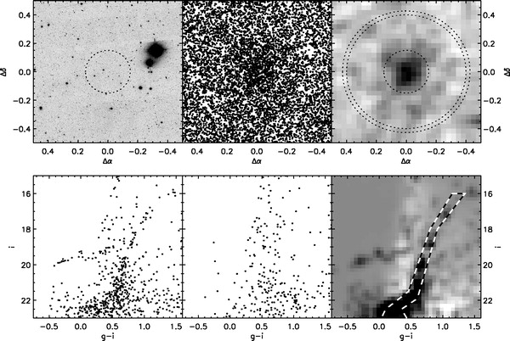
Figure 1: Bootes dSph discovery images and CMD
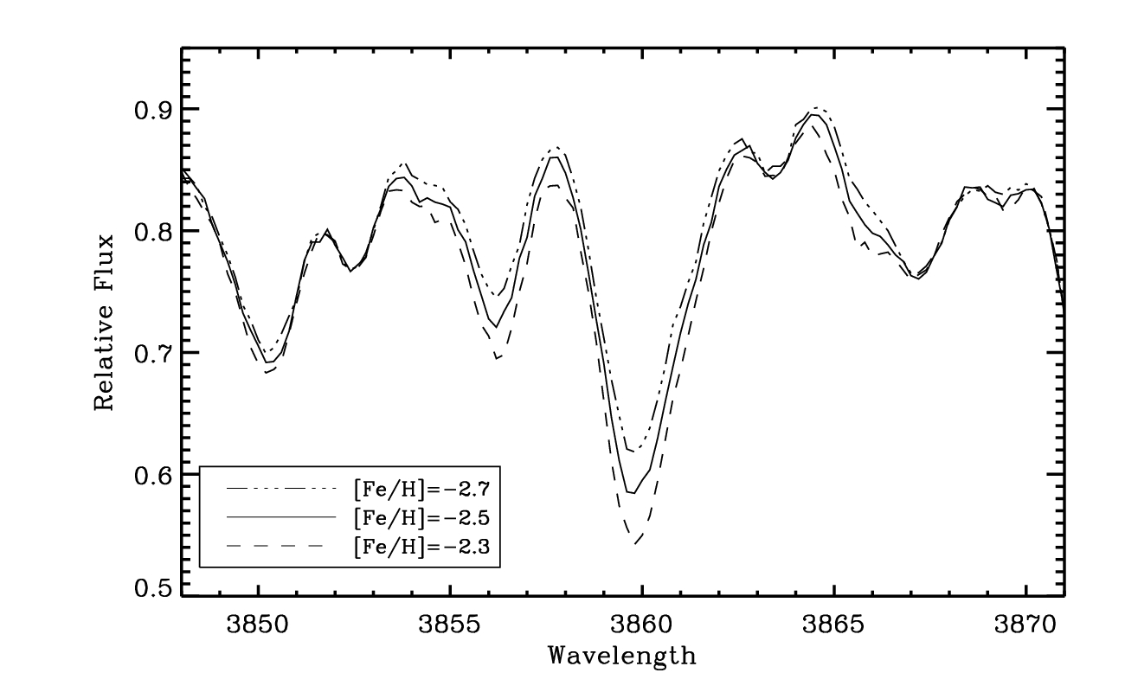

Figure 2: synthesis for two Fe lines @ S/N=70 showing precision at the 0.2 dex level will likely be possible

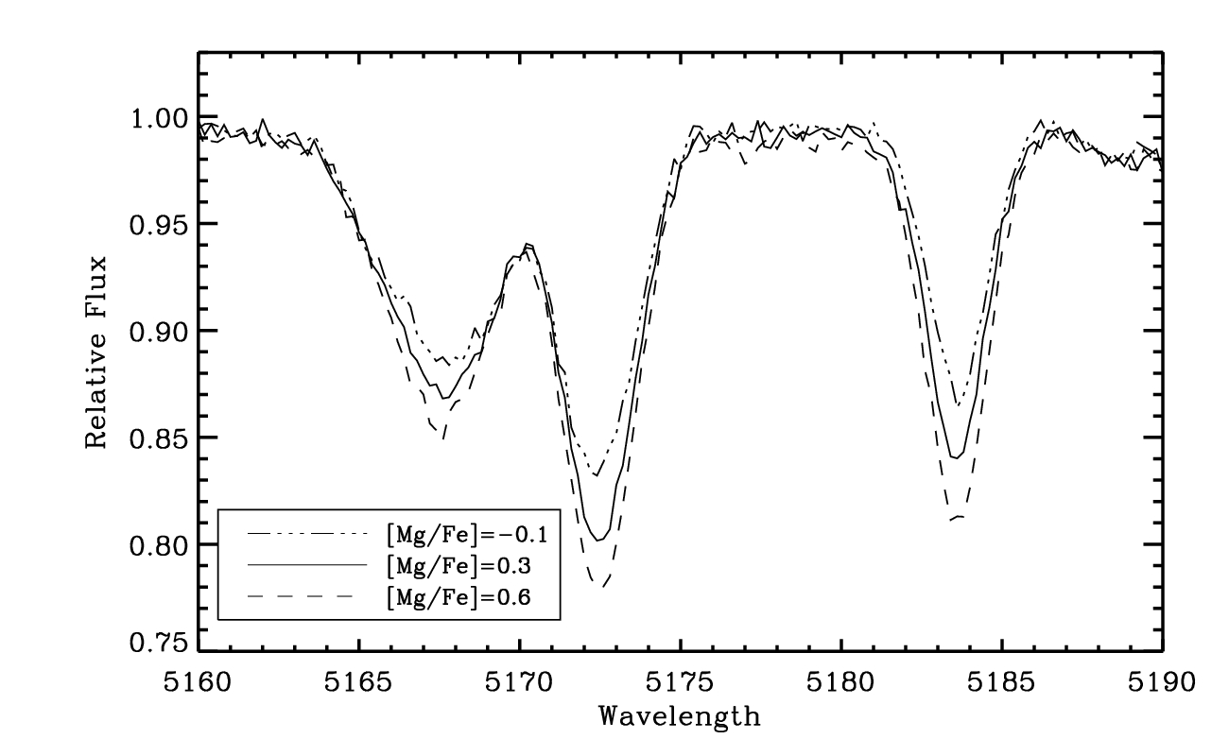
Figure 3: Mg Triplet region synthesis

Technical Remarks: The useful lines are the strongest Fe and Ca lines in the region from 380nm – 520nm, the Mg triplet at ~5150 and CH G band lines at ~4300 and the C2 Swan band lines at ~4800 and ~5100.

Targets and Exposures: There are 38 known radial velocity members between g=18 and 22.3. Based on MBs white dwarf program with a similar LRIS set up, we can achieve S/N of 50 at the faint end of this range in 2.5 hr under good conditions. At 14hr and +14 we can observe this galaxy most of the night in April. It is important to obtain spectra of stars that fall to the red and blue of the RGB as this is where stars of higher and lower metallicity reside in the CMD. We will inevitably have some field contamination. We would like to observe 6 masks in the field in order to build a sample of between 80 and 100 member stars. In the Galactic halo the ratio of stars with -2.0 >[Fe/H]>-2.6 to those with [Fe/H]<-3.5 is ~50. If the MDF for Bootes looks like that of the metal-poor Galactic halo, we will need a sample of this size in order to expect to find a few very metal-poor stars if they exist in the Bootes dSph. Even a sample of 100 will barely allow a significant null result. We will easily reach the 13 Gyr turnoff in 1 hr in B and 40 minutes in V. In order to calibrate our abundance measurements will use observations of stars in the conveniently placed M5, M13 and M92 along with a handful of well measured [Fe/H]<-3 stars from our HIRES survey. These observations very efficient fill two full spring nights. Because most of the calibration fields are at larger RA, nights in April or later are best.

Path to Science: We have much experience in measuring abundances from stellar spectra and producing CMDs. All the tools we need are in place.

Status of previously approved Keck proposals related to this program: This is a new program in a new area, but we have have been assigned a total of 13 ESI or HIRES nights on stellar abundance related program since Aug 2000. Nine of those nights were clear enough to get useful data. This is resulted in seven journal articles with three additional papers near completion there are also numerous conf proceedings reporting on this work.

Johnson, J. & Bolte, M., 2001, ApJ, 554, 888, ``Th Ages for Metal-poor Stars''.
Johnson, J., 2002, ApJS, 139, 219, ``Abundances of 30 Elements in 23 Metal-Poor Stars''
Johnson, J. & Bolte, M., 2002a, ApJ, 579, 616, ``The r-Process in the Early Galaxy''.
Johnson, J. & Bolte, M., 2002b, ApJ, 579, L87 ``Abundances in the Very Metal Poor s-Process-rich Star CS 22183-015''.
Johnson, J. & Bolte, M., 2004, ApJ, 604, 579, ``The s-process in metal-poor stars: Abundances for 22 neutron-capture elements in CS 31062-050''.
Lai, D. K., Bolte, M., Johnson, J. & Lucatello, S., 2004, AJ, 128,2402.``Abundances for Extremely Metal-poor Star Candidates''.
Lai, D. K., Bolte, M., Johnson, J. & Lucatello, S., 2007, ApJ accepted, ``Carbon and Strontium Abundances of Metal Poor stars'', astro-ph/ 0706.3043
Lai, D. K., Bolte, M., Johnson, J. & Lucatello, S., 2007, in prep, “Detailed Abundances for 26 Extremely Metal Poor Stars: Clues to Pop III”.

