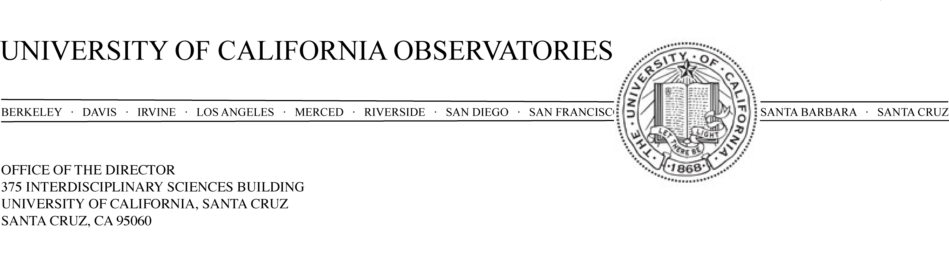
May 12, 2008

Members of the Bower Award Committee,

This is a letter in support of Dr. Jerry Nelson as a candidate for the 2009 Bower Award and Prize for Achievement in Science. Dr. Nelson’s work has had a profound impact on essentially every aspect of optical/infrared astronomy in the last 15 years. Astronomy is a field in which advances in discovery and understanding have followed technology. Galileo’s confirmation that the Copernican heliocentric model for the solar system was correct was made possible by the invention of the first telescopes. As new, more capable telescopes were designed, built and used for science, many of the fundamental properties of the Universe were discovered: the existence of a Universe of galaxies beyond the Milky Way Galaxy by Keeler of Lick Observatory using the Crossley 36-inch reflector and the new technology of photographic plates, the expansion of the Universe by Hubble using the newly commissioned 100-inch Hooker telescope at Mt. Wilson, and the basics of stellar evolution and stellar populations in galaxies made possible by the commissioning of the Palomar Observatories Hale 200-inch (5-meter) telescope.

Dr. Nelson began his scientific career as an experimental high-energy physicist, but early on made a transition to the study of pulsars, neutron stars and other types of stellar x-ray sources. He authored a number of papers utilizing high-speed optical observations of pulsars, notably making one of the first discoveries of timing “glitches” in the Crab Nebula pulsar rotation period (Nelson, et al. ApJ, L161, 1970).

However, Dr. Nelson made his most significant contributions to astronomy and astrophysics in a completely different area—he conceived of a new and wildly innovative approach to building a new generation of giant, ground-based telescopes. When he started his work in this area in the late 1970s, the Palomar 200-inch telescope had reigned as the largest optical/infrared telescope for three decades. For monolithic mirrors, the difficulty of supporting the mirror and maintaining the exquisite figure under a varying gravity vector increases rapidly with the mirror diameter. The feasibility of building a larger telescope that could make excellent images all over the accessible sky was in doubt and the cost of scaling the Palomar design to a larger primary mirror and telescope was considered prohibitive. Nelson proposed a radically new approach to build a primary mirror composed of a number of relatively small, thin, actively controlled segments that would fit closely together and act as a single primary mirror.

This was a revolutionary design concept and can be considered the first advance in telescope design since Newton. If successfully implemented, the segmented-mirror concept would break the cost curve for telescope primary mirror size increases and it was a design that was inherently scalable to very large diameter. However, there were very significant technical challenges to be surmounted in implementing this design and many in the community dismissed the idea completely in the early years of its development.

The two major hurdles that had to be overcome were the fabrication and polishing of off-axis segments and the complex problem of passive support, sensing, and active control of the segments to maintain continuously the figure of the primary in the face of variable gravity vector, temperature changes and wind. Nelson’s solution to the segment polishing problem was to develop a technique of “stressed-mirror polishing” where carefully calculated forces were applied to the blanks, they were polished to spheres and when the stressing forces were removed the segments relaxed into the proper shape to be a part of the parabolic surface of the telescope primary. The active and passive control system of the array of segments needed to hold all motions other than piston and tip-tilt of each segment fixed and sense and control these three degrees of freedom to a precision of ~0.02 microns was the second very difficult problem that was overcome. Although Dr. Nelson is the first to offer that he had a number of colleagues who made important contributions to solving these problems, he was the undisputed leader in pressing this concept forward and he played a crucial role time and time again in identifying solutions to the most difficult problems.

The results of this labor are the two 10-meter Keck Telescopes at the W.M. Keck Observatory in Hawai`i. From the first light image, it was clear that the segmented-mirror concept was a spectacular success. The telescopes and the science they have produced are monuments to Dr. Nelson’s brilliance and his ability to take a new idea from the blackboard through a $150M construction project and to producing forefront science. The Keck telescopes were a huge leap forward in capability for astronomy. The factor of four increase in light collecting area, and the quality of the Mauna Kea site made the Kecks an extraordinary advance. The combination of the Keck Telescope’s spectroscopic reach with the Hubble Space Telescope imaging led to an almost unprecedented decade of discovery in astronomy. The discoveries of the extra-galactic nature of gamma-ray bursts, the star formation history of the Universe, the most distant galaxies, the acceleration of the expansion of the Universe and the majority of the known extra-solar planets are only a few examples of the science made possible by the Keck Telescopes.

Although the Keck Telescopes have had and continue to have an enormous impact on astronomy and astrophysics research, it is possible that the greatest contribution of Dr. Nelson’s work will be that it enabled the construction of truly enormous telescopes. There are two projects to build giant telescopes, the Thirty-Meter Telescope (TMT) and the European Extremely Large Telescope (42-meter diameter primary), and each has primary-mirror designs and segment polishing procedures essentially identical to those of the Keck telescopes. Dr. Nelson is the Project Scientist for the TMT.

Dr. Nelson has made an additional, very substantial, contribution to the tools of astronomy. He was an early proponent of the development of adaptive optics (AO) for correction of atmospheric distortions and the use of laser guide stars to increase the sky coverage over which AO could be used for astronomy. At the time of the completion of the second Keck Telescope, Nelson spearheaded an effort, that was funded by the Keck Foundation, to build a laser guide star AO system for Keck. The system was built based largely on the Lick Observatory system and, when completed, these were the only two AO systems in routine use at working observatories for several years. As was the case with the segmented-mirror concept, Dr. Nelson proved to be a visionary, and now AO is a crucial component of all of the 8m and 10m telescopes and a core capability of the planned extremely large telescopes. In recognition of Dr. Nelson’s expertise and leadership in this area, he was selected to be the Director of the National Science Foundation Science and Technology Center, the Center for Adaptive Optics. He led the CfAO for the first five years (2000-2005) to a very successful mid-term review and the program was renewed for an additional five years.

In summary, Dr. Nelson will be ranked as one of the most important innovators of the tools of astronomy in the history of this science. The impact of his creative ideas and profound expertise has already been enormous with the advances in knowledge that have resulted from the Keck Telescopes and AO systems around the world. In the coming decades, the even larger impact of his contributions will be realized as the next generation of 30-meter and larger telescopes will be built based on Dr. Nelson’s designs. I am honored to be able to put his name forward for the Brower Award.

Sincerely,

Michael Bolte
Director, University of California Observatories

