UNIVERSITY of CALIFORNIA OBSERVATORIES
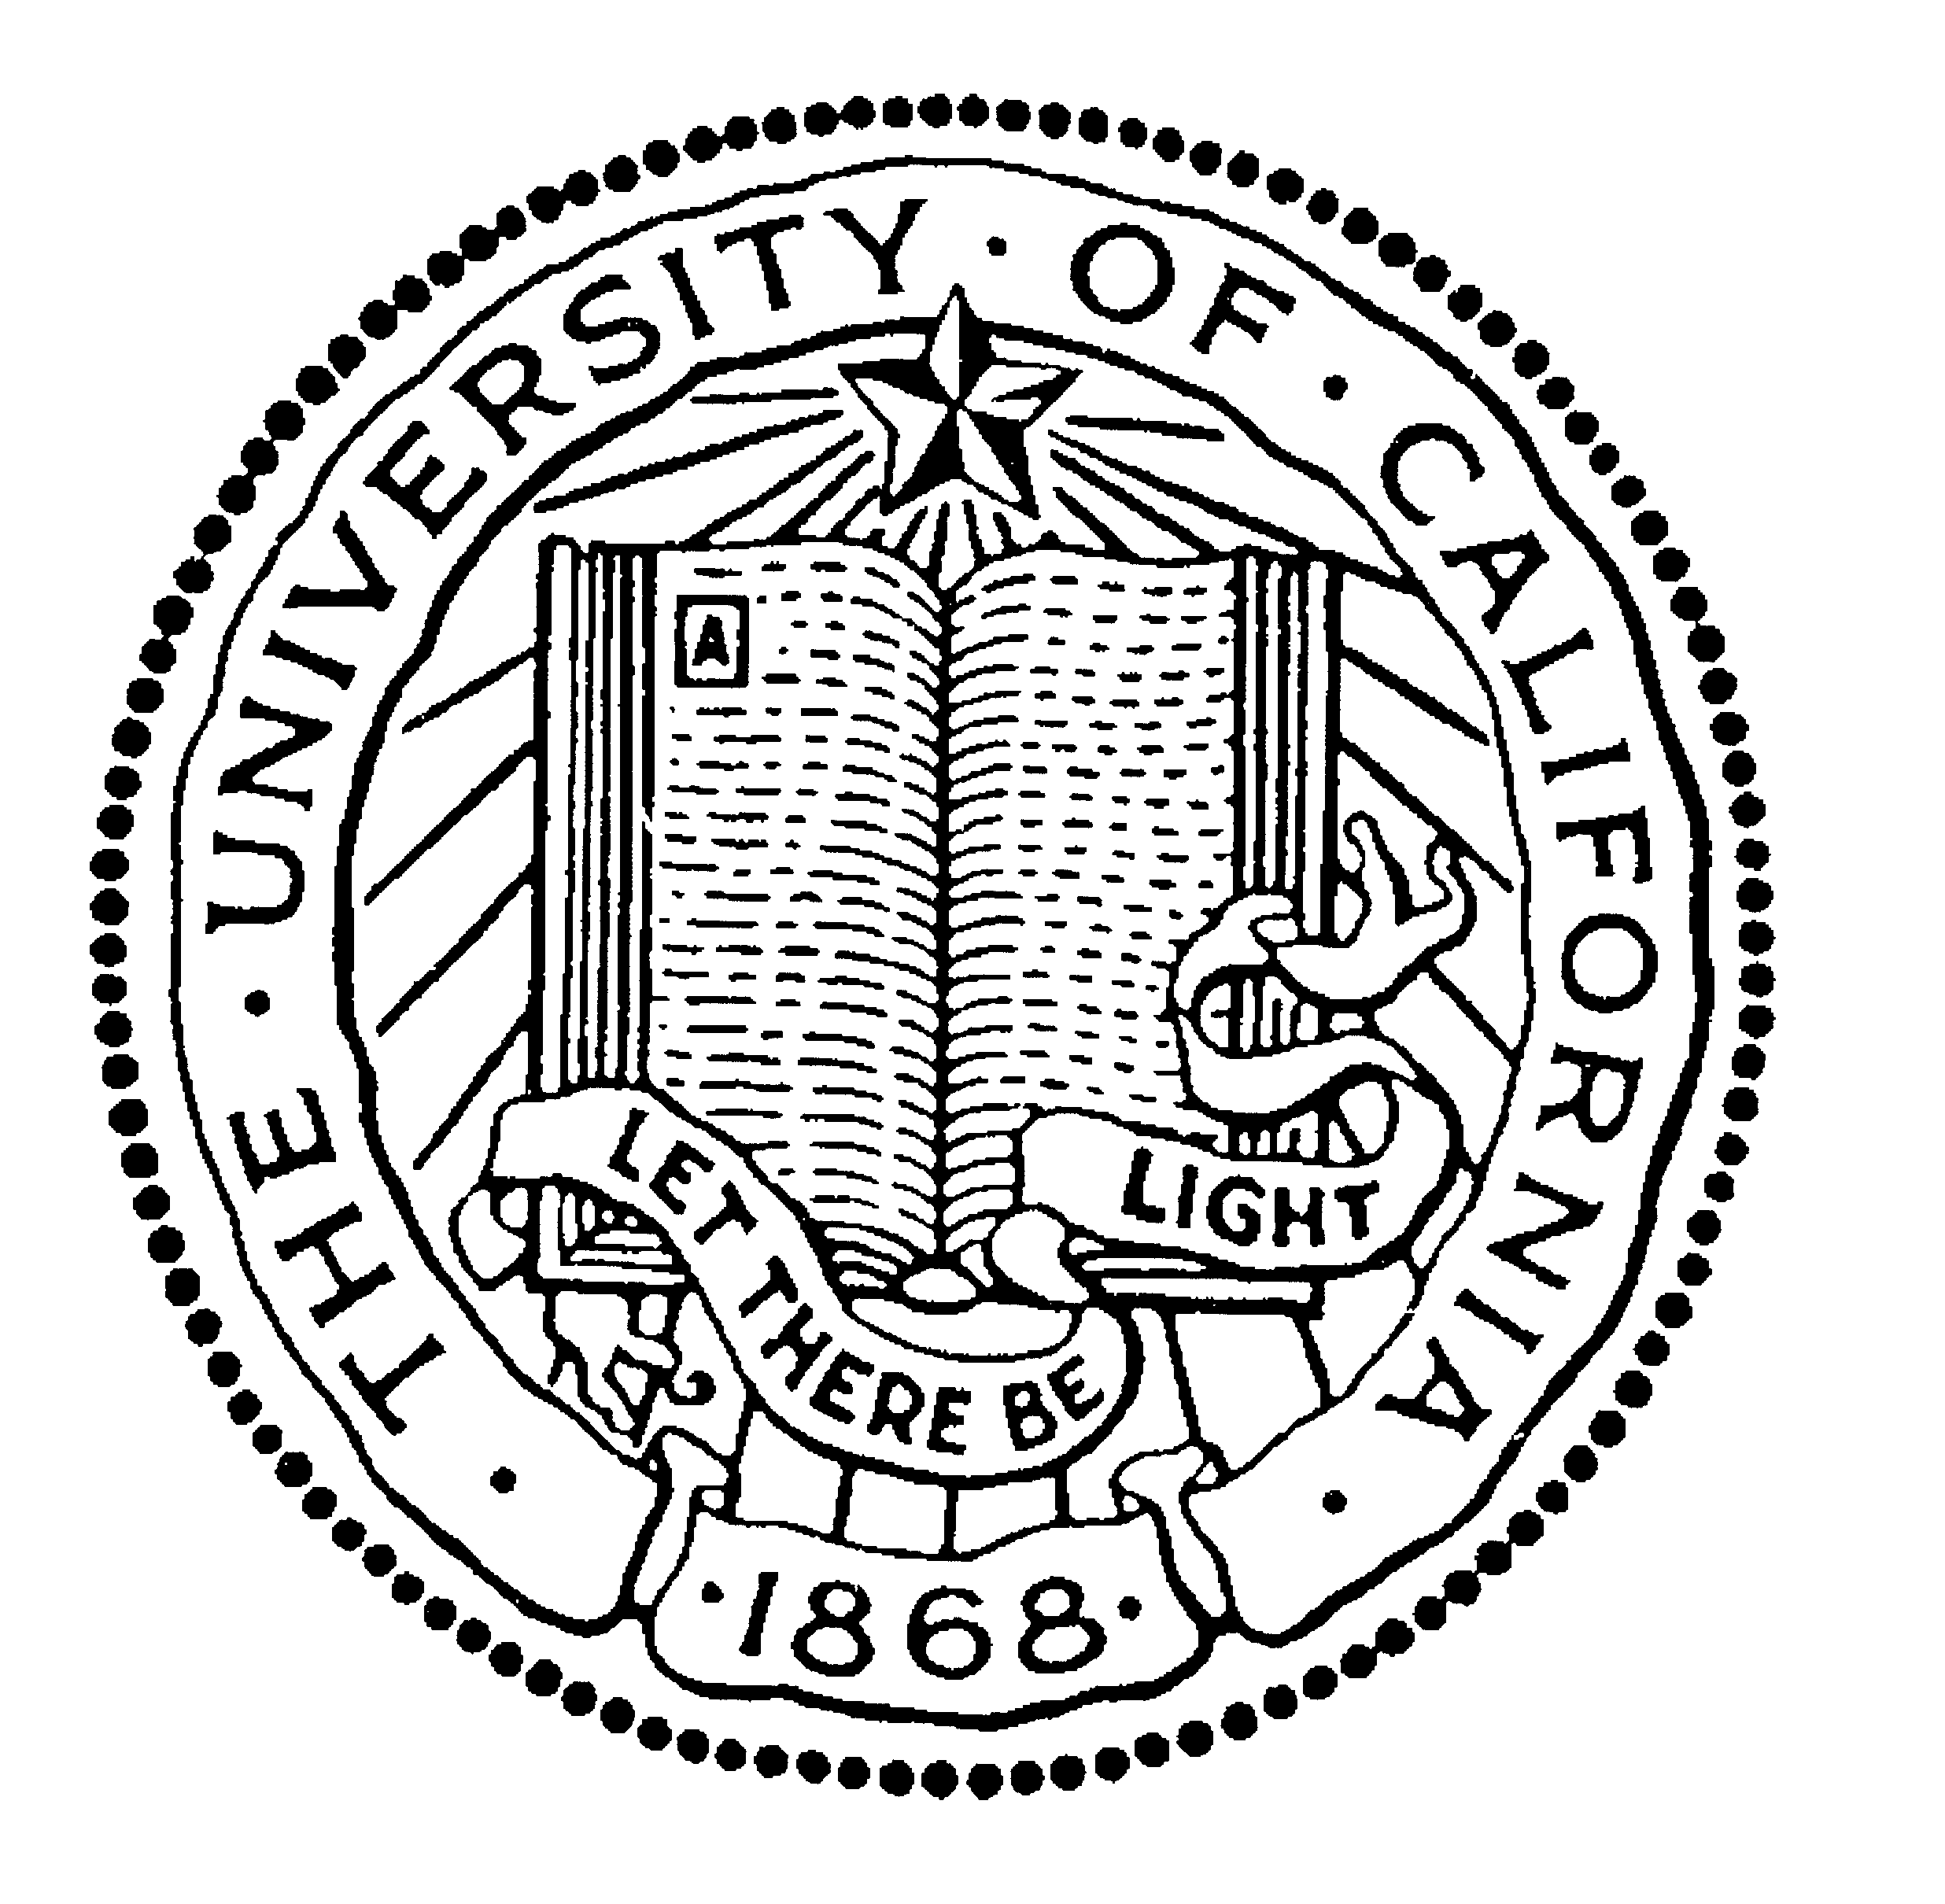

BERKELEY • DAVIS • IRVINE • LOS ANGELES • MERCED • RIVERSIDE • SAN DIEGO • SAN FRANCISCO SANTA BARBARA • SANTA CRUZ

OFFICE OF THE DIRECTOR MICHAEL BOLTE
375 INTERDISCIPLINARY SCIENCES BUILDING 831 459-2991
UNIVERSITY OF CALIFORNIA, SANTA CRUZ bolte@ucolick.org
SANTA CRUZ, CALIFORNIA 95064

2 December 2009

Dr. Rocky Kolb
Chair, Department of Astronomy and Astrophysics
Re: Assistant Professor Position

Dear Rocky and Members of the Selection Committee,

I am happy to provide a strong letter of recommendation for Dr. Kurtis Williams as a candidate for your faculty position. The short summary of this letter is that he is smart, accomplished, creative, erudite and an excellent colleague.

Starting as an undergraduate, Kurtis had a stellar career as a student. He received University and national awards as a Fulbright Scholar (1996/97), a National Science Foundation Graduate Student Fellow (1998-2000) and an ARCS Fellow in 1999/2000. He won our Department ``Whitford'' Prize as the top performer in graduate classes and on the Preliminary exam in 1999. Before settling on his dissertation area Kurtis published three papers (including a single-author paper and another first-author paper) all on different topics. In addition to his excellent performance in graduate classes and early start in publishing research, Kurtis initiated and kept alive the first successful ``journal club'' at UC Santa Cruz as well as a successful ``Ask an Astronomer'' WWW site.

Kurtis completed his dissertation with me as his advisor seven years ago. For his dissertation, he tackled a long-standing problem: the initial-mass, final-mass relation for white dwarfs. Of particular interest was the question of the upper mass limit of main-sequence stars that become white dwarfs. The answer to this question is important to topics ranging from the physics of core-collapse supernovae to the lower mass cutoff of galaxies that can survive their initial star burst at early times in the Universe. Kurtis completed his dissertation in a remarkably short period of time given the size of the project. Along the way he had to master the art of wide-field, crowded-field photometry, reduction and analysis of white dwarf spectra (including development of a sophisticated code for maximum-likelihood comparison of spectra to models to derive physical parameters of WDs) and a statistical understanding of our somewhat complex sample selection function. He did all this essentially completely on his own, with apparent ease and excellent results. His paper on the massive white dwarfs in the young cluster NGC 2168 sets a new level for state-of-the art in this area. This was the third paper to be published from his dissertation material. He has since added five more and branched out into other related WD research areas. Kurtis is the leader of and brains behind this program. We have been very successful getting time for wide-field imaging at CTIO and KPNO and have an active (and continuing) Keck-based observational program for the crucial followup spectroscopy. We received a $300k NSF grant in 2004 to support this work. He has published 25 journal papers and is first author on a little more than a third of these.

Kurtis is one of the four or five strongest students in astronomy of the last decade at UC Santa Cruz. We have had four Santa Cruz graduates go on to become Hubble Fellows in that time period: Romeel Dave', Jason Harris, Anthony Gonzales and Marla Geha. Two additional students, Jennifer Johnson and Katy Flint, went on to Carnegie Fellowships. Dave', Johnson, Gonzales and Geha all now have faculty positions at the University of Arizona, Ohio State, the University of Florida and Yale respectively. Kurtis is in this same league. Kurtis is likely the broadest of the group with his expertise in several, different research areas.

In my opinion, Kurtis is an excellent candidate for a faculty position this year. In addition to his strong research record and programs, he is an excellent Department citizen⎯responsible, sensible and efficient. He has a strong interest in public outreach and is good at applying modern tools to this activity. He is also simply fun to be around. He is very smart, has broad interests outside of astronomy, is articulate and is humorous in a low-key way. I believe he will make an excellent faculty member.

Of course I would be happy to discuss Kurtis further. Please feel free to contact me if that would be useful.

Sincerely yours,

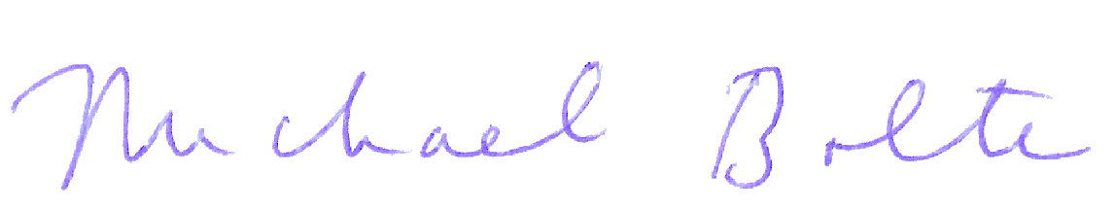

Michael Bolte
Director, University of California Observatories
Professor of Astronomy and Astrophysics
University of California, Santa Cruz

