UNIVERSITY of CALIFORNIA OBSERVATORIES
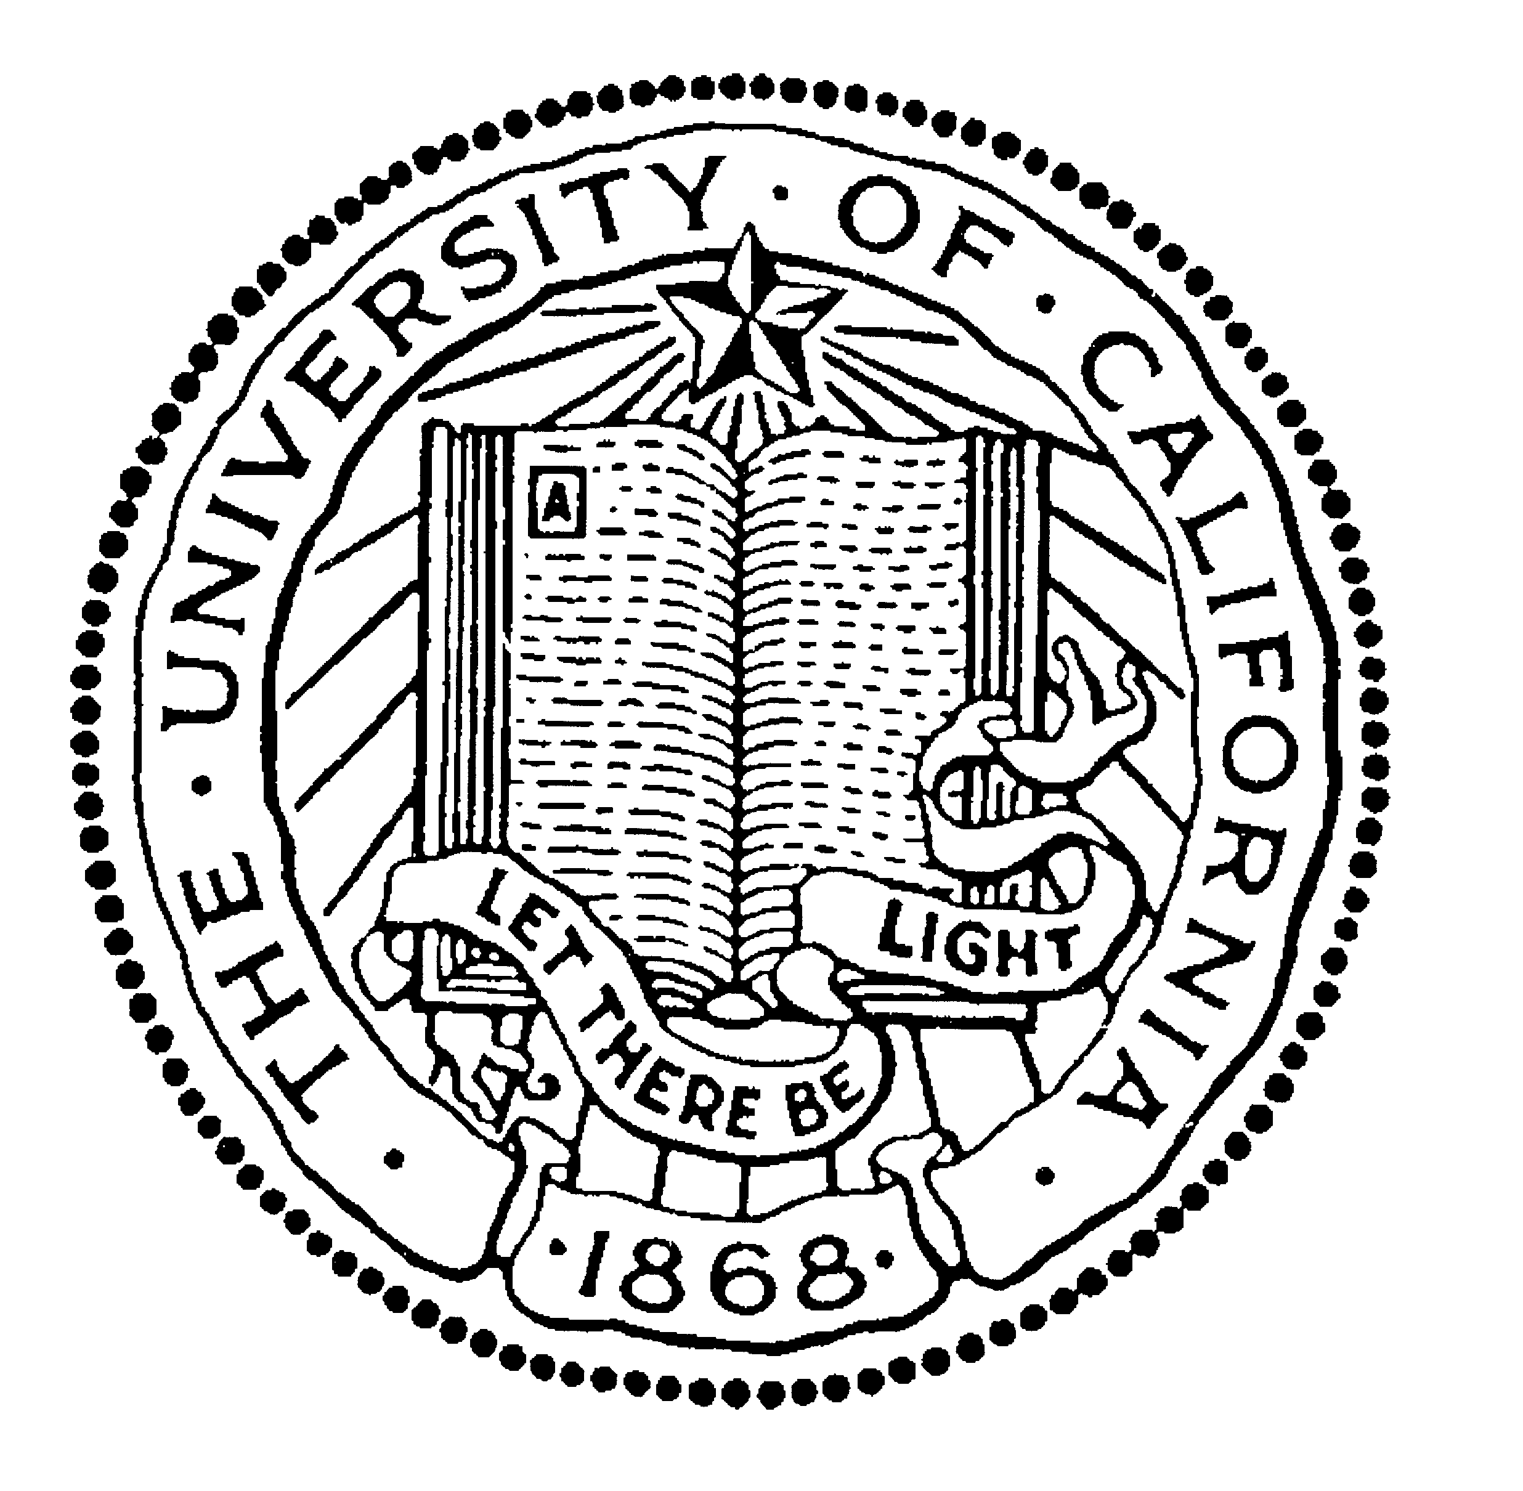

BERKELEY ● DAVIS ● IRVINE ● LOS ANGELES ● MERCED ● RIVERSIDE ● SAN DIEGO ● SAN FRANCISCO SANTA BARBARA ● SANTA CRUZ

OFFICE OF THE DIRECTOR
UNIVERSITY OF CALIFORNIA, SANTA CRUZ
375 INTERDISCIPLINARY SCIENCES BUILDING
SANTA CRUZ, CALIFORNIA 95064

31 July 2026

To: Dean Stephen Thorsett

From: Michael Bolte, Interim Director, UCO

Subject: Proposed Merit Increase for Dr. Claire Max

The full professors and astronomers of UCO/Lick Observatory and the Astronomy and Astrophysics Department met on November 19, 2009, to consider the case for advancement to Above Scale for Dr. Steve Vogt. XXX of the eligible YYY faculty members attended the meeting. Votes from MMM of the remaining faculty members were collected after the meeting. Three faculty members who are on leave from the Department this year waived their right to vote. Dr. Vogt was advanced to Above Scale scale on July 1, 2006. The case is summarized below.

RESEARCH

TEACHING

Dr. Max holds an 80% Observatory 20% Department appointment and therefore has proportionately smaller teaching responsibility than is carried by a regular faculty appointment at UCSC. She developed two new classes during the review period. Techniques of Adaptive Optics is a graduate-level class which has been very well received by our students and those on other campuses. Dr. Max is one of the first to utilize distance learning technologies to include students from other campuses in her classes. She is also the first in our program to incorporate peer-instruction and inquiry-based learning techniques in the classroom. The second newly-developed class was Planets and Planetary Systems, Astronomy 18. In addition to developing the new classes, Dr. Max taught the graduate Electricity and Magnetism class. The student evaluations for all of her classes are uniformly positive. Dr. Max has also played an active role in the innovative and very success education and outreach programs of the Center for Adaptive Optics.

Dr. Max also is active as a mentor of graduate students. During the review period she was co-advisor for two PhD students, advisor for a student’s Master’s degree project and is academic advisor for another of our graduate students working in AO instrumentation.

SERVICE AND LEADERSHIP

Dr. Max has a distinguished record of service to the Department, Observatory and University. During the review period she was initially an Associate Director and Deputy Director then the Director of the NSF Center for Adaptive Optics headquartered on the UCSC campus. This is a ~$4M/year NSF Science and Technology Center whose mission is to advance and disseminate adaptive optics technology. Dr. Max was one of the PIs for the original $40M NSF grant and has guided the Center to very positive reviews from the Oversite Committee and the community it serves. Dr. Max was also PI of a successful proposal to the Moore Foundation to fund the first Laboratory for Adaptive Optics (LAO). This proposal was funded in 2003 via a $9.1M grant from the Moore Foundation and it is sited on the UCSC campus. The LAO has proven to be a huge success on several fronts. The lab is carrying out key component testing and system design for the Thirty-Meter Telescope Project, the Keck Observatory Next Generation AO system and the Gemini (US 8-m telescope) Extreme AO coronagraph for imaging extra-solar planets.

Dr. Max has also served on the Department of Astronomy and Astrophysics Graduate Admissions Committee, the campus Academic Senate Committee on Computing and Telecommunications and the University of California Observatories Advisory Committee. She is a member of a number of advisory groups for the US astronomical community and the US government.

This section on service and leadership is perhaps the appropriate place to comment on the extraordinarily positive letters that we received from the outside referees. This is a particularly distinguished set of letter writer including members of the National Academy and directors of major observatories and scientific institutions in the US and Europe. Referee A comments that she has been the driving force in pushing AO as an engineering development program to a powerful new working tool for astronomical development and then used this capability to carry out her own forefront research programs. This referee concludes by stating “…I consider Dr. Max to be unique and outstanding as a leader of astronomical research”. Referee C notes her excellence in the three areas of administration/leadership of the CfAO, research and teaching. His summary statement is “I cannot think of anyone else in academia who rivals her ability to multitask so many exciting initiatives to fruition”. Referee D also comments on her wide breadth of excellence: “She has the rare combination of talents making her a sterling communicator, educator, scientist, technologist and leader.” Her international reputation as a pioneer and leader of AO development and the recognition of her vision and abilities to realize major goals is stated in one form or another in every letter.

PRIZES AND SPECIAL RECOGNITION

During the review period, Dr. Max received three prestigious external awards. In 2002 she was elected to the American Academy of the Sciences, in 2003 she was selected as the Alameda County Woman of the Year in Science and in 2004 won the E. O. Lawrence Award from the Department of Energy. The latter award carries a $50,000 prize and is awarded in a ceremony in Washington D.C. by the Secretary of Energy.

CONCLUDING REMARKS

We are very fortunate to have a faculty member with the international stature of Dr. Max. Her reputation as a visionary and leader of major initiatives is widely praised. Through her leadership of the development of adaptive optics for use in astronomical facilities she has made the largest telescopes in the world more powerful by as much as an order of magnitude. Dr. Max continues to very capably lead one of the largest and most visible research centers on the UCSC campus. She has an active and forefront research program and is an effective and energetic teacher who is bringing many aspects of modern education practices to our curriculum. The strong recommendation of the Observatory and Department of Astronomy and Astrophysics is for advancement to Above Scale with a further recommendation of an eleven-month salary of $191,590.
Sincerely,

Michael Bolte
Interim Director, University of California Observatories

Concurrence: _____________________________
Sandra Faber

Chair, Astronomy and Astrophysics Department

