Summary
There is a great and pressing need for improved coatings for astronomical optics. By moving to multi-layer, Ag-based coatings, reflectivity of mirrors can be improved significantly for wavelengths >400nm. Improvements in the durability of reflective coatings could significantly reduce telescope downtime, particularly for large segmented-mirror telescopes, and the reduce major impact on observatory operation budgets that is incurred by regular mirror recoating. . Efficient anti-reflection coatings are generally not available for transmission optics of 1-m and greater size, such as will be required all of the large wide-field cameras currently being proposed. The University of California Observatories (UCO) has been engaged in trying to develop both types of improved coatings. In this proposal, we ask for funding to make major infrastructure improvements to our coating facilities to enable us to explore efficient coatings for large substrates using Ion-Assisted Deposition processes. Results of this research potentially has immediate impact for all optical/IR telescopes; we are in particular targeting experiments to settle on processes for the new Keck Observatory segment coating chamber and to finalize design of the Thirty-Meter Telescope segment coating facility
We propose to upgrade key components of the UCO 1-m testbed chamber to permit state-of-the-art, ion-assisted deposition via e-beam and magnetron sputtering. These improvements will extend the coating capabilities to include the reliable reactive deposition of nitrides, which have proven critical to the Gemini coating. Another upgrade is a novel moving stage, which will allow coverage of large substrate areas with excellent thickness and process uniformity.
The intellectual merit of this proposal is in expanding our knowledge of optical thin-film coatings, especially in relation to protected silver coatings for telescope mirrors. While there has been much interest in these coatings for several decades, many of the problems (such as plasmon absorptions) have no widely-recognized solutions.
The broader impacts of the proposed activity are numerous. Durable silver coatings represent a significant upgrade to astronomical infrastructure. They could be immediately applied to essentially any optical telescope with gains of ~20-30% or more in efficiency, along with decreased time lost to frequent recoating. Gains in the thermal IR, where telescope emissivity is a major component of the background level, can be even more impressive. Since most observing projects are limited by time needed to collect a certain number of photons, these gains translate directly into number of science projects that can be completed. More widely, protected Ag mirrors are of great interest in construction of solar concentrators.
Project Description

Introduction
Since the work of J. Strong (1933), aluminum has been the standard coating material for astronomical telescope mirrors. It is easy to deposit, has reflectance above 90% for most of the optical-UV to the near IR (although there is a significant drop in the 700-900nm region), and it develops a native layer that enables it to survive for 2-3 years before recoating is necessary. However, in modern 3-mirror telescopes, a 10% loss at each surface degrades throughput by nearly 30% (Fig. 1).
Similarly, modern instruments often contain transmissive optics with ~12-20 surfaces in total. If only 1.5% of the light is lost at each surface, there is a reduction of ~20-30% in throughput. Combining these two means that the total throughput of telescope plus instrument optics is reduced to half. Since efficiency of astronomical observations is usually in direct proportion to the number of photons collected, this results in serious reduction in science. Another way of looking at this is that twice as many observing programs could be carried out were it not for losses at optical surfaces! Clearly, even modest improvements to coatings can have a large impact on optical astronomy.
In the thermal infrared, where the sensitivity to faint objects is dominated by the background thermal emission as well as by throughput, potential improvements using better coatings are even more dramatic. While instruments are cooled to cryogenic temperatures to control thermal emission, by necessity the telescopes (at ambient temperature) are warm and dominate the background. In the near and mid IR, aluminum (Al) has an emissivity of 3%, while silver (Ag) and gold (Au) are close to 1%. In this case, sensitivity could be improved by a factor of three by using Ag rather than Al coatings on telescope mirrors. The next generation of large telescopes will be used increasingly in the IR, both because that is where adaptive optics is most efficient, and because of studies of galaxies at high redshift require observing the spectra at longer wavelengths.

Improved Coatings For Astronomy
Only silver has higher reflectivity than Al over the broad wavelength range required for most astronomical telescopes. However, Ag has two drawbacks: (a) under normal conditions, bare Ag tarnishes and corrodes in a few weeks to months; and (2) the reflectance of Ag falls rapidly in the UV. The tarnishing/corrosion problem must be addressed through overcoating the metal with protective layers of transparent material. The UV drop-off can be reduced (but not completely solved) by using the protective layers to produce a constructive-interference boost in blue reflectance. In order to maintain the low IR emissivity, the protective layers must be optically thin at IR wavelengths. Thus, the layers must be transparent over a wide wavelength range; be chemically stable; be excellent barriers, especially to moisture; and have good refractive index contrast for the UV interference. The challenge for Ag mirror coatings is to find materials and processes that will satisfy these criteria in layers less than 1-μm total thickness. The coatings must be long-lived, and have sufficient abrasion-resistance for regular cleaning (we adopt the term “durable” for these properties). Furthermore, the coating process must be able to coat large substrates with good uniformity in all properties. Finally, the coatings must have low intrinsic or thermal stress to avoid deforming the optical surfaces.
An additional problem of overcoated-Ag coatings is the ubiquitous presence of Surface Plasmon Resonances (Stanford & Bennett 1969). These produce anomalous absorption in the UV/blue, which can be quite severe (Fig.2). It is known that the location and amplitude of these features is dominated by grain size in the metal layer, so that rapid deposition on cool substrates minimizes the problem. However, our trials have also found that the material over the Ag has an effect (higher-index materials have worse absorption) and even the layer under the Ag modifies the resonance. Therefore, an additional challenge is to find materials and processes that reduce surface plasmon resonances to an acceptable level.
It has become clear that thin film qualities and properties depend both on the material deposited and on the process used for deposition. Optical thin film properties can often be improved by heating the optics to 300-500C, an option that is not practical for telescope optics. However, modern optical thin films are increasing deposited by the higher-energy techniques of sputtering and/or ion-assisted deposition (IAD). Sputtering can be applied to relatively large substrates, but deposition rates tend to be low and certain materials, notably fluorides, cannot be deposited easily. IAD shows great promise, but to date has been limited to small substrates.
Reactive deposition wherein oxides or nitrides are created by evaporating metals in an O₂ or N₂ plasma, are possible by both sputtering and IAD. These reactive depositions can produce superior films of correct stoichiometry, low-porosity, lower internal stress and excellent film structure. Certain materials such as nitrides can only be deposited reactively. However, great care must be taken in reactive depositions as pressures and deposition rates can affect film properties, and even small partial pressures of non-working gas can lead to impurities. For example, it is now understood that pressures ~10⁻⁷ torr are needed to make Si₃N₄ films with good barrier properties; at higher pressures, residual H₂O reacts with the forming film resulting in silicon oxynitride, which is much poorer as a barrier material.
Multi-layer anti-reflection (AR) coatings are a well-developed product; although good efficiency is hindered by the lack of low-index material, recent progress with silica solgel coatings has improved this situation significantly. Fluorides are commonly required in good AR coatings, and here only IAD is practical for large optics (since sputtering dissociates fluorides). Again, to date, IAD processes have been limited to small substrates.

Recent Efforts
Reflective coatings for mirrors: Gemini Observatory undertook a major development effort for Ag-based mirrors in the 1990’s (Jacobson et al. 1998; Boccas et al. 2004); their requirements emphasized low IR emissivity and high reflectance in the visible, at the expense of wavelengths below ~500 nm. The result (Fig.3a) was a coating that seems to have an effective lifetime of 2-4 years (Vucina et al. 2008). Another coating (Thomas & Wolfe 2000; Wolfe et al. 2002), developed in parallel at LLNL, used the same layers as the Gemini coating, but added several high-low index pairs over this base to extend reflectance into the UV, at the expense of high IR emissivity at some wavelengths due to interference fringes. The key to these coatings appears to be a thin layer of NiCr-nitride on each side of the Ag. Unfortunately, NiCr-nitride is nearly opaque, so the front layer needs to be exceedingly thin (0.3–1nm, ie, of order 1–3 molecular layers!) to avoid too severe loss of reflectance. How this thin, non-continuous layer works is controversial; Chu et al. 2006 conclude that it acts as a “seed” layer to build a defect-free Si₃N₄ barrier layer above it. However it works, it appears to be vital to the durability of these coatings.
For most astronomical telescopes, neither the Gemini nor LLNL coating is suitable as both low IR emissivity and good blue-UV response are required. The coatings rely on sputtering for reactive deposition of nitrides, and the process appears to be somewhat fragile, that is, it is sometimes difficult to get repeatable results. This is likely a result of poor vacuum (at least in the case of the Gemini-N coating) as at pressures greater than ~10⁻⁷ torr there is sufficient water vapor so that oxynitrides, rather than pure nitrides, are produced. Also, getting the required thickness uniformity across the 8-m Gemini primary was a major technological challenge.
Recently, Surface Optics Corporation (SOC) deposited the Gemini coating using IAD rather than sputtering. Furthermore, they place their e-gun and ion source on a radially-moving stage, allowing them to cover large surfaces with excellent uniformity in film properties, because the e-beam/ion-stream geometry is the same for all regions of the substrate. This technique was used by SOC to coat the space-based Kepler telescope mirror, and we are testing some of their Gemini-style samples at Keck Observatory to check longevity under actual observatory conditions.
Bill Brown at University of California Observatories (UCO developed a Ag-based coating using conventional e-beam deposition that has enjoyed some success; we refer to this coating as the “HG” coating (Fig. 3b). Reflectance of the HG coating is excellent across all wavelengths of interest. While the HG coating survives well in the protected environments of instruments (in HIRES at Keck, it lasted ~15 years without signs of significant degradation), it does not hold up well exposed to the night sky (less than ~1.5 year). In this coating we have the efficiency we seek (e.g. Fig.4), but not the required durability. Given the conventional deposition technique used in HG coatings to date, its short lifetime is not unexpected, and we are encouraged that the improved film structure with IAD could extend the lifetime by a factor of several.
Anti-Reflection coatings: At UCO we developed a 3-layer coating with excellent broad-band anti-reflection properties (Fig.5). This coating was applied to the 1.05-m prisms of the Keck ADC (Phillips et al. 2008a). The two bottom layers are vacuum deposited, while the top layer is spin-coated silica sol-gel. The lack of high-energy deposition means these coatings are somewhat fragile to abrasion and possibly chemical attack. Coatings such as these are being planned for the next-generation of wide-field cameras, where exposed optical elements of ~1.5-m diameter will be used. Improving the hardness of the vacuum-deposited layers is highly desirable. Furthermore, simple coatings like these can be easily applied to large substrates because thickness uniformity is not as crucial, whereas multi-layer coatings have strict tolerances on uniformity across the substrate.
Much of our recent work on these coatings is summarized in Phillips et al. (2008b).
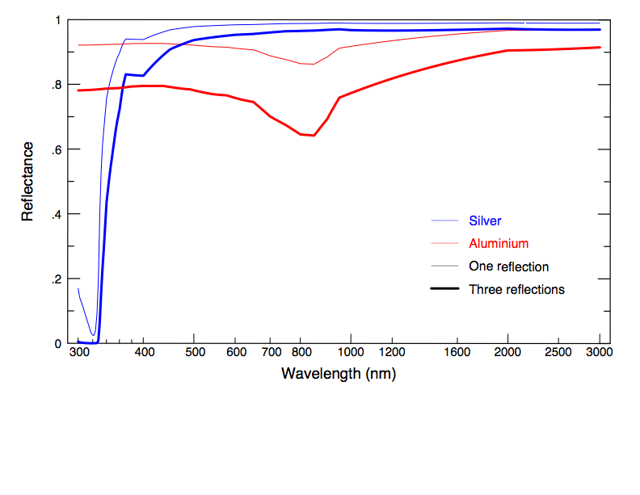 | Figure 1: Reflectance of Ag vs Al for single reflection, and the overall throughput for three reflections, typical of large telescopes. Ag clearly wins everywhere except in the UV. The thermal IR reflectance is critical because emissivity of the coating contributes to the background signal; there, Ag is better by a factor of 3.

Figure 2: Violet/UV absorption caused by Surface Plasmon Resonances (arrows), in silver overcoated with Si₃N₄. At higher deposition rates, the absorption is shifted to bluer wavelengths, becomes narrower and has reduced amplitude. These measurements are of sputtered samples produced by Pacific Northwest National Laboratories for a Lick/TMT study of surface plasmon resonances. | 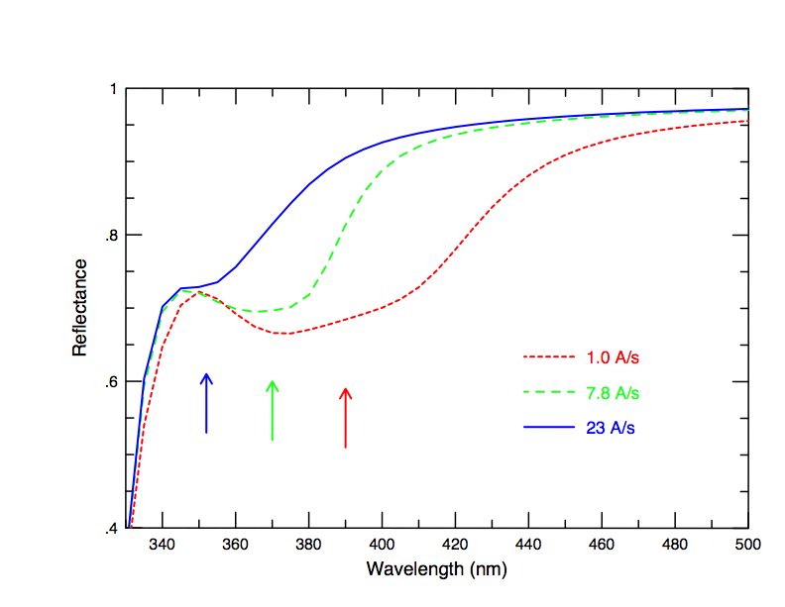

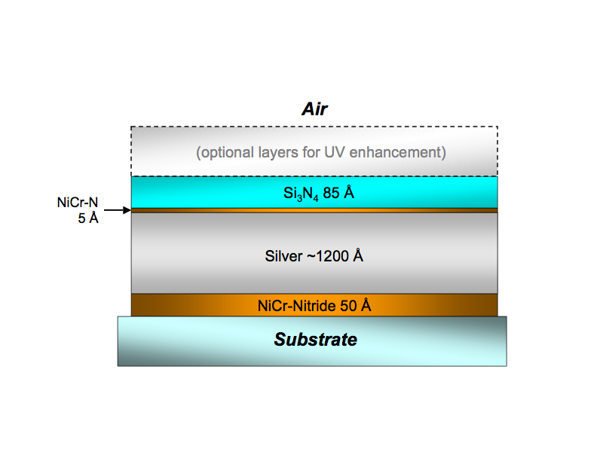  (a) | (b)  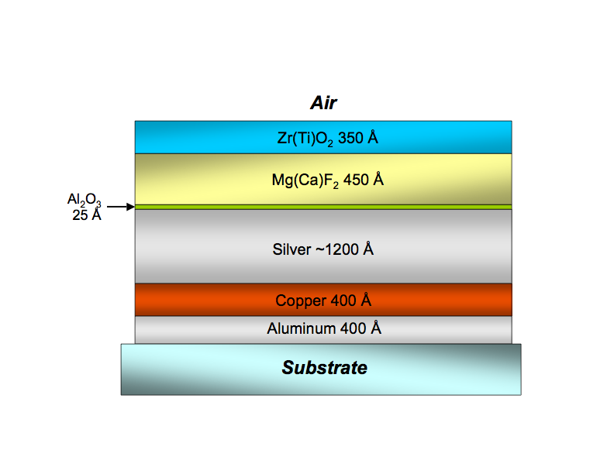
Figure 3: Schematics of two protected-Ag coatings. (a) The Gemini-style coating. The LLNL coating is similar, with several high/low-index dielectric pairs on top. The ~5 Å layer of NiCr-Nitride appears to be crucial; we refer to this very thin film as the “magic layer”. (b) The original Lick “HG” formulation. The thicknesses of the two upper layers can be modified to “tune” the coating for specific wavelengths of interest. We are exploring the use of Titanium or Chromium in place of Copper, with encouraging results.

Figure 4: A modified HG coating (red). For comparison, we show the curves for fresh aluminum and the Gemini coating. Note that the HG coating is nearly as good as the Gemini coating in the IR while having much better blue reflectivity. The arrow marks surface plasmon absorption in the silver coating. (The small steps in the measured coatings at 800, 1200 and 2000 nm are spectrophotometer artifacts.) | 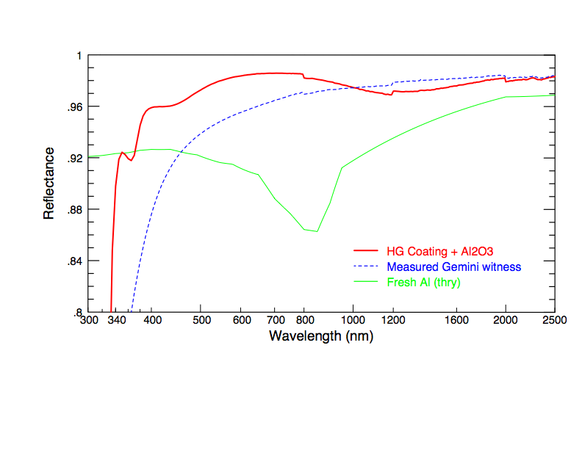
Fig. 5: Example of a sol-gel based 3-layer AR coating developed at UCO/Lick Observatory. The layers are MgF₂, a thin layer of Al₂O₃ (both applied in the vacuum chamber) and the top layer of silica sol-gel applied via spin-coating. This coating was “tuned” for 0.38<λ<1.0μm. The MgF₂ and Al₂O₃, however, were not applied using IAD or other higher-energy technique, and thus are not very durable. | 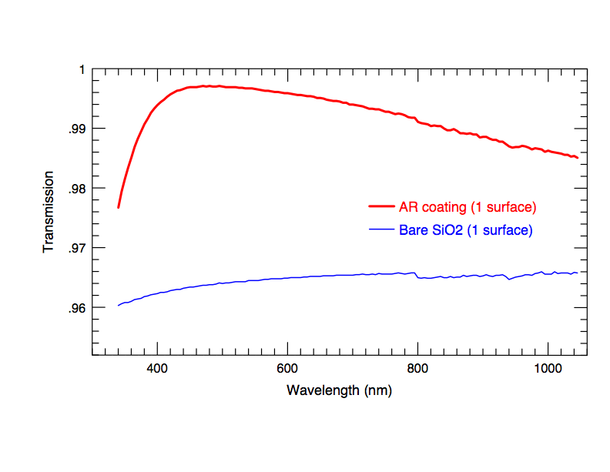

Proposed Work
We propose a major effort to develop practical, high-performance coatings for astronomical optics, addressing the key issues of durability and scalability to large substrate sizes. This work is aimed at optical elements exposed to an observatory environment, although optics in vacuum instruments may also benefit. The research requires upgrades to our coating chamber, consisting of two major subsystems: (1) a high-efficiency cryopump, needed to reach vacuums of ~10⁻⁷ Torr for deposition of pure nitrides; and (2) a radial stage carrying e-gun and ion-source to explore applicability to large substrates. This second system will consist of a “swing-arm” rather than a linear stage as used by SOC; this approach is simpler, requires no motors within the chamber, and has fixed water and gas plumbing (whereas the SOC plumbing is flexible, creating sites for vacuum leakage).
With this equipment in place, we will execute the following program:
- reproduce the Gemini-style coating as a base-line for further development;
- explore other metal nitrides with better optical properties as a substitute for NiCr-nitride (Ti, Zr and Hf nitrides show some promise);
- explore ways to boost the blue/UV response of the Gemini coatings through thickness variations in the Si₃N₄ layer or an additional (thin) oxide layer;
- explore various metal oxides as barrier layers (the most likely candidates are HfO₂, Ta₂O₅, ZrO₂; also mixtures of these, which can produce a more amorphous film structure and may thus have better barrier properties); and
- explore the use of fluorides (notably MgF₂, CaF₂, YF₃, AlF₃) in both protected-Ag and sol-gel based coatings. (Thermal deposition alone does not produce robust fluorides, but IAD can. Fluorides may be the only choice for low-index materials in protected-Ag coatings in the 8-12μm window, where both SiO₂ and Al₂O₃ have strong absorption bands at non-normal incidence; see Cox et al. 1975, 1978).
Samples produced will be subjected to accelerated aging tests in humid and high-H₂SO₄ environments, and checked for adhesion and abrasion using standard tests.
At the same time as this research into coating development is on-going, the swing-arm facility will allow us to coat large substrates without reconfiguring our coating chamber, so we can easily deposit experimental coatings on optics that will go into actual observatory conditions for field testing. While much can be learned from laboratory tests, how the results translate to the “real world” is unknown, so it is extremely important to field test coatings in order to empirically determine actual lifetimes and aging processes. These coatings will be closely monitored for failure, and can be quickly recoated if needed. Thus, we expect to see science benefits of increased throughput immediately while we work on the difficult problem of coating durability.

In-house vs. commercial development
A valid question is “Why not go to industry to develop these coatings?” The answer is multi-facetted. Astronomical optics are usually low-volume and hence an unattractive market, so there is little incentive for industry to spend resources developing such coatings. Our requirements are often extreme: best reflectance over a very wide wavelength range, very durable, large substrates, etc. Unlike most users, we must be able to strip and recoat substrates when their coatings degrade. On the other hand, some requirements that are common in the coating industry – abrasion resistance and adhesion – may be relaxed for astronomical mirrors that are usually in semi-protected environments and are handled and cleaned with great care. In short, astronomical coatings are very specialized compared to the needs of most optical consumers.
In principle, we could contract with commercial coating vendors to produce witness samples for us, but we have tried this route with discouraging results. First, since it is all custom work, it is very costly and has a long turn-around time. Furthermore – and more importantly – it is clear that successful coatings depend at least as strongly on process as it does on materials or “recipe”. It is the process-related techniques that give one coating vendor its advantage over another, and these process parameters are closely-guarded secrets. Thus, even if we contracted with commercial vendors to produce witness samples for us, without a full understanding of the entire process involved, the results would be subject to variability that we could not control.

Justification for EAGER Program
This research has a critical time component, as both current observatories (e.g. W. M. Keck Observatories) and the next generation of large telescopes search for coating improvements. Keck is currently planning upgrades to their coating facilities with the eventual goal of depositing Ag-based coatings at least on K2, and possibly on K1 if the blue response is adequate. The Thirty-Meter Telescope (TMT) project is searching for a viable, durable Ag-based coating to meet its design specifications. As part of this search, they are considering the SOC approach of IAD with radially-translating stage, so an immediate verification of this technique, as well as discovery of potential difficulties with it, is extremely desirable to mitigate or retire a serious project risk. These are just two examples of the urgency for coating development.
There is also a degree of risk involved, as durable, efficient Ag-based coatings are a difficult problem; however, the immediate payback to observational astronomy is high. In addition, there could potentially be valuable results for solar concentrators, which share many of the same criteria as astronomical mirrors.
Due to the urgency, this project is not a good match for standard proposal programs, such as ATI. Furthermore, to fully investigate advanced coatings would require comparing IAD against magnetron sputtering processes, something which is beyond the scope of this proposal but may suitable for a follow-up program. All equipment upgrades here are compatible with and necessary for future studies with magnetrons, and indeed the radially-moving stage approach is a way to make sputtering processes “expandable” to arbitrary sized substrates (whereas currently each sputtering facility is specific to substrate size).

Conclusion
This program asks for funding through the EAGER program to execute an urgent development of improved coatings for optical/infrared coatings. It has intellectual merit in development of thin-films, although its primary impact is in the broader areas of significant and immediate improvement in efficiency of telescopes and instruments, as well as reduced operations overhead with less frequent recoating of optics. It benefits the entire astronomical community. There are potential benefits to endeavors in outside fields, such as the development of more efficient collectors for solar energy. We feel we have made significant progress toward these coatings with our current facilities, and with modest but significant improvements could reach our goal of a durable silver-based coating. We are ready to execute this program at the earliest opportunity.

Additional Information

Facilities currently available for present research:
Our coating chamber can handle optics up to ~1-m in diameter. It is equipped with a shuttered 4-pocket Temescal e-gun with a 6KW power supply and MDC sweep control; an Inficon IC-5 thickness monitor; two Varian diffusion pumps with cryotraps; a residual gas analyzer; vacuum gauge; and single-axis rotation for substrates. In addition, there is a K&R EH2000 broad-beam ion source with three gas feeds. The coating chamber is housed in a modular clean-room. Both the vacuum system and e-gun are obsolete by current standards and need replacing.
Reflectance measurements are made in a dedicated Varian-Cary 5000 spectrophotometer with near-normal reflectance accessory. In addition, we have access to a differential interference microscope and a scanning electron microscope for close surface analysis. We also have equipment set up to perform environmental testing in humid H₂S atmospheres (10-20 ppm, ~70% RH, comparable to test of Jacobson et al., 1998), and for evaluating abrasion-resistance and adhesion under standard tests.

Schedule and Publication:
It is anticipated that the purchase, delivery and installation of the cryopump equipment in the coating chamber will take approximately 3.5 months. Fabrication and assembly of the swing-arm stage should require less than 2.5 months, some of which could be coincident with the above. We estimate approximately 1 month will be needed to calibration of the swing-arm stage control and thickness uniformity. Thus, the time needed for facility upgrade is 6 months prior to the start of coating development.
Experiments in IAD e-beam depositions, and environmental testing and evaluation of the samples will need approximately 10 months. The total time to completion of studies should be 16 months.
Major findings will be published periodically, most likely in SPIE Proceedings. At the end of this project, we expect to be able to provide to the astronomical community a full description of the processes and material combinations needed to deposit protected, enhanced Ag coatings with a multi-year lifespan.
We are ready to commence this project at the earliest date possible.

Results From Prior NSF Support (Past 5 Years)
PI Phillips is a Co-I on two NSF astronomy grants:
- AST-0507483 (“Collaborative Research: The DEEP Survey-Emergence of the Modern Universe,” PI Sandra Faber, awarded $1,305,439 from 12/1/05 to 11/30/09). Survey complete; data reduction nearly 100% complete; data release #3 is on-line for public access, including 1-D and 2-D spectra, photometric and redshift data for ~50,000 galaxies; at least 26 refereed publications for DEEP and many more with the AEGIS collaboration (including the entire ApJ (Letters) 660 (1) issue); XXX graduate students supported. This project has had high impact on the field of extragalactic astronomy and galaxy evolution.
- AST-0808133 (“Collaborative Research: The DEEP3 Survey – Three Fundamental Tests of Galaxy Evolution,” PI Sandra Faber, awarded $1,635,807 from 12/1/08 to 11/30/13). First year of data collection underway. XXX graduate students currently supported.
Neither of these projects has any bearing on the project described in this proposal, although these observational projects would have benefited from more efficient coatings!

Co-PI Bolte …
For PI and Co-PI:
- NSF award number, amount and period of support;
- Title
- Summary of results incl. contribution to development of HR in sci/eng;
- Publications
- Brief descrip of avail data, samples, phys collection and other research products

