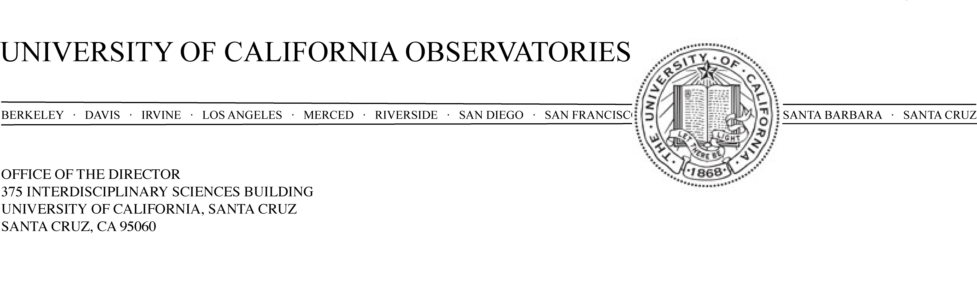

20 March 2007

To: Campus Provost and EVC David Kliger

Re: Rebecca Bernstein Target of Excellence request

Dear David,

I am requesting permission to pursue a Target of Excellence recruitment of Dr. Rebecca Bernstein at the Associate Professor/Astronomer level, waiving an open recruitment. The UCO and Department of Astronomy and Astrophysics faculty met on March 19, 2007 and voted unanimously to support this request.

Although at a relatively junior stage in her career, Dr. Bernstein is an internationally recognized leader in the design of forefront astronomical instrumentation. She is one of literally only a few researchers in the world who have successfully led the design and construction of a major instrument for one of the new generation of large telescopes. She was the Principal Investigator for the Magellan Inamori Kyocera Echelle Spectrometer now in use at the Magellan 6.5m telescope in Chile. She designed the spectrometer, ran the project through its very successful commissioning in 2003 and has already authored six journal papers based on data obtained with the instrument. She is currently the principal member of the team designing the “Dark Energy Survey” camera, a $20M DoE-funded project with a goal to a precise measurement of the evolution of the Universe’s dark energy content.

It is anticipated that >$80M dollars will be spent over the next decade designing and building Thirty-Meter Telescope (TMT) instruments. Having Dr. Bernstein as a member of our UCO faculty will put us in a much stronger position to take the intellectual lead on TMT instrumentation. Our field is such that the leaders in instrumentation are naturally also leaders in carrying out forefront research and Dr. Bernstein brings a record of accomplishment in more traditional areas of research. She has an excellent record of teaching at all levels including graduate student mentoring and an equally excellent record of service at the University of Michigan. As a woman in a science field, she would increase the Department, Division and campus diversity. Dr. Bernstein would come with a funded NSF program, and a significant design role in the DOE-funded $20M Dark Energy Survey camera.

UCO has responsibility to guide and strongly participate in the scientific and technical futures of the Keck and Lick Observatories. Dr. Bernstein would also be a tremendous asset in this area. As our faculty ages, with nearly all of our experienced instrumentalists now reaching ages when retirement becomes a consideration, it is crucially important right now that we maintain and renew our strength in instrumentation, which is fundamental and central to our mission.

Dr. Bernstein was recently tenured at the University of Michigan where she has been a faculty member since 2001. She has been approached by (at least) two institutions. She has an offer from the University of Texas and an offer in the works from the University of California Davis. In particular the offer from Texas eliminates the possibility of considering Dr. Bernstein as part of the pool in an open recruitment next fall. I am also pressing within the TMT project to initiate three major design studies here at UCO headquarters this summer. My case would be much stronger if I could anticipate the arrival of Dr. Bernstein in the next 6 months.

The request for pursuing a ToE appointment for Dr. Bernstein was discussed at an Astronomy & Astrophysics faculty meeting on March 19, 2007. There was broad and enthusiastic support for going forward. I propose that this position be a standard 80% UCO, 20% Department of Astronomy and Astrophysics faculty appointment. If this appointment request goes forward and we are successful in bringing Dr. Bernstein to UCSC, UCO would not go forward with the approved recruitment in Fall 2007 to replace Peter Bodenheimer and instead use the Bodenheimer FTE for the Bernstein position. We would use the same arrangement for start up funds as was planned for the Bodenheimer position recruitment.

Thank you for your consideration of this request.

Sincerely,

Michael Bolte, Director, University of California Observatories

Concurrence:

Sandra Faber, Chair, Department of Astronomy & Astrophysics

