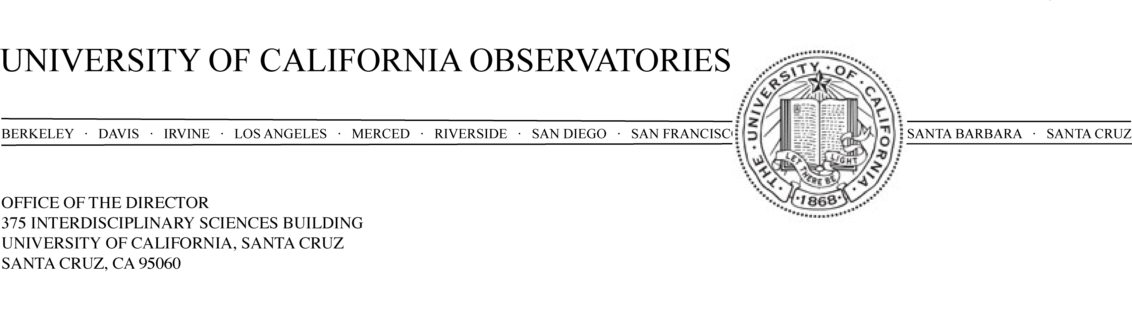

20 March 2007

To: Campus Provost and EVC David Kliger

Re: Rebecca Bernstein Target of Excellence request

Dear David,

I am requesting permission to pursue a Target of Excellence recruitment of Dr. Rebecca Bernstein at the Associate Professor/Astronomer level, waiving an open recruitment.

Dr. Bernstein received her PhD from Caltech in 1998, went on to a prestigious Hubble Postdoctoral Fellowship at the Observatories of the Carnegie Institutes of Washington and from there to a faculty position at the University of Michigan. Although at a relatively junior stage in her career, Dr. Bernstein is a recognized leader in the design of forefront astronomical instrumentation: one of literally only a few researchers in the world who have successfully led the design and construction of a major instrument for one of the new generation of large telescopes. She was the Principal Investigator for the Magellan Inamori Kyocera Echelle Spectrometer now in use at the Magellan 6.5m telescope in Chile. She designed the spectrometer, ran the project as PI through its very successful commissioning in 2003 and has already authored six journal papers based on data obtained with the instrument. Currently, Dr. Bernstein is the optical designer of the “Dark Energy Survey” camera, an ambitious $20M DoE-funded project with a goal to make precise measurements of the evolution of the Universe’s dark energy content. She is the optical designer for a third major instrument now in the conceptual design phase, also for the Magellan 6.5m telescope.

UCO has responsibility to guide and strongly participate in the scientific and technical futures of the Keck and Lick Observatories. Dr. Bernstein would also be a tremendous asset in this area. Even more important strategically, is the UCO role in the Thirty-Meter Telescope project. It is anticipated that >$80M dollars will be spent over the next decade designing and building TMT instruments. These are very challenging instruments and, based on our long track record at UCO of building state-of-the-art instruments for Lick and Keck, we want to play a leadership role in the design and construction of the TMT instruments. Having Dr. Bernstein as a member of our UCO faculty will put us in a much stronger position to take the intellectual lead in this area. As our faculty ages, with nearly all of our experienced instrumentalists now reaching ages when retirement becomes a consideration, it is crucially important right now that we maintain and renew our strength in instrumentation, which is fundamental and central to our mission.

Our field is such that the leaders in instrumentation are naturally also leaders in carrying out forefront research and Dr. Bernstein brings a record of accomplishment in astronomy research. She concentrates on particularly difficult observational problems and carries out very meticulous and detailed work. Her areas of interest, the structure of disk galaxies, stellar populations in galaxies based on integrated spectra, the evolution of galaxies in cluster environments and the intergalactic medium are excellent complements to the research areas of our current faculty. In addition to her grants and contracts for instrumentation, Dr. Bernstein has NSF support for her more traditional research programs.

Dr. Bernstein has an excellent record of teaching at undergraduate and graduate levels including graduate student mentoring. She has provided student evaluations from an undergraduate survey class, an undergraduate physics major class and a graduate level class all at the University of Michigan. The evaluations are uniformly very positive. The common themes are good organization, clarity in presentation, availability to students and challenging material.

As a woman in a science field, she would increase the Department, Division and campus diversity. She is a participant in the NSF Advance Program at the University of Michigan. This is a program to increase the participation and advancement of women in academic science and engineering careers. In Astronomy & Astrophysics we currently have only four women out of twenty-three faculty. Physics has only a single woman on their faculty.

Dr. Bernstein was recently tenured at the University of Michigan where she has been a faculty member since 2001. She has this year been approached by (at least) two institutions. She has an offer from the University of Texas and an offer in the works from the University of California Davis. In particular the offer from Texas eliminates the possibility of considering Dr. Bernstein as part of the pool in an open recruitment next fall. I am also pressing within the TMT project to initiate three major design studies here at UCO headquarters this summer. My case would be much stronger if I could anticipate the arrival of Dr. Bernstein in the next 6 months.

The request for pursuing a ToE appointment for Dr. Bernstein was discussed at an Astronomy & Astrophysics faculty meeting on March 19, 2007. There was broad and enthusiastic support for going forward. I propose that this position be a standard 80% UCO, 20% Department of Astronomy and Astrophysics faculty appointment. If this appointment request goes forward and we are successful in bringing Dr. Bernstein to UCSC, UCO would not go forward with the approved recruitment in Fall 2007 to replace Peter Bodenheimer and instead use the Bodenheimer FTE for the Bernstein position. We would use the same arrangement for start up funds as was planned for the Bodenheimer position recruitment.

Thank you for your consideration of this request.

Sincerely,

Michael Bolte, Director, University of California Observatories

Concurrence:

Sandra Faber, Chair, Department of Astronomy & Astrophysics

