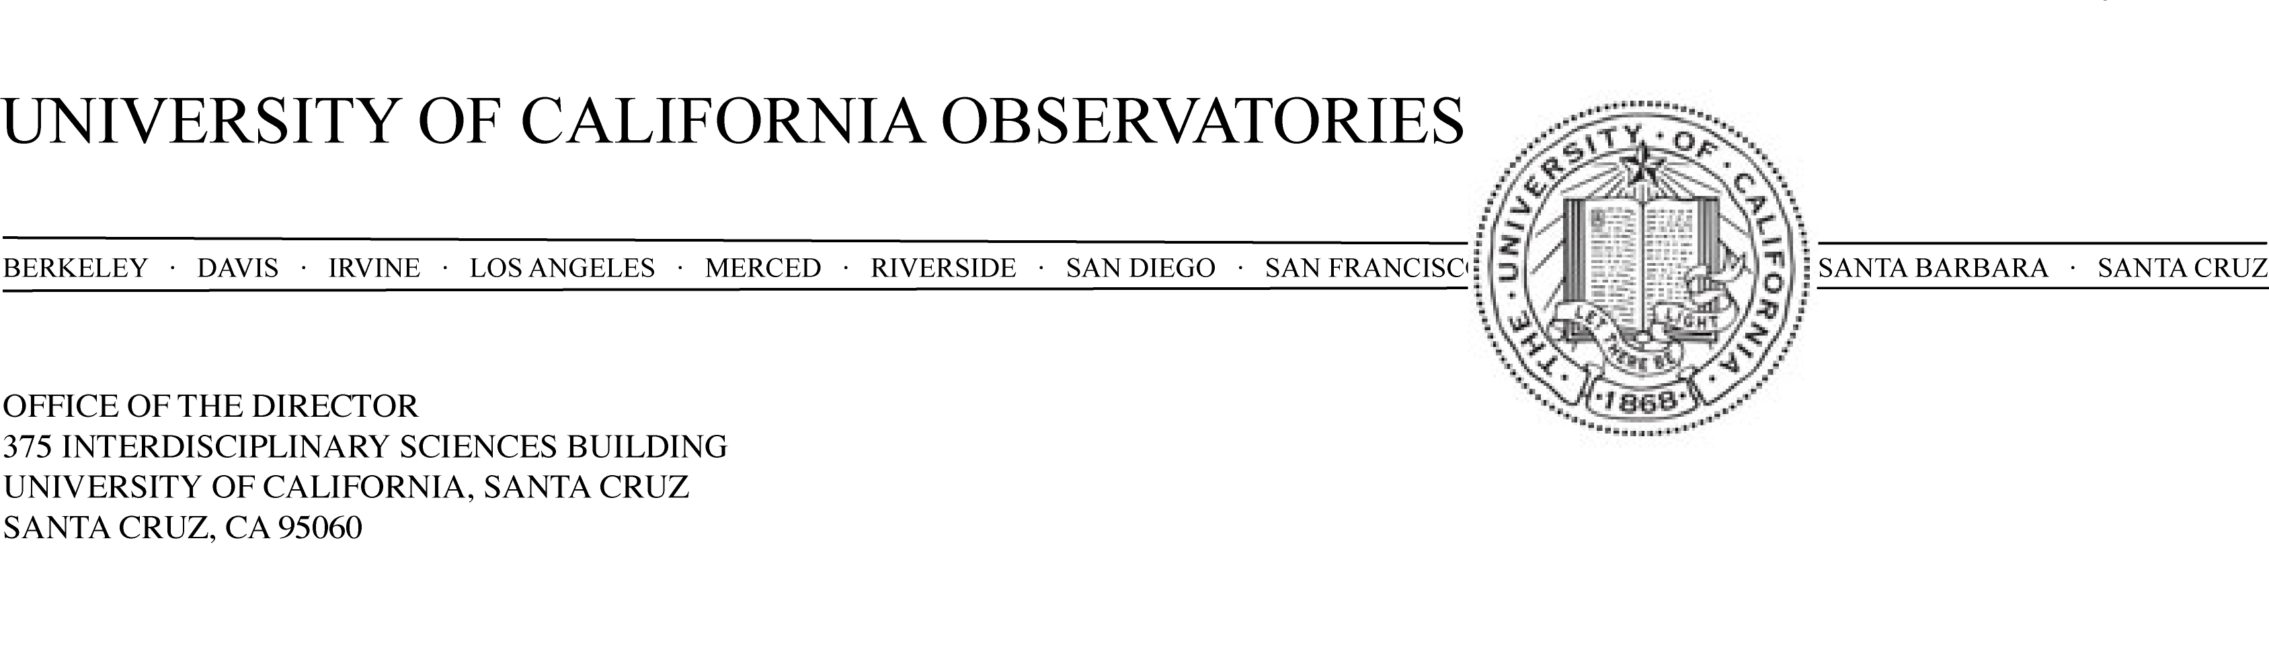
December 1, 2009

To: Steve Thorsett, Dean, Physical & Biological Sciences
From: Michael Bolte, Director, UCO
Subject: Proposed Merit Increase for Constance Rockosi
The eligible UCO/Lick and Astronomy and Astrophysics faculty met on 19 November 2009, to consider the case for a merit increase for Dr. Connie Rockosi. Dr. Rockosi was advanced to Associate Astronomer/Associate Professor Step II on July 1, 2008, so this review comes at the normal time. Ten of the eligible 20 faculty members attended the meeting; votes from six of the remaining faculty members were collected after the meeting. Three faculty members who are in administrative posts this year waived their right to vote. Two votes were taken, nn faculty voted for an action of advancement to Associate Astronomer/Associate Professor Step III with off scale component of $7000 resulting in a salary of $91,900. MM faculty voted for an action of a two-step advancement to Associate Astronomer/Associate Professor Step IV retaining the current off-scale salary. This latter is fully justified by Dr. Rockosi’s excellent performance in all three of the categories by which faculty are evaluated.
RESEARCH: Dr. Rockosi continues to very energetically pursue research on several different fronts. She has been the leader of one major aspect of the first extension of the Sloan Digital Sky Survey (SDSS). The SDSS was one of the most ambitious and successful astronomical surveys in history and is the model for a new approach to carrying out astronomy research. More than 200 million celestial objects were imaged with diagnostic spectra obtained of ~1.2 million stars and galaxies. SDSS II, the first extension of the original survey, included a major component concentrating on new observations of ~240,000 stars in our Galaxy to carry out “galactic archeology”—reconstructing the history of the Galaxy based on current-day abundance and kinematic substructure for stars in the galactic halo. Dr. Rockosi was one of two program leaders for this survey for which that data were obtained between 2006 and 2009 and for which science papers are now starting to appear in the literature.
Based on the initial success of SDSS II, she also led an effort to extend the project through 2014 that received NSF and DOE funding and is now underway. SDSS III is one of the major observational initiatives in astronomy worldwide. Dr. Rockosi is the leader and principal proposal author of one of the four areas of SDSS III. This effort (her area of SDSS III) involves more than 75 scientists, technicians and managers. As has been commented on before, it is remarkable at this early point in her career that Dr. Rockosi has the ability to lead such large and important programs so effectively. It is also important to note that Dr. Rockosi’s activities in the SDSS/SDSSII/SDSSIII surveys give our institution automatic early access to this vast database.
Dr. Rockosi authored twelve papers during the two-year period of this review. Several of these involve a large number of authors. This is the nature of collaborations such as the SDSS and SDSSII. As one of the leaders of the SDSS II project, Dr. Rockosi has played a major role in all of the papers listed. I will note that for the papers that are published based on SDSS or SDSSII data, she has the option to have her name as author on all publications based on the SDSS database. This number is now 2000 papers including many with over 500 citations.
During this review period, Dr. Rockosi has also published papers (N3, N6, N9, N10 and papers submitted that will be a part of the next evaluation period) of a different nature. These are science results in her main area of interest, galactic formation and evolution, that include a much smaller group of collaborators. Her area of “near-field cosmology” is one in which there is great interest as the kinematic and abundance pattern structures measured the Galactic halo today are presenting the sharpest tests of models in which galaxies form in the widely-accepted model for the Universe in which cold dark matter dominates dynamics on galaxy-sized scales. As the major project papers are completed that describe the survey data and describe the analysis and calibration procedures, science papers will increasingly dominate Dr. Rockosi’s bibliography.
Instrumentation: During the review period, Dr. Rockosi, as Principal Investigator, completed a $1.35M upgrade to the Low-Resolution Imaging Spectrometer at the Keck Observatory. The upgrade replaced the detector, dewar, mechanical focus mechanisms and all the associated electronics. Dr. Rockosi carried this project off in a very professional manner, providing excellent leadership, bringing important knowledge to the project and interfacing very well with the design and construction team here and at the Keck Observatory.
Dr. Rockosi is also co-I on a successful $2M NSF Major Research Instrument to build a “next generation” adaptive optics system including upgraded camera for the Lick Observatory 3-meter telescope. She also contributed a significant fraction of the required matching funds for this proposal from her Packard fellowship. Providing PIs for projects such as this is one of the most important roles for UCO. All astronomers in the University of California benefit from the instruments and upgrades designed and built in Santa Cruz. Dr. Rockosi combination of technical expertise, leadership abilities and project management savvy is proving to be a terrific asset for UCO.
TEACHING
Dr. Rockosi holds the 80 percent Astronomer, 20 percent Professor appointment that is normal for the Observatory faculty. Thus, her teaching load is one-fifth that of a normal professorial appointment. She taught classes during the review period, ASTR 260 (“Instrumentation for Astronomy”) and ASTR 240A which is one of the core required graduate classes in the Astronomy program. The student evaluations are very strong. Common themes in the evaluations are praise of Dr. Rockosi’s deep command of the topics, enthusiasm and approachability. She has quickly become one of foundation teachers for the UCSC astronomy graduate program.
Dr. Rockosi has also been active in working with and mentoring graduate students and undergraduates. She is putting her access to SDSS data and expertise in utilizing it to excellent use by involving graduate students in programs that benefit from the enormous database. She has two graduate students working with her as advisor. Dr. Rockosi supervised the Senior Thesis of one Physics undergraduate. We feel that Dr. Rockosi has an excellent record with her teaching and student mentoring responsibilities.
SERVICE
Dr. Rockosi has given excellent service throughout her time here at UCSC. She continues to chair our Computing Policy Management Committee (CPMC) that sets policy and oversees computing services for all astronomy faculty and scientific staff, the Lick Observatory Business and Director Offices, and Lick Observatory at Mt. Hamilton. There are four full-time employees in our computing services. Dr. Rockosi brings her combination of technical expertise, efficiency, excellent judgment and people skills to this important role. We have had some personnel issues in the last two years and there have been some challenges in running this group. Dr. Rockosi easily rose to the challenges. She also was a member of the Graduate Advising Committee, chairing this for one of the two years of the review period. Her performance has been outstanding on all of these committees.
Finally, Dr. Rockosi’s instrumentation activities for Keck and Lick Observatory instruments do dual duty as research and service to the entire UC community. As discussed above, she has been very active and done an excellent job in this area.
CONCLUDING REMARKS
As was the case at her last evaluation, the astronomy faculty concludes that we are very fortunate to have Dr. Rockosi at Santa Cruz. In each of the three areas by which we evaluate faculty, her performance is exemplary. In the context of the University of California Observatories faculty responsibilities, she brings a crucial and difficult-to-find set of skills. The faculty are unanimous in their strong support of Dr. Rockosi and feel she should be advanced to Associate Astronomer/Associate Professor IV with an annual salary of XXXX, effective July 1, 2010.

Sincerely,

Michael Bolte
Director, University of California Observatories

Concurrence: _____________________________
Sandra Faber
Chair, Astronomy and Astrophysics Department

