Raja Guha Thakurta bio

Raja (Puragra) Guha Thakurta is a professor in the Department of Astronomy & Astrophysics at the University of California Santa Cruz. His main research area is the formation and evolution of galaxies, with a particular emphasis on our neighboring Andromeda galaxy. He started the Science Internship Program at UCSC, a program in which high-school students conduct cutting-edge research in a variety of STEM fields under the supervision of Ph.D. students, post-doctoral researchers, and faculty. He received his bachelor’s degree in physics from Saint Xavier’s College, Calcutta, India and his M.A. and Ph.D. in astrophysical sciences from Princeton University.

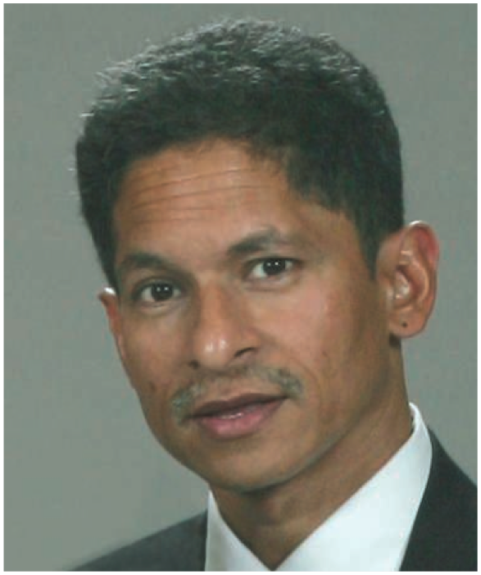

The astrophysics portion of module 2 of Rm⁴ will be co-taught by Guha Thakurta and UCSC Ph.D. student Claire Dorman. The students will analyze imaging data from the Hubble Space Telescope and spectroscopic data from the Keck telescope, the world’s largest optical telescope, in order to explore the physical properties of “star cluster” (tight-knit families of stars) in the Andromeda galaxy. The module will start with a presentation of a few basic facts by the mentors after which the students, working in small groups of 2–4, will be guided to look for patterns in the data, ask their own questions, sharpen these questions, and then proceed to answer them. They will use the python programming language for their analysis. The module will conclude with a session of brief presentations by each group of students on Wednesday March 6 from 6:30–7:30 PM.

